Bucharest Polytechnic University

Faculty of Engineering in Foreign Languages

Databases Project:

*Clothes Shop*

Coordinator Student   
Asist. Drd. Ing. Iuliana Marin Matei Cristina

Contents

1.Introduction

2. Entity Relationship Diagrams

3.Tables

3.1 Tables created in SQL

3.2 Foreign key constraints

Introduction

My project is called Clothes Shop Database. The shop consists of different ***departments***, in which every ***employee*** works***.*** Each employee has assigned a specific ***job*** inside the department. The employees work in ***shifts*** and perform their ***job assignments***. If the employees reach different targets (extra hours, double shifts, sell a certain amount of items etc.), they have the opportunity to receive ***bonuses*** and they also have the right to ***vacations*** every year.

We have various ***stores*** in many ***locations***, in different ***cities*** and ***counties.*** The shops have their privileged ***clients*** that own a fidelity card that store their personal information. Anyone who enters any of our stores can choose from a large variety of ***products*** that are arranged in ***categories***. They can also benefit from a lot of ***sales***, so we keep track of all the decreased prices.

The stores have a very good relationship with our ***suppliers*** who bring us items of the best quality and keep our ***stocks*** full.

The most requested form of shopping is online, so our website can meet any demand of our ***users***. They can place ***orders*** and we take the ***order details*** and deliver the items to the users’ address.

Entity Relationship Diagrams

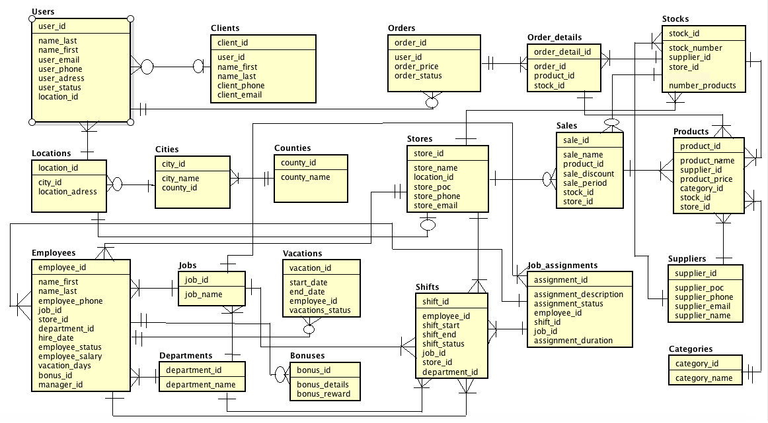

Tables

|  |  |  |  |  |
| --- | --- | --- | --- | --- |
| Nr ctr | Table | Primary Key | Foreign Key | Attributes |
| 1 | Users | user_id | location_id | name_last,name_first  user_email,user_phone,  user_address,user_status |
| 2 | Clients | client_id | user_id | name_first,name_last  client_email,client_phone |
| 3 | Orders | order_id | user_id | order_price,order_status |
| 4 | Orders_details | order_detail_id | order_id,product_id,  stock_id |  |
| 5 | Stocks | stock_id | supplier_id,store_id | stock_number,  number_products |
| 6 | Locations | location_id | city_id | location_address |
| 7 | Cities | city_id | county_id | city_name |
| 8 | Counties | county_id |  | county_name |
| 9 | Stores | store_id | location_id | store_name,store_poc,  store_phone,store_email |
| 10 | Sales | sale_id | product_id,stock_id, store_id | sale_name,sale_discount,  sale_period |
| 11 | Products | product_id | supplier_id,category_id,  stock_id,store_id | product_name,  product_price |
| 12 | Employees | employee_id | job_id,store_id,  department_id,bonus_id | name_first,name_last,  employee_phone,  hire_date,employee_status,  employee_salary,  vacation_days |
| 13 | Jobs | job_id |  | job_name |
| 14 | Vacations | vacation_id | employee_id | start_date,end_date,  vacation_status |
| 15 | Departments | department_id |  | department_name |
| 16 | Bonuses | bonus_id |  | bonus_details,  bonus_reward |
| 17 | Shifts | shift_id | employee_id,job_id,  store_id,department_id | shift_start,shift_end,  shift_status |
| 18 | Job_assignments | assignment_id | employee_id,shift_id,  job_id | assignment_description,  assignment_status,  assignment_duration |
| 19 | Suppliers | supplier_id |  | supplier_poc,  supplier_phone,supplier_name,  supplier_email |
| 20 | Categories | category_id |  | category_name |

|  |  |  |  |
| --- | --- | --- | --- |
| **Nr. Crt.** | **Attribute** | **Type** | **Constraint** |
| 1 | user_id | NUMBER(10) | PRIMARY KEY |
| 2 | location_id | NUMBER(10) | FOREIGN KEY |
| 3 | name_last | VARCHAR(32) | NOT NULL |
| 4 | name_first | VARCHAR(32) | NOT NULL |
| 5 | user_email | VARCHAR(16) | CHECK: user_email LIKE ‘%_@__.__% |
| 6 | user_phone | VARCHAR(16) | NOT NULL |
| 7 | user_address | VARCHAR(64) | NOT NULL |
| 8 | user_status | VARCHAR(16) | CHECK (user_status IN (‘active’, ‘inactive’)), DEFAULT: ‘active’ |

1.Users

2.Clients

|  |  |  |  |
| --- | --- | --- | --- |
| **Nr. Crt.** | **Attribute** | **Type** | **Constraint** |
| 1 | client_id | NUMBER(10) | PRIMARY KEY |
| 2 | user_id | NUMBER(10) | FOREIGN KEY |
| 3 | name_first | VARCHAR(32) | NOT NULL |
| 4 | name_last | VARCHAR(32) | NOT NULL |
| 5 | client_phone | VARCHAR(16) |  |
| 6 | client_email | VARCHAR(32) | CHECK: client_email LIKE ‘%_@__.__%’ |

3.Orders

|  |  |  |  |
| --- | --- | --- | --- |
| **Nr. Crt.** | **Attribute** | **Type** | **Constraint** |
| 1 | order_id | NUMBER(10) | PRIMARY KEY |
| 2 | user_id | NUMBER(10) | FOREIGN KEY |
| 3 | order_price | NUMBER(10) | NOT NULL |
| 4 | order_status | VARCHAR(16) | CHECK (order_status IN (‘shipped’, ‘canceled’)), DEFAULT: ‘shipped’ |

4.Order_details

|  |  |  |  |
| --- | --- | --- | --- |
| **Nr. Crt.** | **Attribute** | **Type** | **Constraint** |
| 1 | order_detail_id | NUMBER(10) | PRIMARY KEY |
| 2 | order_id | NUMBER(10) | FOREIGN KEY |
| 3 | product_id | NUMBER(10) | FOREIGN KEY |
| 4 | stock_id | NUMBER(10) | FOREIGN KEY |

5.Stocks

|  |  |  |  |
| --- | --- | --- | --- |
| **Nr. Crt.** | **Attribute** | **Type** | **Constraint** |
| 1 | stock_id | NUMBER(10) | PRIMARY KEY |
| 2 | supplier_id | NUMBER(10) | FOREIGN KEY |
| 3 | store_id | NUMBER(10) | FOREIGN KEY |
| 4 | product_id | NUMBER(10) | FOREIGN KEY |
| 5 | stock_number | NUMBER(10) | UNIQUE |
| 6 | number_products | NUMBER(10) | NOT NULL |

6.Locations

|  |  |  |  |
| --- | --- | --- | --- |
| **Nr. Crt.** | **Attribute** | **Type** | **Constraint** |
| 1 | location_id | NUMBER(10) | PRIMARY KEY |
| 2 | city_id | NUMBER(10) | FOREIGN KEY |
| 3 | location_address | VARCHAR(64) | NOT NULL |

7.Cities

|  |  |  |  |
| --- | --- | --- | --- |
| **Nr. Crt.** | **Attribute** | **Type** | **Constraint** |
| 1 | city_id | NUMBER(10) | PRIMARY KEY |
| 2 | county_id | NUMBER(10) | FOREIGN KEY |
| 3 | city_name | VARCHAR(32) | UNIQUE |

8.Counties

|  |  |  |  |
| --- | --- | --- | --- |
| **Nr. Crt.** | **Attribute** | **Type** | **Constraint** |
| 1 | county_id | NUMBER(10) | PRIMARY KEY |
| 2 | county_name | VARCHAR (32) | UNIQUE |

9.Stores

|  |  |  |  |
| --- | --- | --- | --- |
| **Nr. Crt.** | **Attribute** | **Type** | **Constraint** |
| 1 | store_id | NUMBER(10) | PRIMARY KEY |
| 2 | location_id | NUMBER(10) | FOREIGN KEY |
| 3 | store_name | VARCHAR(32) | UNIQUE |
| 4 | store_poc | VARCHAR(32) |  |
| 5 | store_phone | VARCHAR(16) |  |
| 6 | store_email | VARCHAR(16) | CHECK: store_email LIKE ‘%_@__.__%’ |

10.Sales

|  |  |  |  |
| --- | --- | --- | --- |
| **Nr. Crt.** | **Attribute** | **Type** | **Constraint** |
| 1 | sale_id | NUMBER(10) | PRIMARY KEY |
| 2 | product_id | NUMBER(10) | FOREIGN KEY |
| 3 | stock_id | NUMBER(10) | FOREIGN KEY |
| 4 | store_id | NUMBER(10) | FOREIGN KEY |
| 5 | sale_name | VARCHAR(32) | NOT NULL |
| 6 | sale_discount | NUMBER(10) | NOT NULL |
| 7 | sale_period | NUMBER(10) | NOT NULL |

11.Products

|  |  |  |  |
| --- | --- | --- | --- |
| **Nr. Crt.** | **Attribute** | **Type** | **Constraint** |
| 1 | product_id | NUMBER(10) | PRIMARY KEY |
| 2 | supplier_id | NUMBER(10) | FOREIGN KEY |
| 3 | category_id | NUMBER(10) | FOREIGN KEY |
| 4 | stock_id | NUMBER(10) | FOREIGN KEY |
| 5 | store_id | NUMBER(10) | FOREIGN KEY |
| 6 | product_name | VARCHAR(32) | NOT NULL |
| 7 | product_price | NUMBER(10) | NOT NULL |

12.Employees

|  |  |  |  |
| --- | --- | --- | --- |
| **Nr. Crt.** | **Attribute** | **Type** | **Constraint** |
| 1 | employee_id | NUMBER(10) | PRIMARY KEY |
| 2 | job_id | NUMBER(10) | FOREIGN KEY |
| 3 | store_id | NUMBER(10) | FOREIGN KEY |
| 4 | department_id | NUMBER(10) | FOREIGN KEY |
| 5 | bonus_id | NUMBER(10) | FOREIGN KEY |
| 6 | name_first | VARCHAR(16) | NOT NULL |
| 7 | name_last | VARCHAR(16) | NOT NULL |
| 8 | employee_phone | VARCHAR(16) |  |
| 9 | hire_date | DATE | NOT NULL |
| 10 | employee_status | VARCHAR(16) | CHECK (employee_status IN (‘active’, ‘inactive’)),  DEFAULT: ‘active’ |
| 11 | employee_salary | NUMBER(10) | NOT NULL |
| 12 | vacation_days | NUMBER(10) | DEFAULT:22 |

13.Jobs

|  |  |  |  |
| --- | --- | --- | --- |
| **Nr. Crt.** | **Attribute** | **Type** | **Constraint** |
| 1 | job_id | NUMBER(10) | PRIMARY KEY |
| 2 | job_name | VARCHAR(32) | NOT NULL |

14.Vacations

|  |  |  |  |
| --- | --- | --- | --- |
| **Nr. Crt.** | **Attribute** | **Type** | **Constraint** |
| 1 | vacation_id | NUMBER(10) | PRIMARY KEY |
| 2 | employee_id | NUMBER(10) | FOREIGN KEY |
| 3 | start_date | DATE | NOT NULL |
| 4 | end_date | DATE | NOT NULL |
| 5 | vacation_status | VARCHAR(32) | CHECK (vacation_status IN (‘started’, ‘ended’, ‘not started’)),  DEFAULT: ‘not started’ |

15.Departments

|  |  |  |  |
| --- | --- | --- | --- |
| **Nr. Crt.** | **Attribute** | **Type** | **Constraint** |
| 1 | department_id | NUMBER(10) | PRIMARY KEY |
| 2 | department_name | VARCHAR(32) | UNIQUE |

16.Bonuses

|  |  |  |  |
| --- | --- | --- | --- |
| **Nr. Crt.** | **Attribute** | **Type** | **Constraint** |
| 1 | bonus_id | NUMBER(10) | PRIMARY KEY |
| 2 | bonus_details | VARCHAR(64) | NOT NULL |
| 3 | bonus_reward | VARCHAR(32) | NOT NULL |

17.Shifts

|  |  |  |  |
| --- | --- | --- | --- |
| **Nr. Crt.** | **Attribute** | **Type** | **Constraint** |
| 1 | shift_id | NUMBER(10) | PRIMARY KEY |
| 2 | employee_id | NUMBER(10) | FOREIGN KEY |
| 3 | job_id | NUMBER(10) | FOREIGN KEY |
| 4 | store_id | NUMBER(10) | FOREIGN KEY |
| 5 | department_id | NUMBER(10) | FOREIGN KEY |
| 6 | shift_start | DATE | NOT NULL |
| 7 | shift_end | DATE | NOT NULL |
| 8 | shift_status | VARCHAR(32) | CHECK (vacation_status IN (‘started’, ‘ended’, ‘not started’)),  DEFAULT: ‘not started’ |

18.Job assignments

|  |  |  |  |
| --- | --- | --- | --- |
| **Nr. Crt.** | **Attribute** | **Type** | **Constraint** |
| 1 | assignment_id | NUMBER(10) | PRIMARY KEY |
| 2 | employee_id | NUMBER(10) | FOREIGN KEY |
| 3 | shift_id | NUMBER(10) | FOREIGN KEY |
| 4 | job_id | NUMBER(10) | FOREIGN KEY |
| 5 | assignment _description | VARCHAR(64) | NOT NULL |
| 6 | assignment_status | VARCHAR(32) | CHECK (vacation_status IN (‘started’, ‘ended’, ‘not started’)),  DEFAULT: ‘not started’ |
| 7 | assignment_duration | NUMBER(10) | NOT NULL |

19.Suppliers

|  |  |  |  |
| --- | --- | --- | --- |
| **Nr. Crt.** | **Attribute** | **Type** | **Constraint** |
| 1 | supplier_id | NUMBER(10) | PRIMARY KEY |
| 2 | supplier_poc | VARCHAR(64) | NOT NULL |
| 3 | supplier_phone | VARCHAR(16) |  |
| 4 | supplier_name | VARCHAR(32) | UNIQUE |
| 5 | supplier_email | VARCHAR(32) | CHECK: supplier_email LIKE ‘%_@__.__% |

20.Categories

|  |  |  |  |
| --- | --- | --- | --- |
| **Nr. Crt.** | **Attribute** | **Type** | **Constraint** |
| 1 | category_id | NUMBER(10) | PRIMARY KEY |
| 2 | category_name | VARCHAR(32) | NOT NULL |

Tables created in SQL

CREATE TABLE users

(

user_id numeric(10),

location_id numeric(10),

name_first varchar(32) NOT NULL,

name_last varchar(32) NOT NULL,

user_email varchar(16),

user_phone varchar(16) NOT NULL,

user_status varchar(16) DEFAULT 'active',

user_address varchar(64) NOT NULL,

CONSTRAINT pk_user_id PRIMARY KEY (user_id),

CONSTRAINT check_user_status

CHECK (user_status IN ('active','inactive')),

CONSTRAINT check_user_email

CHECK (user_email LIKE '%_@__.__%')

);

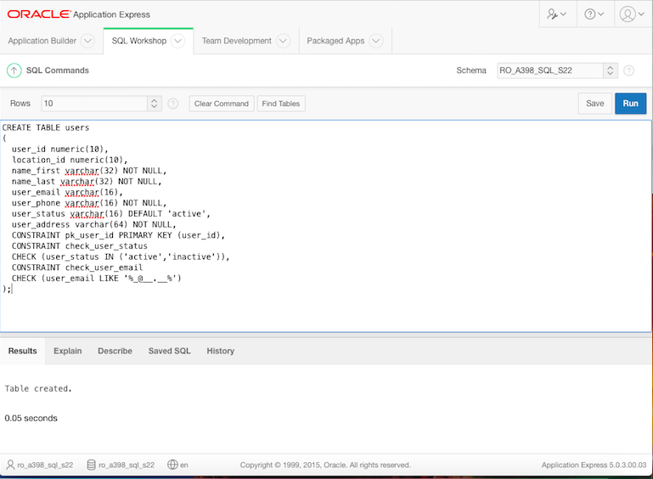

CREATE TABLE clients

(

client_id numeric(10),

user_id numeric(10),

name_first varchar(32) NOT NULL,

name_last varchar(32) NOT NULL,

client_phone varchar(16),

client_email varchar(32),

CONSTRAINT pk_client_id PRIMARY KEY (client_id),

CONSTRAINT check_client_email

CHECK (client_email LIKE '%_@__.__%')

);

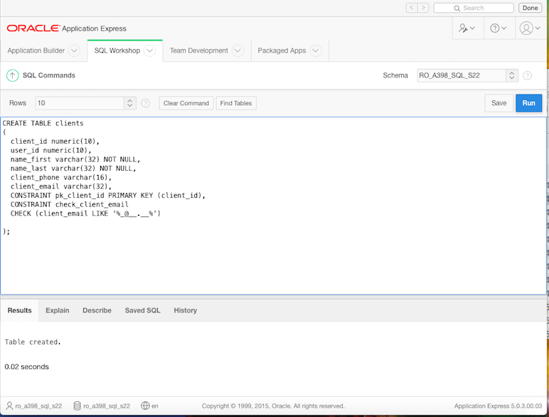

CREATE TABLE orders

(

order_id numeric(10),

user_id numeric(10),

order_price numeric(10) NOT NULL,

order_status varchar(16) DEFAULT 'shipped',

CONSTRAINT pk_order_id PRIMARY KEY (order_id),

CONSTRAINT check_order_status

CHECK (order_status IN ('shipped','canceled'))

);

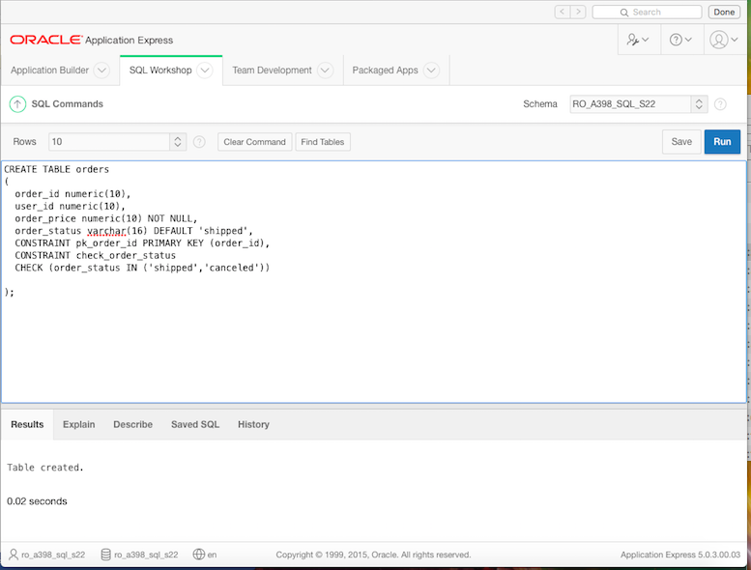

CREATE TABLE order_details

(

order_detail_id numeric(10),

order_id numeric(10),

product_id numeric(10),

stock_id numeric(10),

CONSTRAINT pk_order_detail_id PRIMARY KEY (order_detail_id)

);

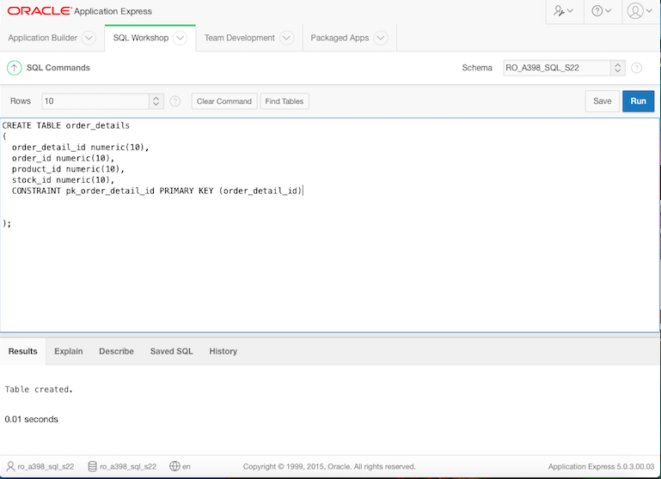

CREATE TABLE stocks

(

stock_id numeric(10),

supplier_id numeric(10),

store_id numeric(10),

product_id numeric(10),

stock_number numeric(10) UNIQUE,

number_products numeric(10) NOT NULL,

CONSTRAINT pk_stock_id PRIMARY KEY (stock_id)

);

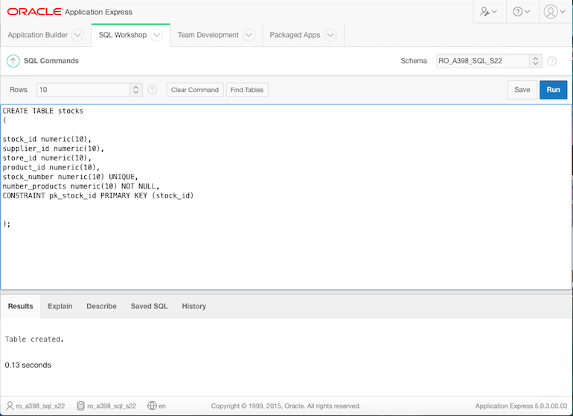

CREATE TABLE locations

(

location_id numeric(10),

city_id numeric(10),

location_address varchar(64) NOT NULL,

CONSTRAINT pk_location_id PRIMARY KEY (location_id)

);

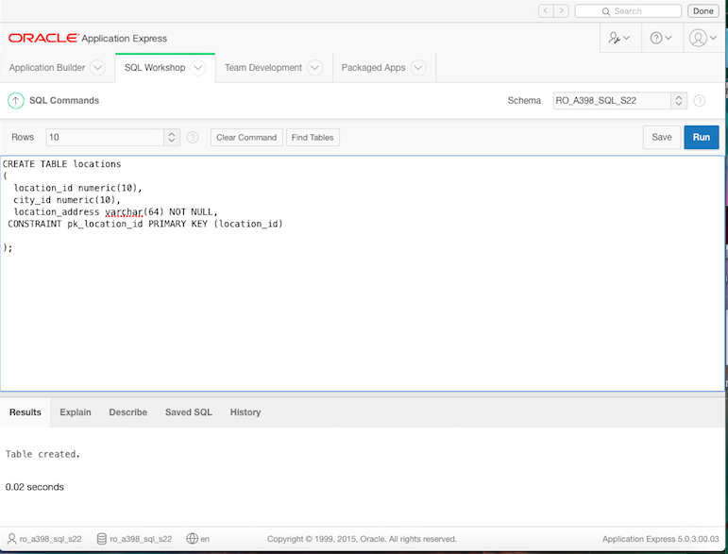

CREATE TABLE cities

(

city_id numeric(10),

county_id numeric(10),

city_name varchar(32) UNIQUE,

CONSTRAINT pk_city_id PRIMARY KEY (city_id)

);

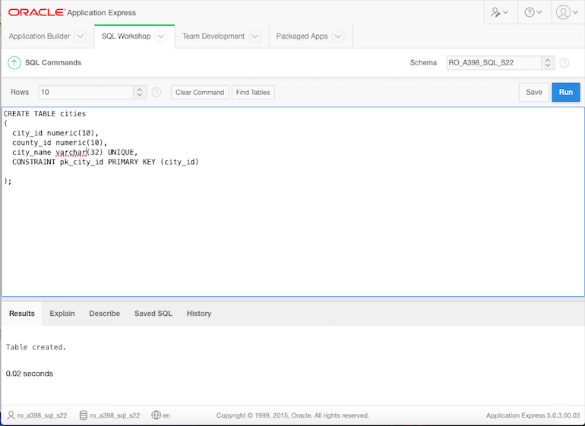

CREATE TABLE counties

(

county_id numeric(10),

county_name varchar(32) UNIQUE,

CONSTRAINT pk_county_id PRIMARY KEY (county_id)

);

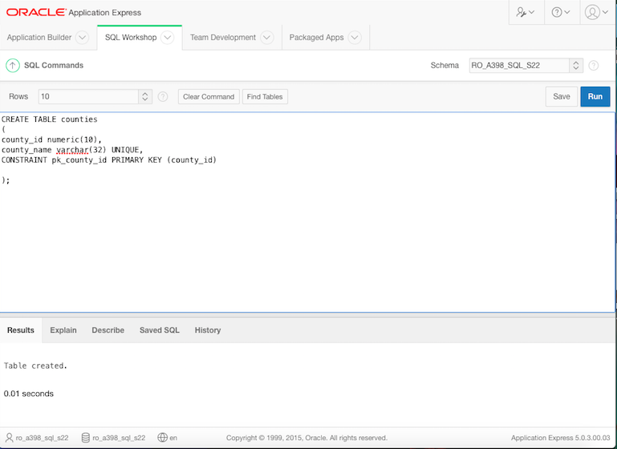

CREATE TABLE stores

(

store_id numeric(10),

location_id numeric(10),

store_name varchar(32) UNIQUE,

store_poc varchar(32),

store_phone varchar(16),

store_email varchar(16),

CONSTRAINT pk_store_id PRIMARY KEY (store_id),

CONSTRAINT check_store_email

CHECK (store_email LIKE '%_@__.__%')

);

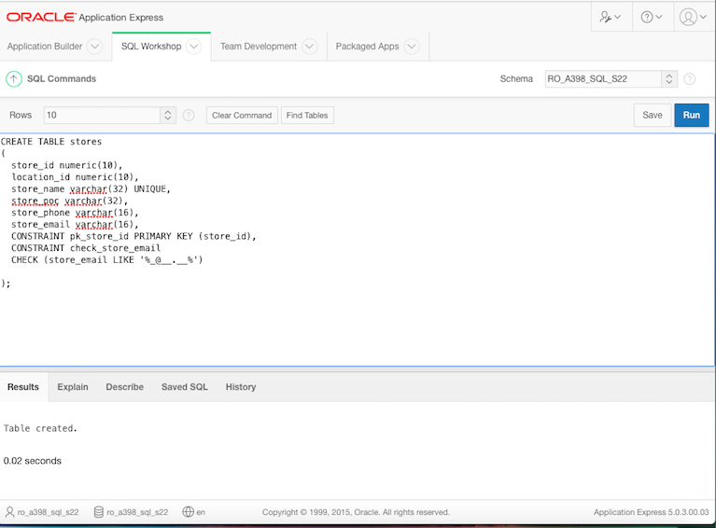

CREATE TABLE sales

(

sale_id numeric(10),

product_id numeric(10),

stock_id numeric(10),

store_id numeric(10),

sale_name varchar(32) NOT NULL,

sale_discount numeric(10) NOT NULL,

sale_period numeric(10) NOT NULL,

CONSTRAINT pk_sale_id PRIMARY KEY (sale_id)

);

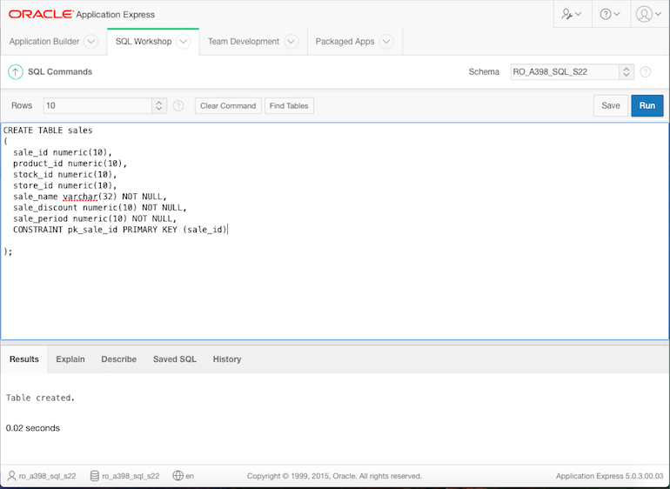

CREATE TABLE products

(

product_id numeric(10),

supplier_id numeric(10),

category_id numeric(10),

stock_id numeric(10),

store_id numeric(10),

product_name varchar(32) NOT NULL,

product_price numeric(10) NOT NULL,

CONSTRAINT pk_product_id PRIMARY KEY (product_id)

);

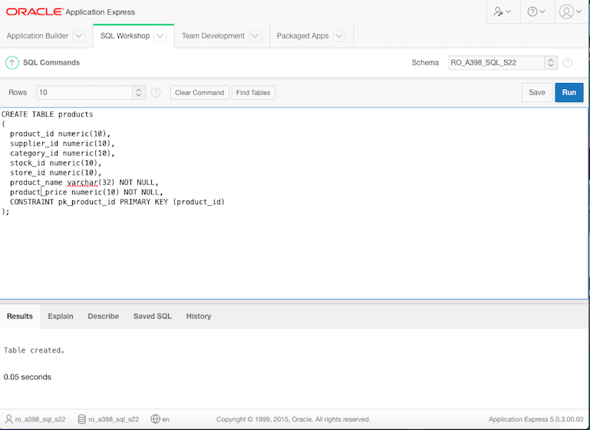

CREATE TABLE employees

(

employee_id numeric(10),

job_id numeric(10),

store_id numeric(10),

department_id numeric(10),

bonus_id numeric(10),

name_first varchar(16) NOT NULL,

name_last varchar(16) NOT NULL,

employee_phone varchar(16),

hire_date DATE NOT NULL,

employee_status varchar(16) DEFAULT 'active',

employee_salary numeric(10) NOT NULL,

vacation_days numeric(10) DEFAULT 22,

CONSTRAINT pk_employee_id PRIMARY KEY (employee_id),

CONSTRAINT check_employee_status

CHECK (employee_status IN ('active','inactive'))

);

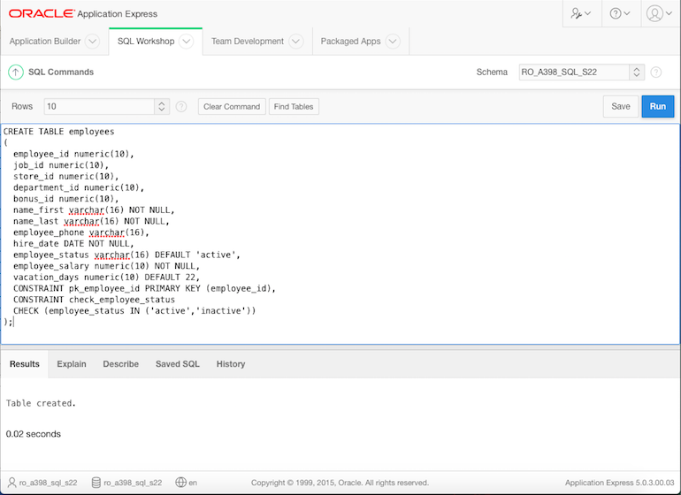

CREATE TABLE jobs

(

job_id numeric(10),

job_name varchar(32) NOT NULL,

CONSTRAINT pk_job_id PRIMARY KEY (job_id)

);

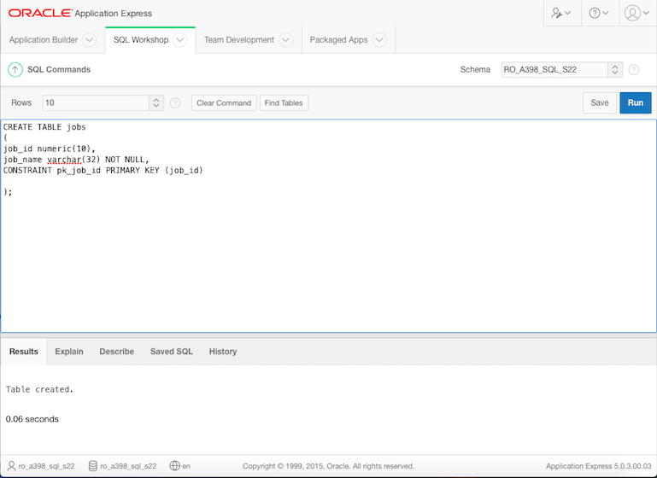

CREATE TABLE vacations

(

vacation_id numeric(10),

employee_id numeric(10),

start_date DATE NOT NULL,

end_date DATE NOT NULL,

vacation_status varchar(32) DEFAULT 'not started',

CONSTRAINT pk_vacation_id PRIMARY KEY (vacation_id),

CONSTRAINT check_vacation_status

CHECK (vacation_status IN ('started','ended','not started'))

);

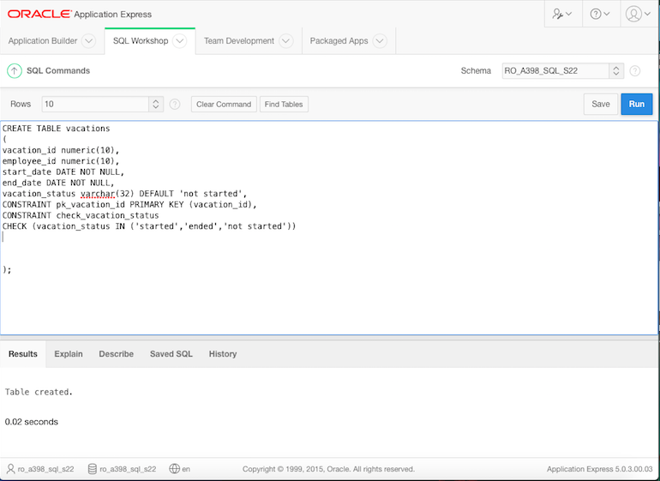

CREATE TABLE departments

(

department_id numeric(10),

department_name varchar(32) UNIQUE,

CONSTRAINT pk_department_id PRIMARY KEY (department_id)

);

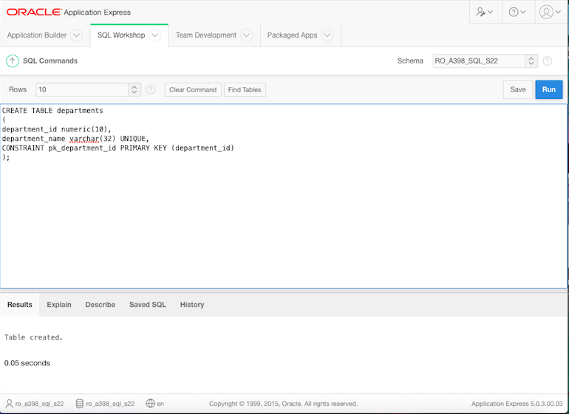

CREATE TABLE bonuses

(

bonus_id numeric(10),

bonus_details varchar(64) NOT NULL,

bonus_reward varchar(32) NOT NULL,

CONSTRAINT pk_bonus_id PRIMARY KEY (bonus_id)

);

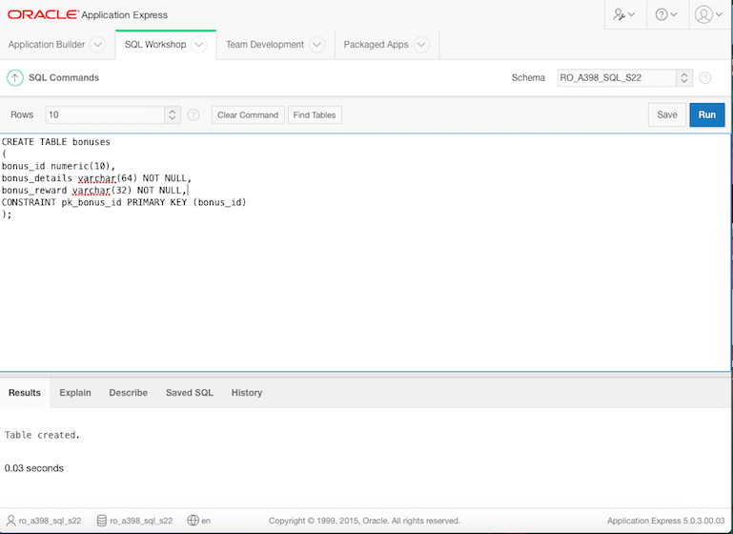

CREATE TABLE shifts

(

shift_id numeric(10),

employee_id numeric(10),

job_id numeric(10),

store_id numeric(10),

department_id numeric(10),

shift_start DATE NOT NULL,

shift_end DATE NOT NULL,

shift_status varchar(32) DEFAULT 'not started',

CONSTRAINT pk_shift_id PRIMARY KEY (shift_id),

CONSTRAINT check_shift_status

CHECK (shift_status IN ('started','ended','not started'))

);

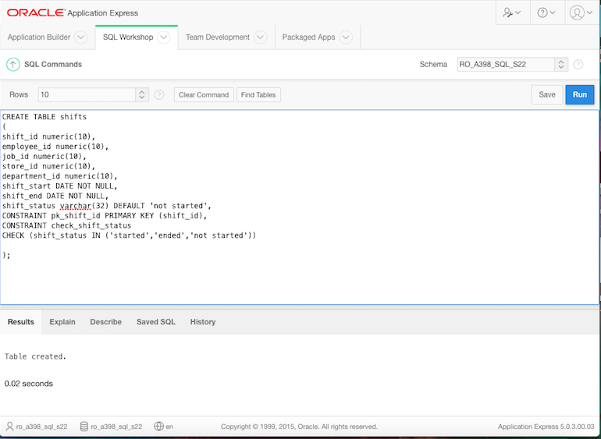

CREATE TABLE job_assignments

(

assignment_id numeric(10),

employee_id numeric(10),

shift_id numeric(10),

job_id numeric(10),

assignment_description varchar(64) NOT NULL,

assignment_status varchar(32) DEFAULT 'not started',

assignment_duration number(10) NOT NULL,

CONSTRAINT pk_assignment_id PRIMARY KEY (assignment_id),

CONSTRAINT check_assignment_status

CHECK (assignment_status IN ('started','ended','not started'))

);

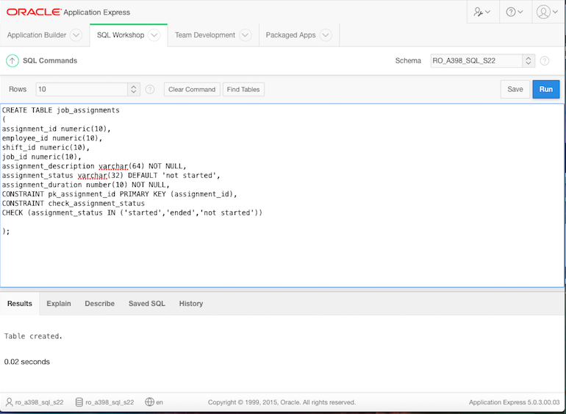

CREATE TABLE suppliers

(

supplier_id numeric(10),

supplier_poc varchar(64) NOT NULL,

supplier_phone varchar(16),

supplier_name varchar(32) UNIQUE,

supplier_email varchar(32),

CONSTRAINT pk_supplier_id PRIMARY KEY (supplier_id),

CONSTRAINT check_supplier_email

CHECK (supplier_email LIKE '%_@__.__%')

);

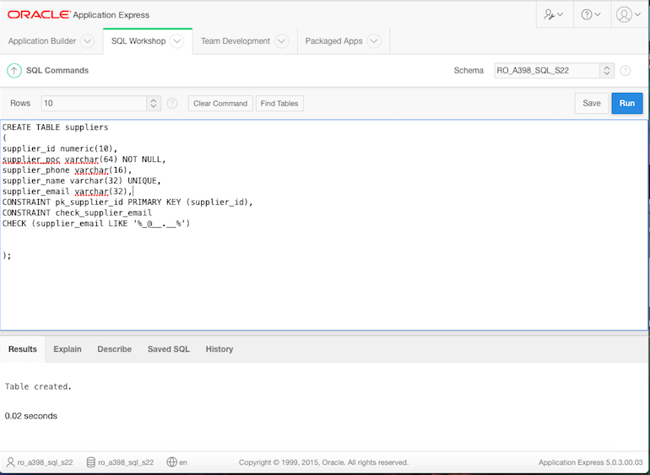

CREATE TABLE categories

(

category_id number(10),

category_name varchar(32) NOT NULL,

CONSTRAINT pk_category_id PRIMARY KEY (category_id)

);

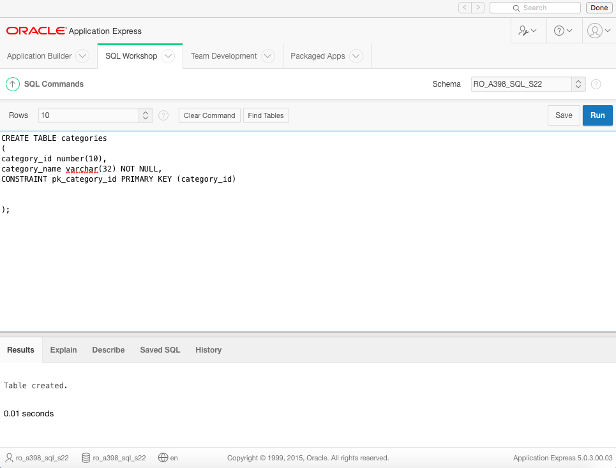

Foreign key constraints

1.Users

ALTER TABLE users ADD CONSTRAINT fk_user_location_id FOREIGN KEY (location_id)

REFERENCES locations (location_id) ENABLE;

2.Clients

ALTER TABLE clients ADD CONSTRAINT fk_client_user_id FOREIGN KEY (user_id)

REFERENCES users (user_id) ENABLE;

3.Orders

ALTER TABLE orders ADD CONSTRAINT fk_order_user_id FOREIGN KEY (user_id)

REFERENCES users (user_id) ENABLE;

4.Order_details

ALTER TABLE order_details ADD CONSTRAINT fk_orderdet_order_id FOREIGN KEY (order_id)

REFERENCES orders (order_id) ENABLE;

ALTER TABLE order_details ADD CONSTRAINT fk_orderdet_product_id FOREIGN KEY (product_id)

REFERENCES products (product_id) ENABLE;

ALTER TABLE order_details ADD CONSTRAINT fk_orderdet_stock_id FOREIGN KEY (stock_id)

REFERENCES stocks (stock_id) ENABLE;

5. Stocks

ALTER TABLE stocks ADD CONSTRAINT fk_stock_supplier_id FOREIGN KEY (supplier_id)

REFERENCES suppliers (supplier_id) ENABLE;

ALTER TABLE stocks ADD CONSTRAINT fk_stock_store_id FOREIGN KEY (store_id)

REFERENCES stores (store_id) ENABLE;

---------------------------------------------------------------------------------

NU MAI AVEM NEVOIE:FK_STOCK_product_id-mai jos

ALTER TABLE stocks ADD CONSTRAINT fk_stock_product_id FOREIGN KEY (product_id)

REFERENCES products (product_id) ENABLE;

6. Locations

ALTER TABLE locations ADD CONSTRAINT fk_location_city_id FOREIGN KEY (city_id)

REFERENCES cities (city_id) ENABLE;

7. Cities

ALTER TABLE cities ADD CONSTRAINT fk_city_county_id FOREIGN KEY (county_id)

REFERENCES counties (county_id) ENABLE;

9. Stores

ALTER TABLE stores ADD CONSTRAINT fk_store_location_id FOREIGN KEY (location_id)

REFERENCES locations (location_id) ENABLE;

10. Sales

ALTER TABLE sales ADD CONSTRAINT fk_sale_product_id FOREIGN KEY (product_id)

REFERENCES products (product_id) ENABLE;

ALTER TABLE sales ADD CONSTRAINT fk_sale_stock_id FOREIGN KEY (stock_id)

REFERENCES stocks (stock_id) ENABLE;

ALTER TABLE sales ADD CONSTRAINT fk_sale_store_id FOREIGN KEY (store_id)

REFERENCES stores (store_id) ENABLE;

11. Products

ALTER TABLE products ADD CONSTRAINT fk_product_supplier_id FOREIGN KEY (supplier_id)

REFERENCES suppliers (supplier_id) ENABLE;

ALTER TABLE products ADD CONSTRAINT fk_product_category_id FOREIGN KEY (category_id)

REFERENCES categories (category_id) ENABLE;

ALTER TABLE products ADD CONSTRAINT fk_product_stock_id FOREIGN KEY (stock_id)

REFERENCES stocks (stock_id) ENABLE;

ALTER TABLE products ADD CONSTRAINT fk_product_store_id FOREIGN KEY (store_id)

REFERENCES stores (store_id) ENABLE;

12. Employees

ALTER TABLE employees ADD CONSTRAINT fk_employee_job_id FOREIGN KEY (job_id)

REFERENCES jobs (job_id) ENABLE;

ALTER TABLE employees ADD CONSTRAINT fk_employee_store_id FOREIGN KEY (store_id)

REFERENCES stores (store_id) ENABLE;

ALTER TABLE employees ADD CONSTRAINT fk_employee_department_id FOREIGN KEY (department_id)

REFERENCES departments (department_id) ENABLE;

ALTER TABLE employees ADD CONSTRAINT fk_employee_bonus_id FOREIGN KEY (bonus_id)

REFERENCES bonuses (bonus_id) ENABLE;

14. Vacations

ALTER TABLE vacations ADD CONSTRAINT fk_vacation_employee_id FOREIGN KEY (employee_id)

REFERENCES employees (employee_id) ENABLE;

17. Shifts

ALTER TABLE shifts ADD CONSTRAINT fk_shift_employee_id FOREIGN KEY (employee_id)

REFERENCES employees (employee_id) ENABLE;

ALTER TABLE shifts ADD CONSTRAINT fk_shift_job_id FOREIGN KEY (job_id)

REFERENCES jobs (job_id) ENABLE;

ALTER TABLE shifts ADD CONSTRAINT fk_shift_store_id FOREIGN KEY (store_id)

REFERENCES stores (store_id) ENABLE;

ALTER TABLE shifts ADD CONSTRAINT fk_shift_department_id FOREIGN KEY (department_id)

REFERENCES departments (department_id) ENABLE;

18.Job_assignments

ALTER TABLE job_assignments ADD CONSTRAINT fk_jobassig_employee_id FOREIGN KEY (employee_id)

REFERENCES employees (employee_id) ENABLE;

ALTER TABLE job_assignments ADD CONSTRAINT fk_jobassig_shift_id FOREIGN KEY (shift_id)

REFERENCES shifts (shift_id) ENABLE;

ALTER TABLE job_assignments ADD CONSTRAINT fk_jobassig_job_id FOREIGN KEY (job_id)

REFERENCES jobs (job_id) ENABLE;

1.Users

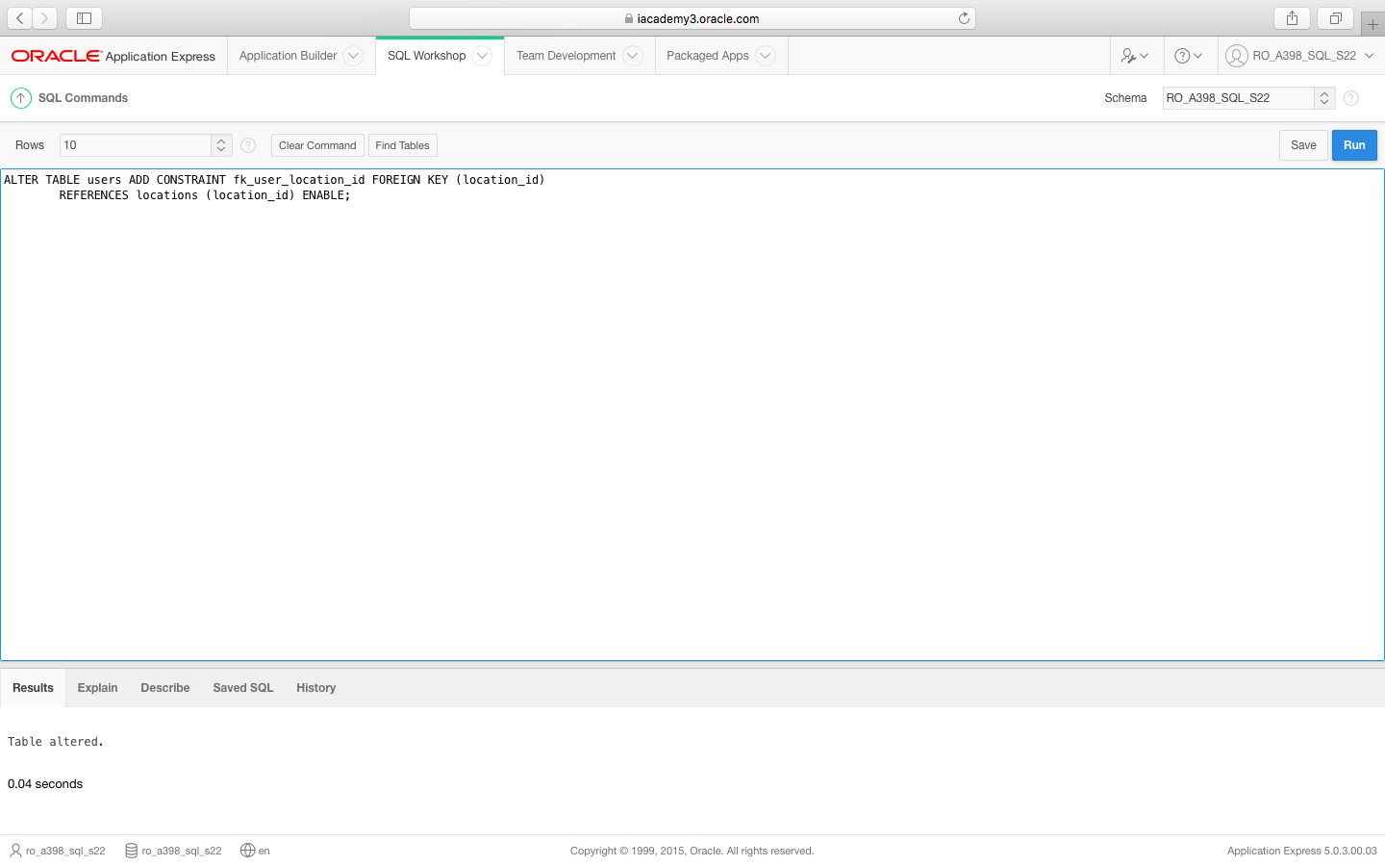

2.Clients

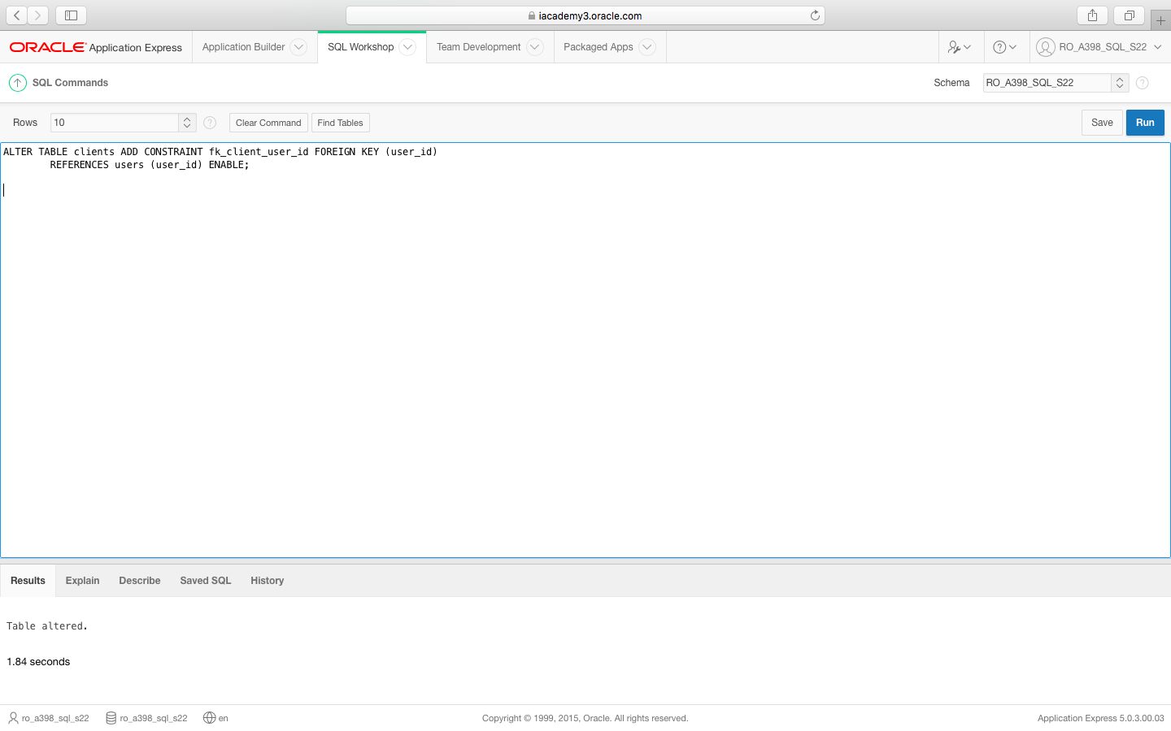

3.Orders

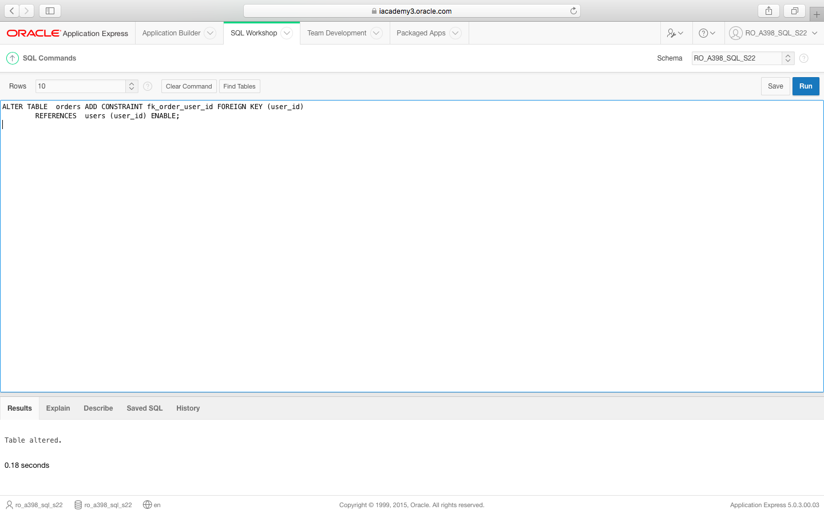

4.Order_details

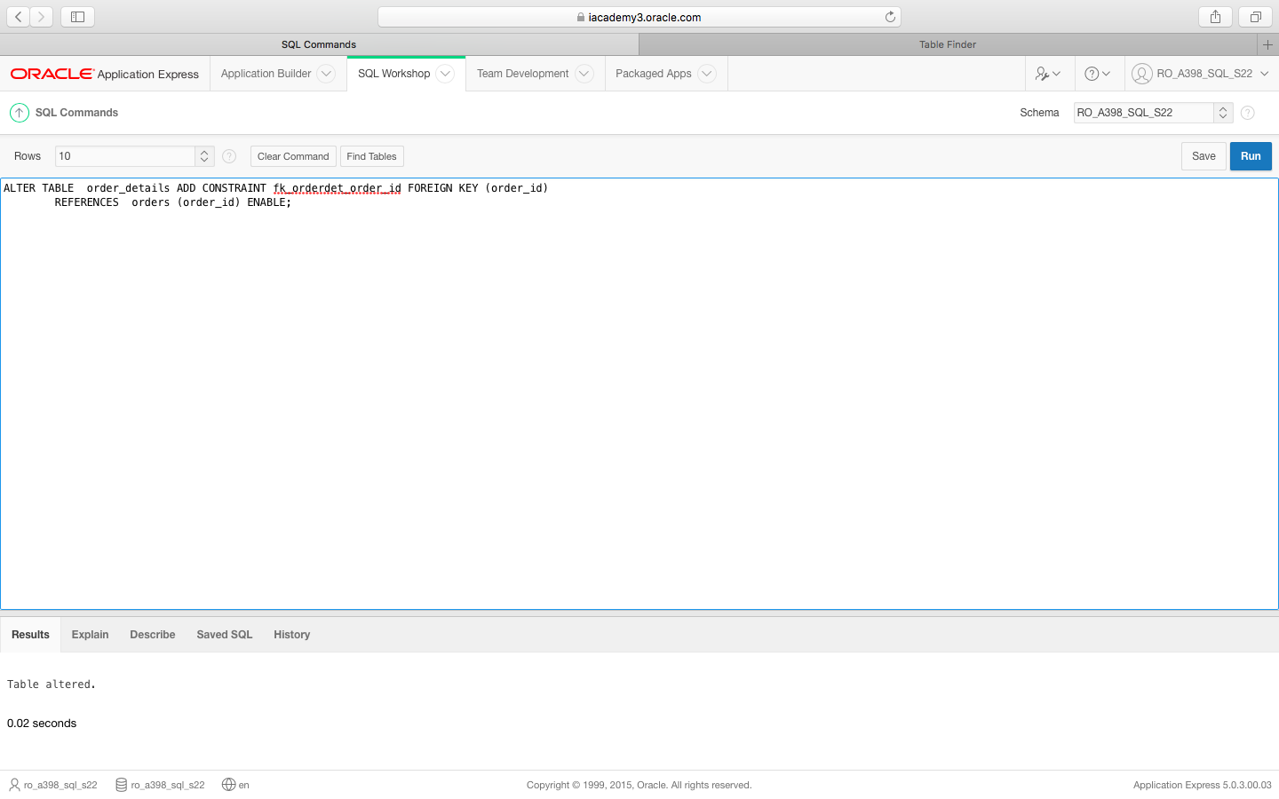

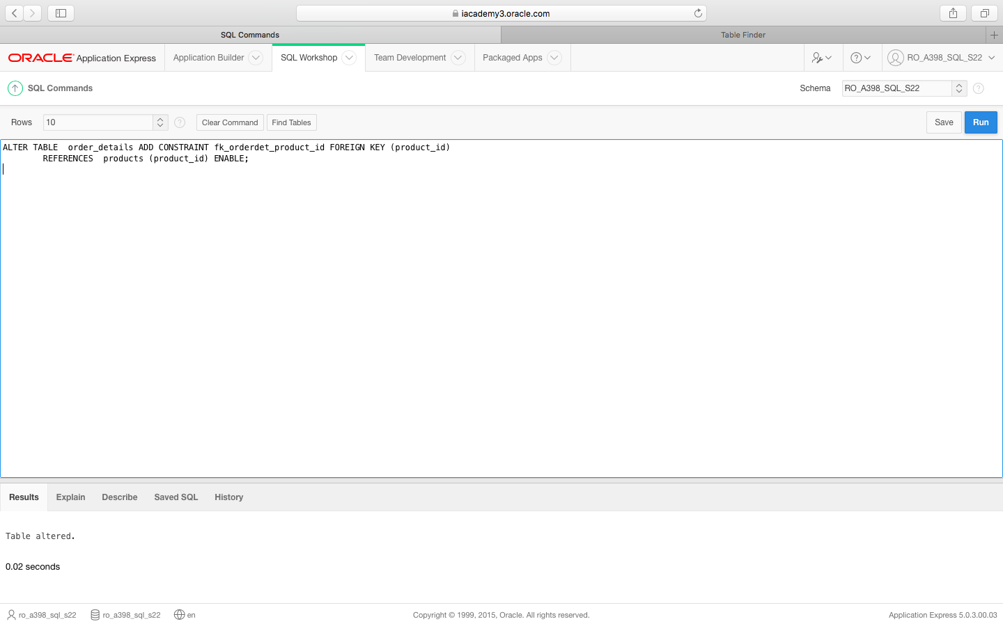

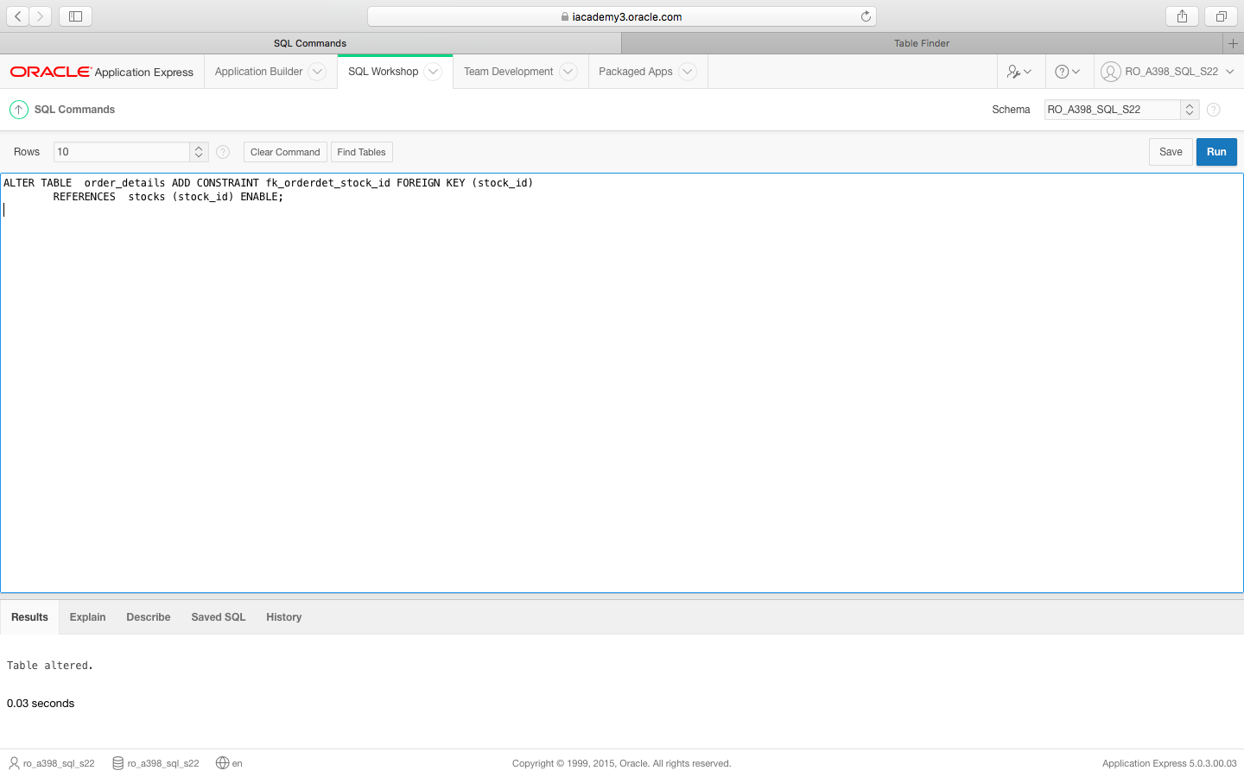

5.Stocks

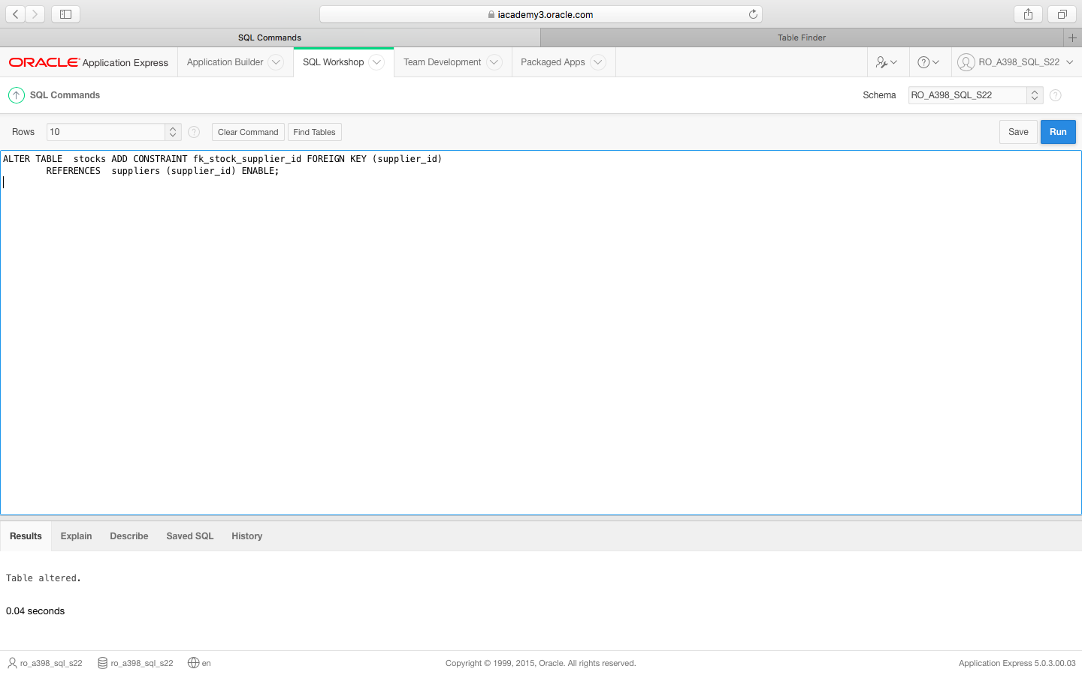

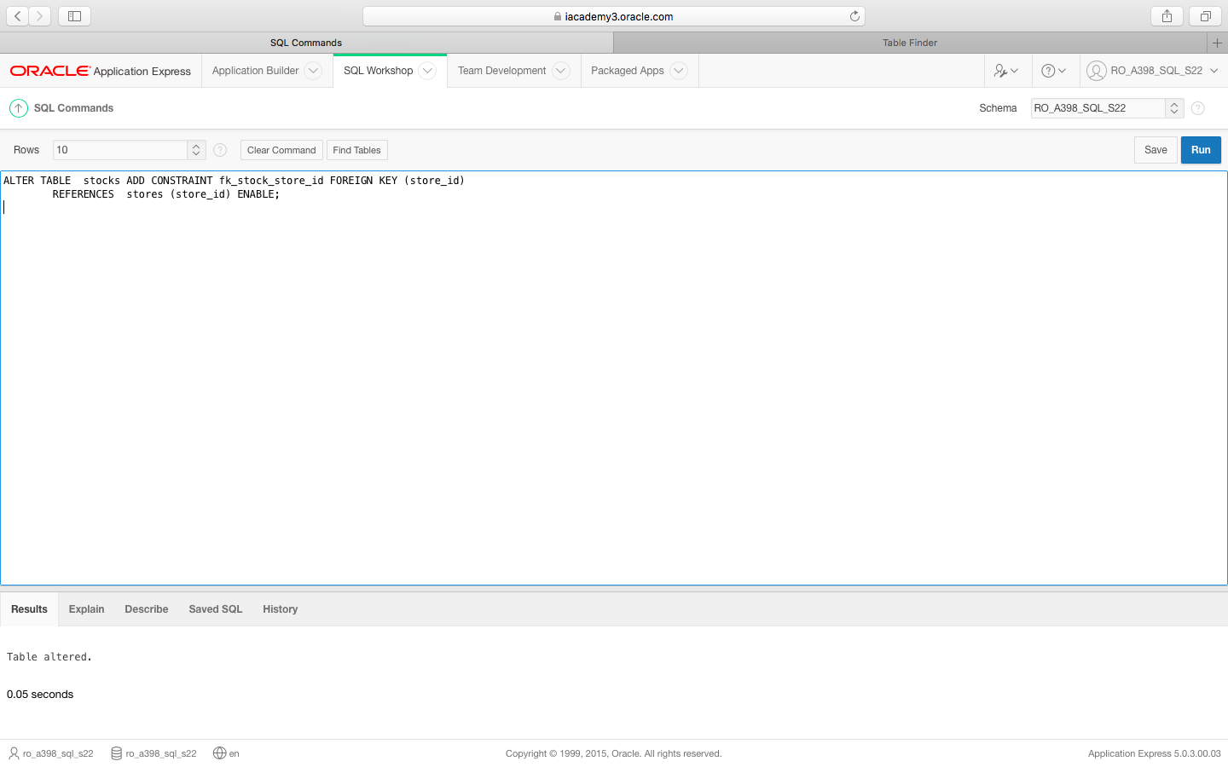

NU MAI AVEM NEVOIE:FK_STOCK_product_id-mai jos

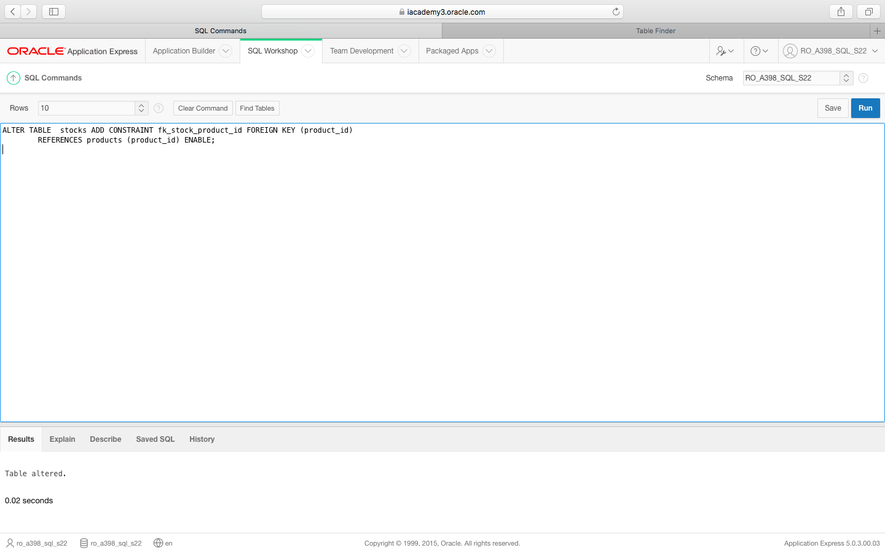

6.Locations

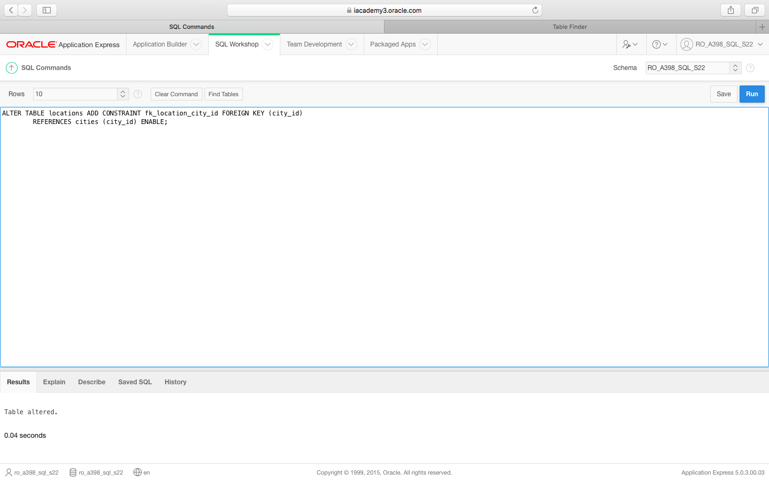

7.Cities

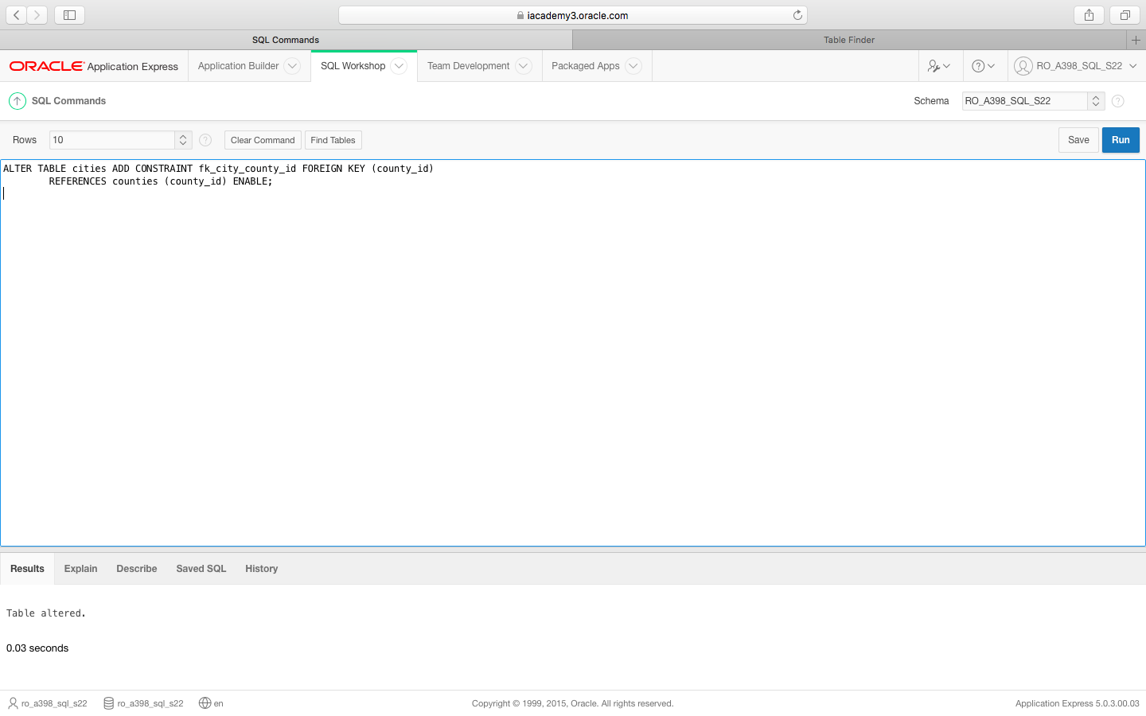

9.Stores

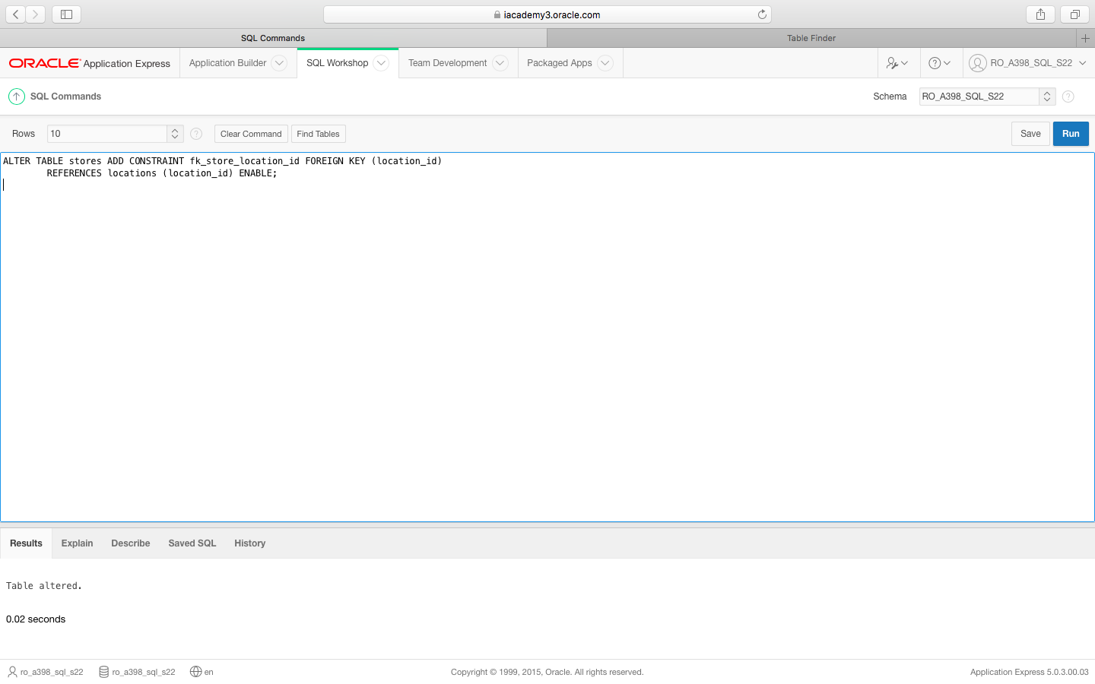

10.Sales

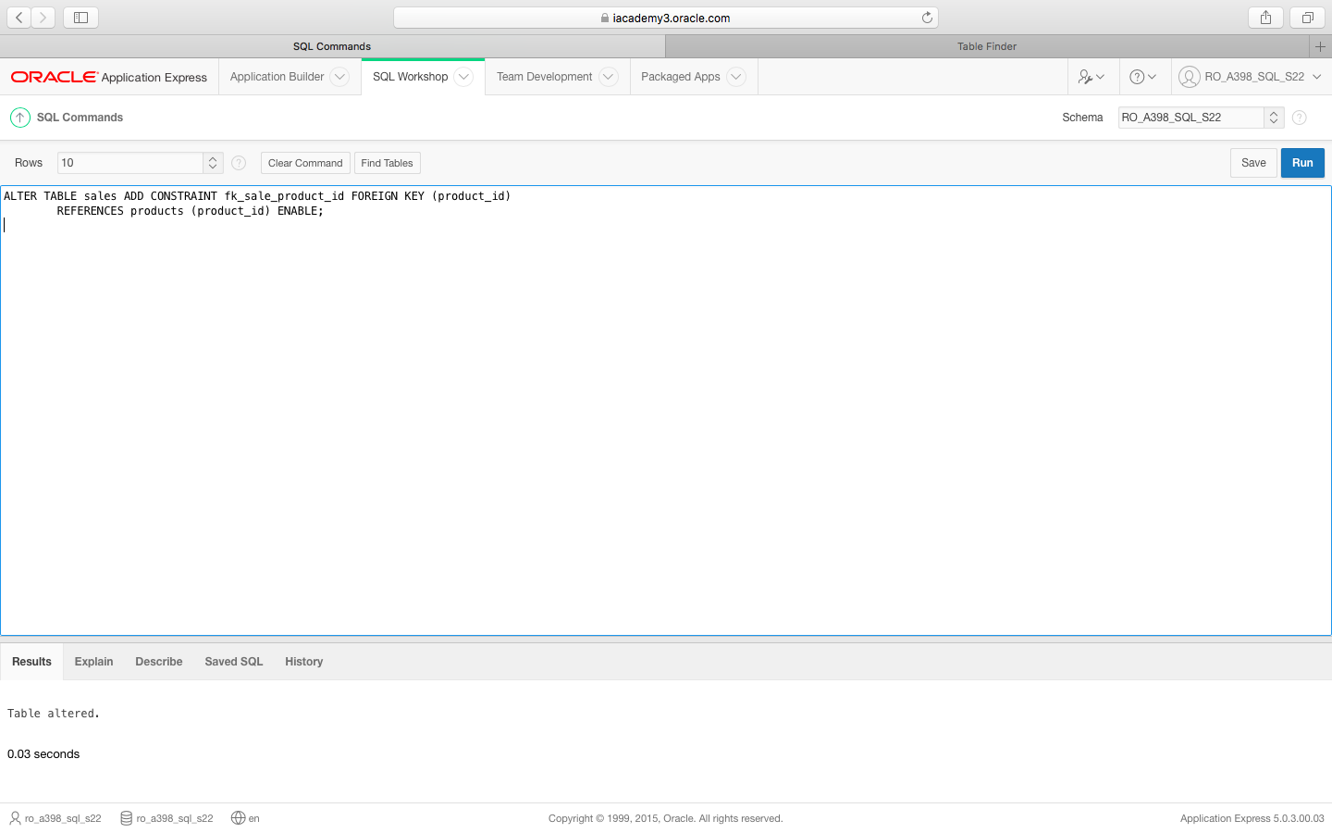

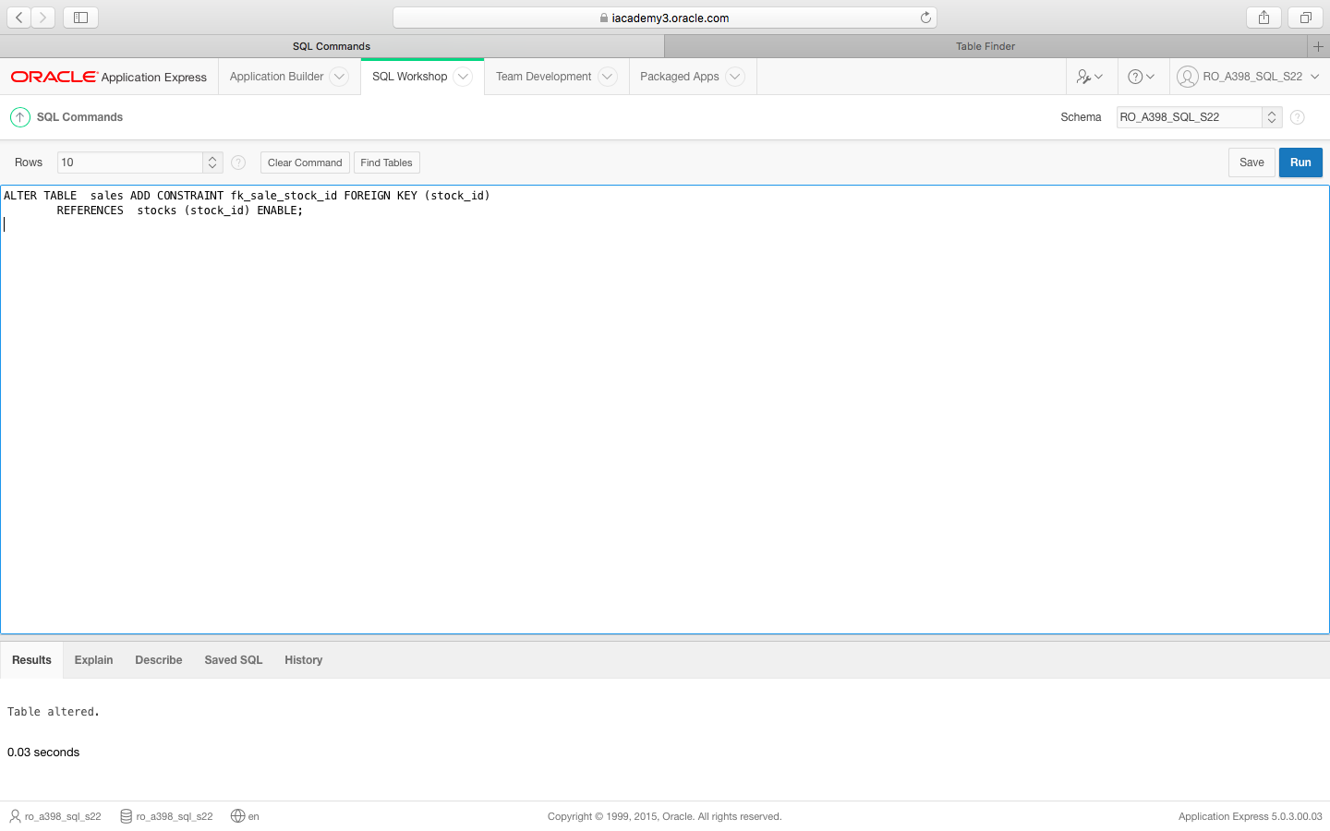

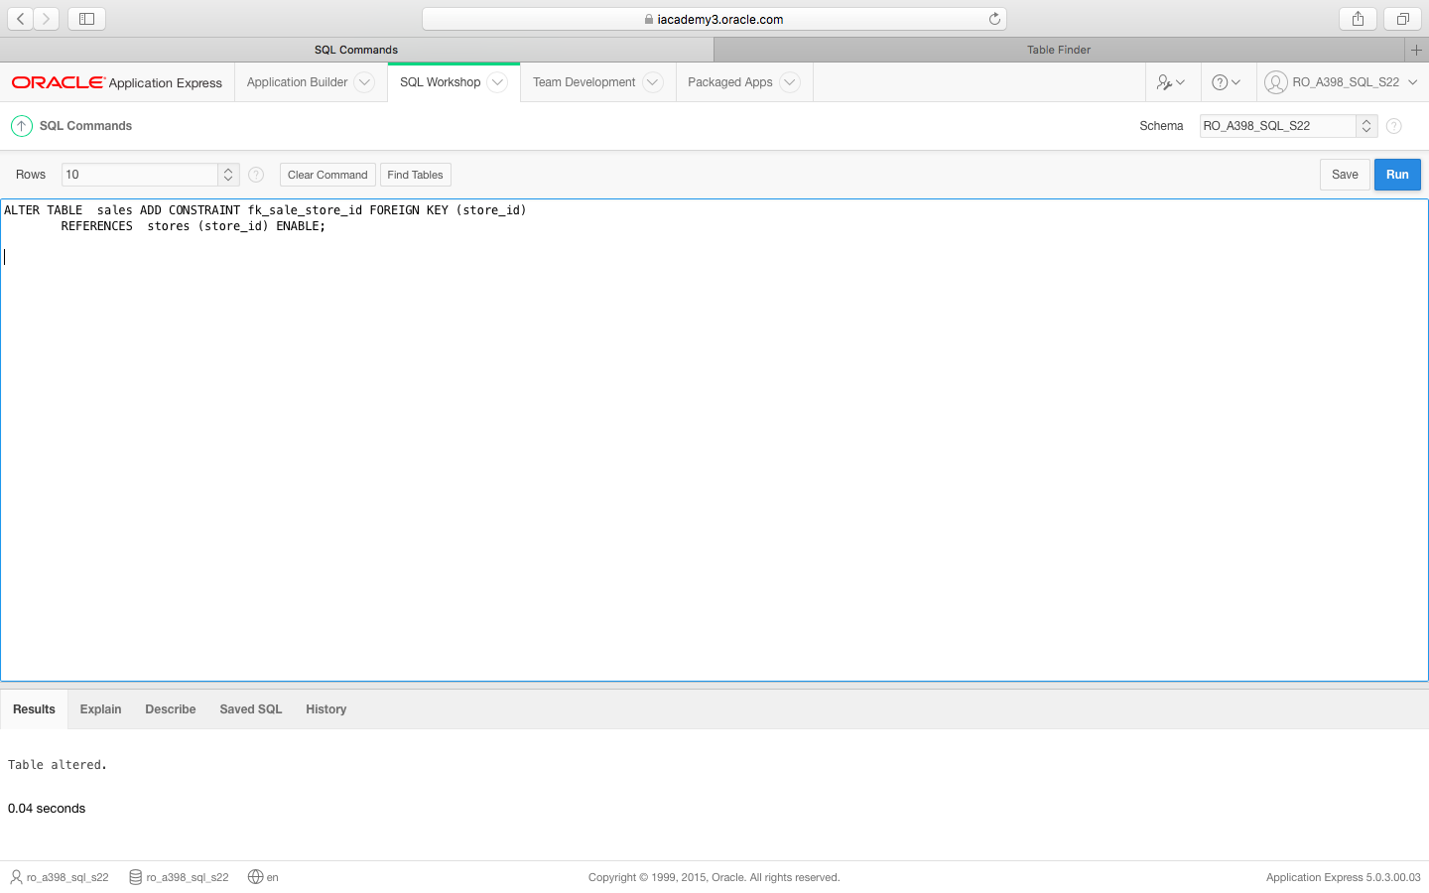

11.Products

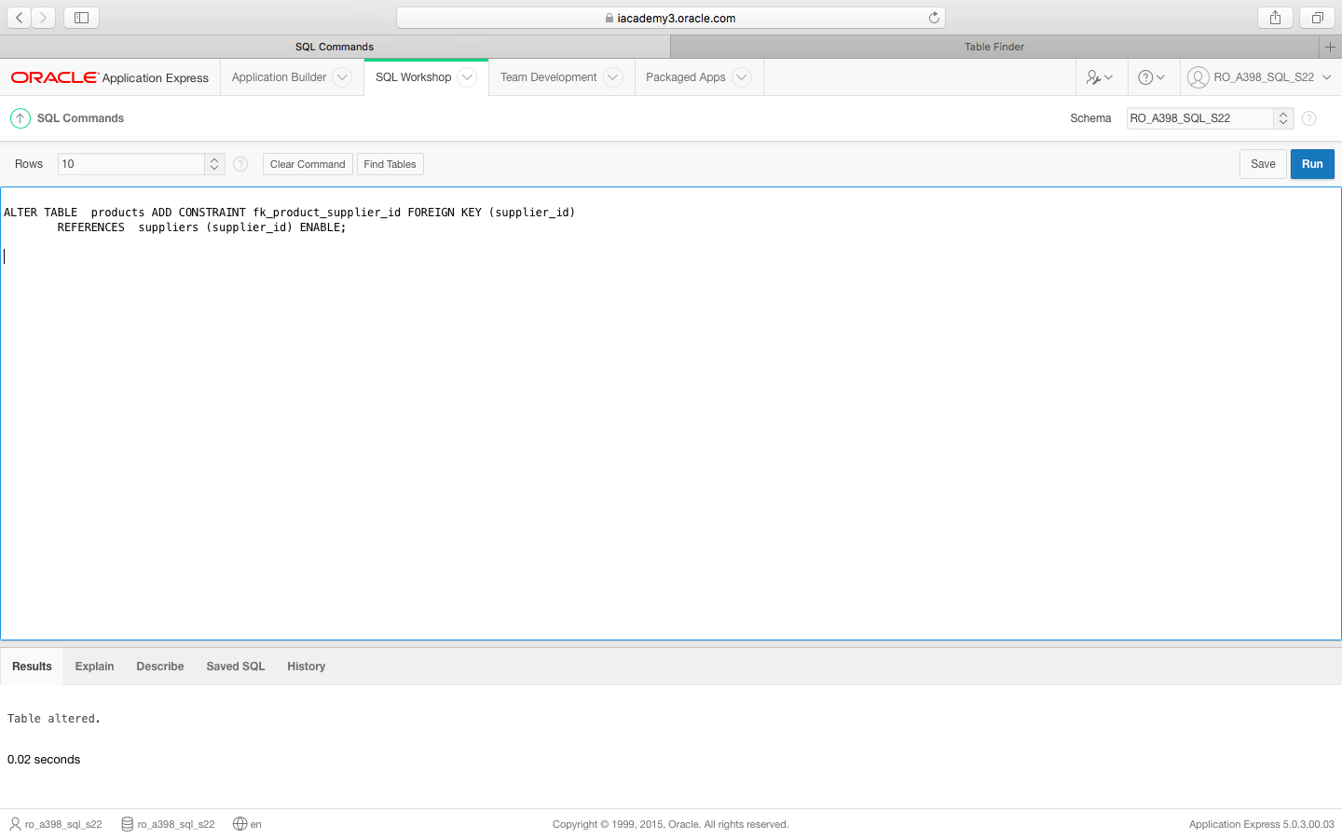

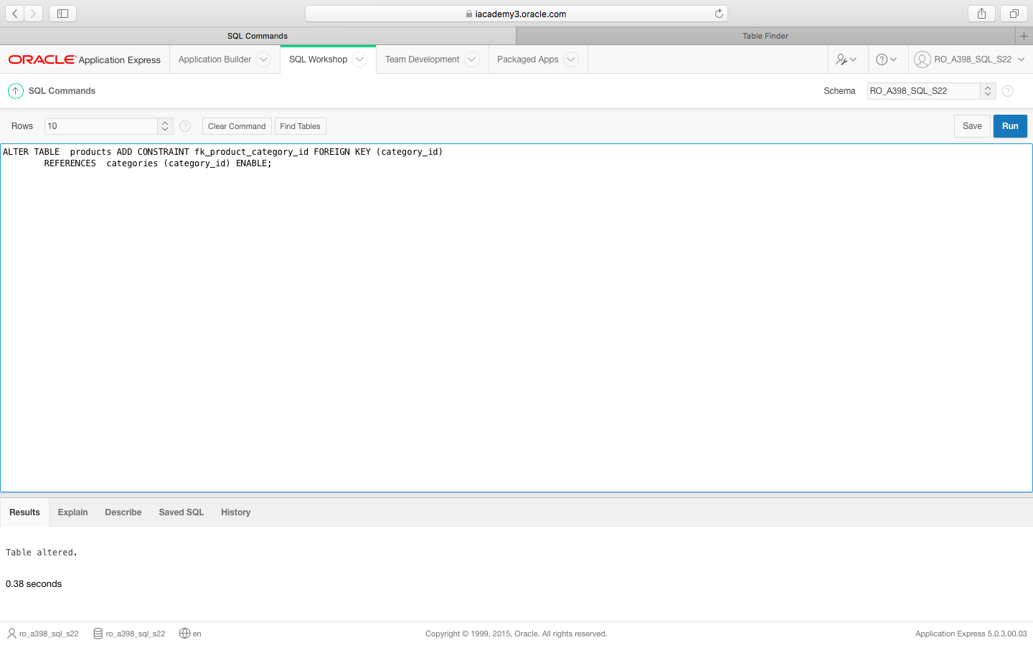

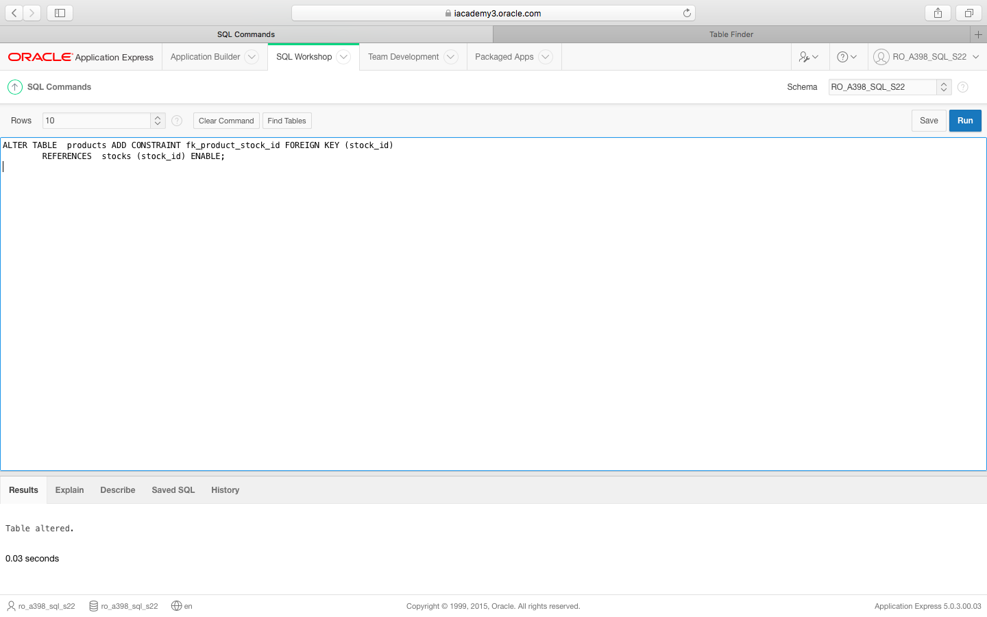

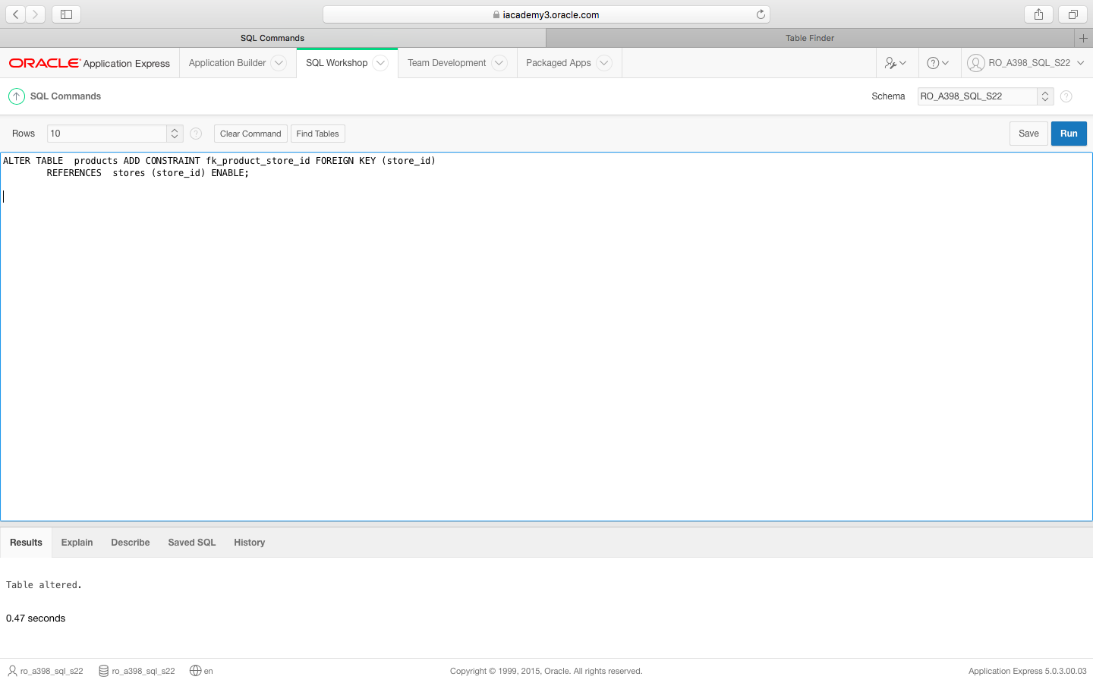

12.Employees

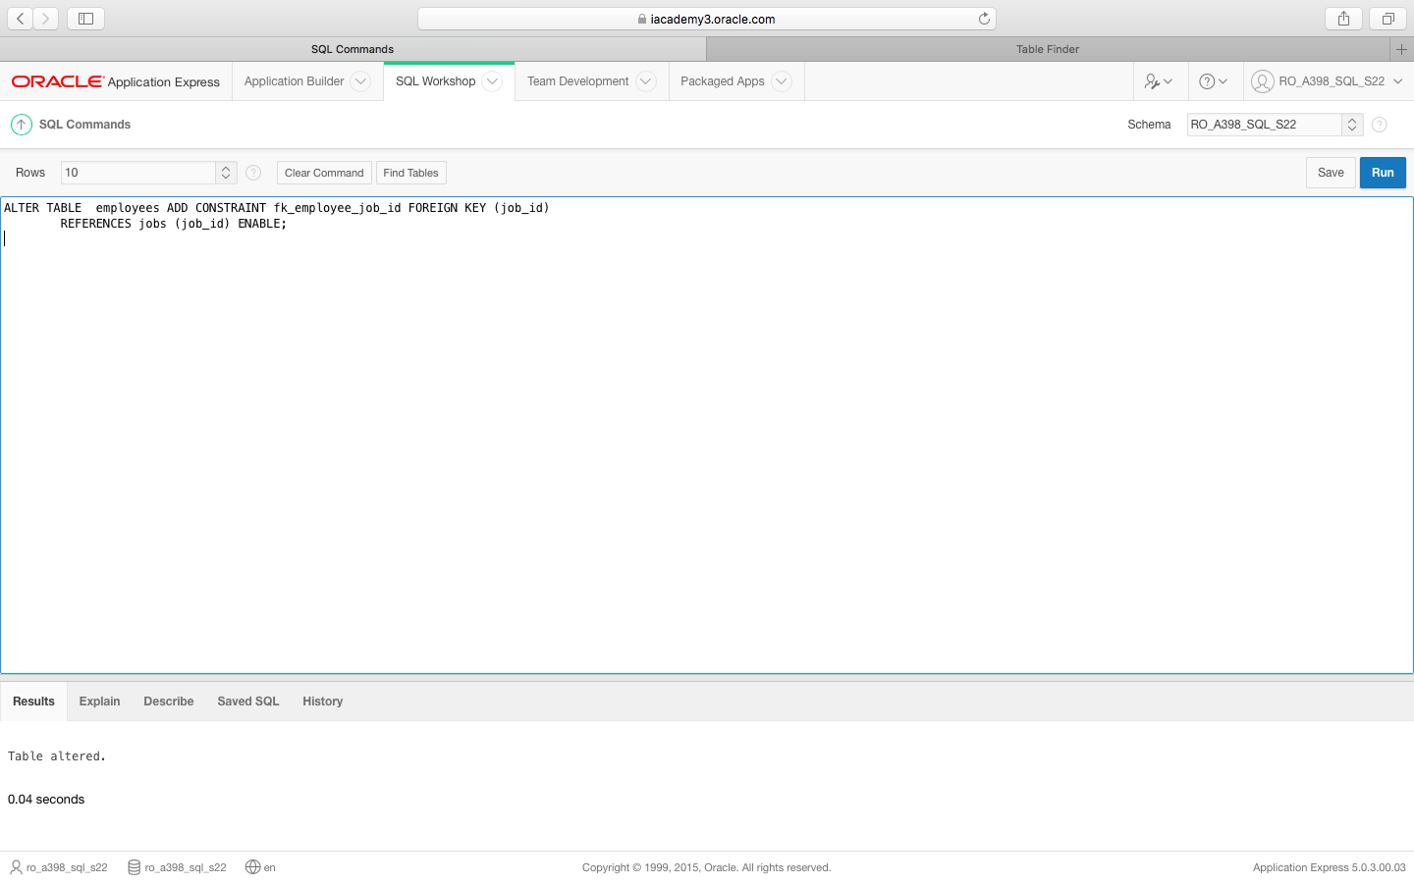

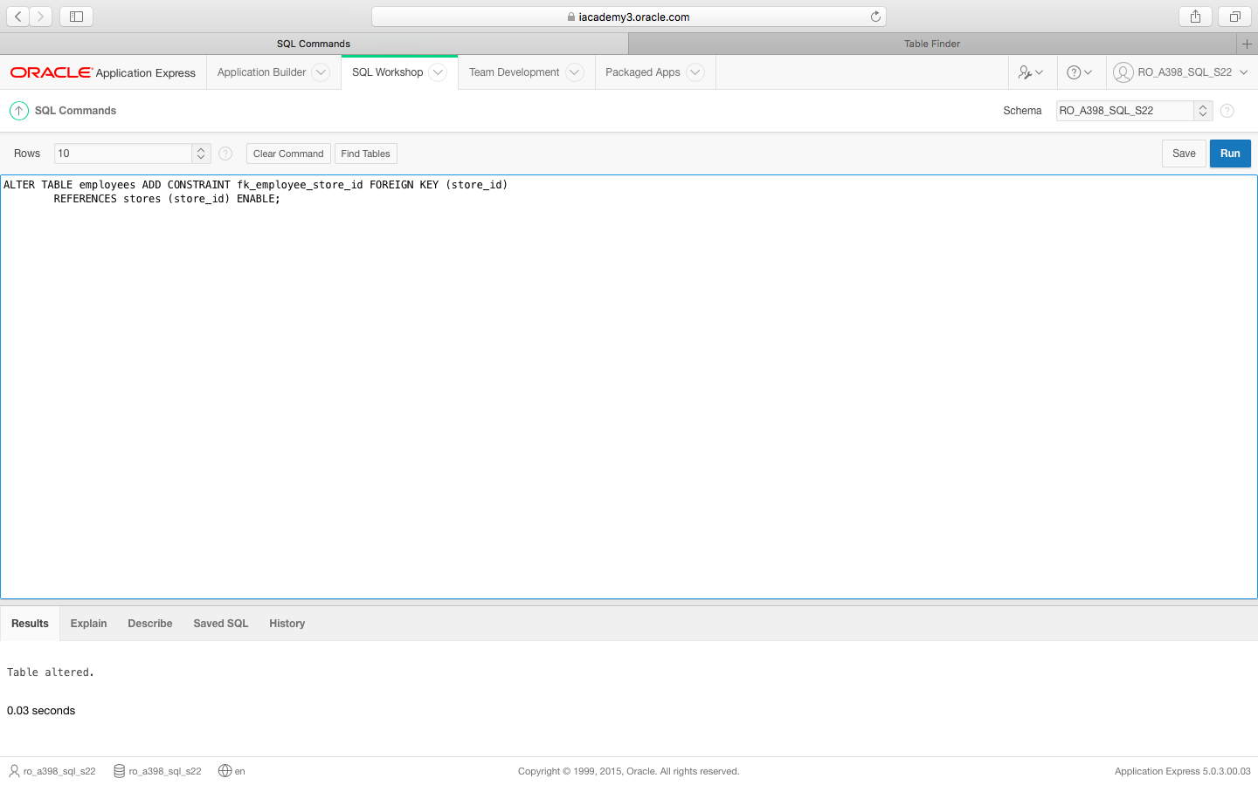

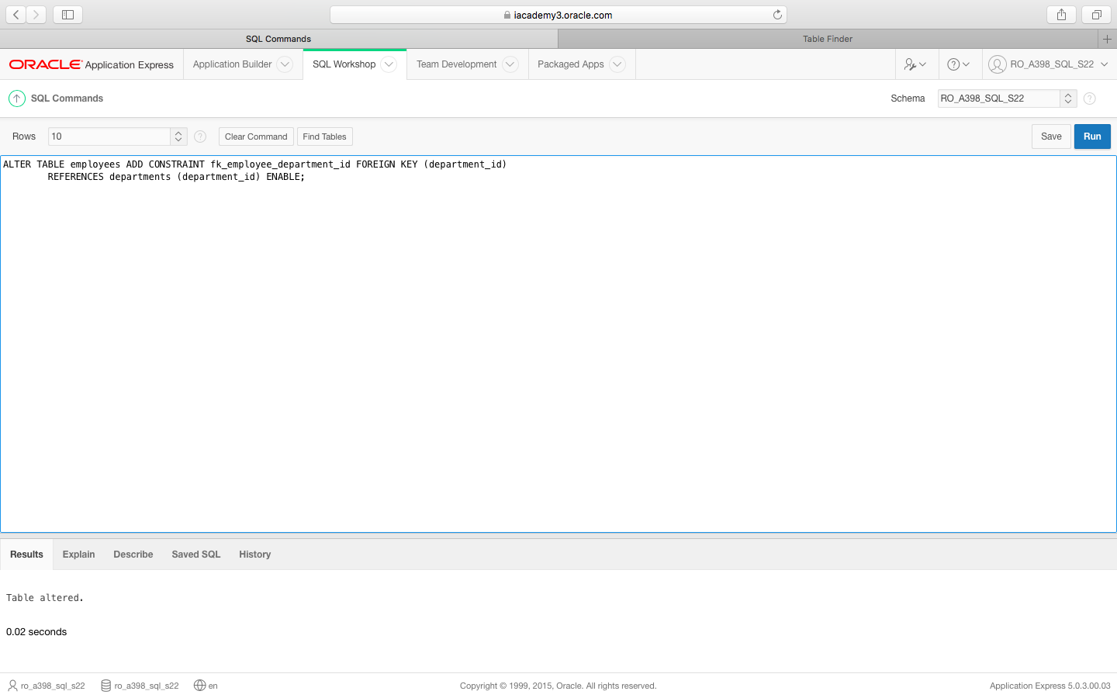

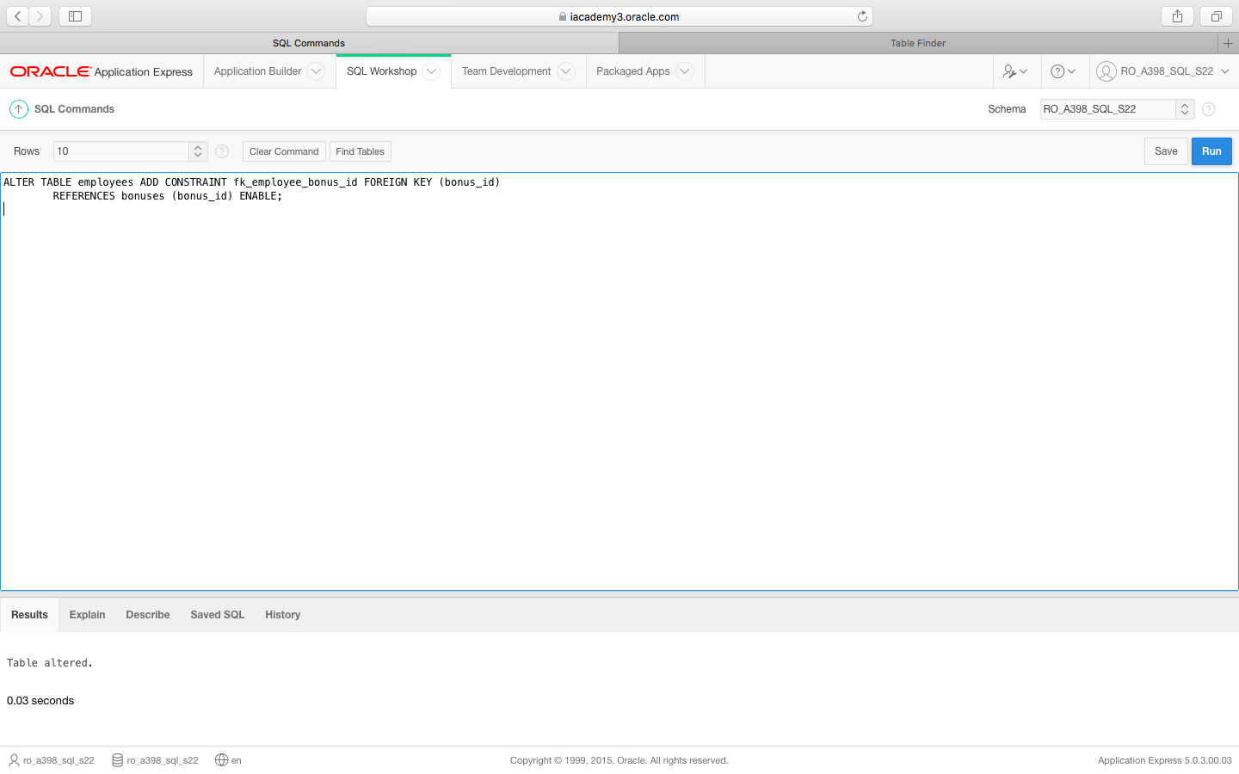

14.Vacations

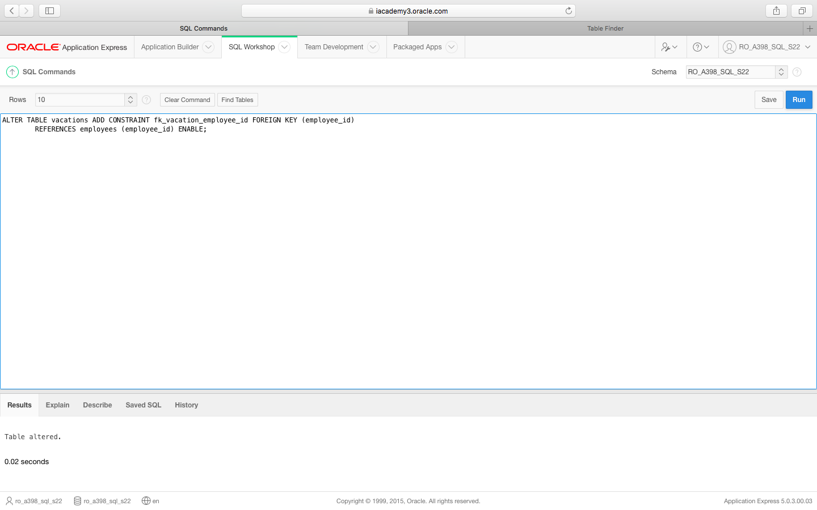

17.Shifts

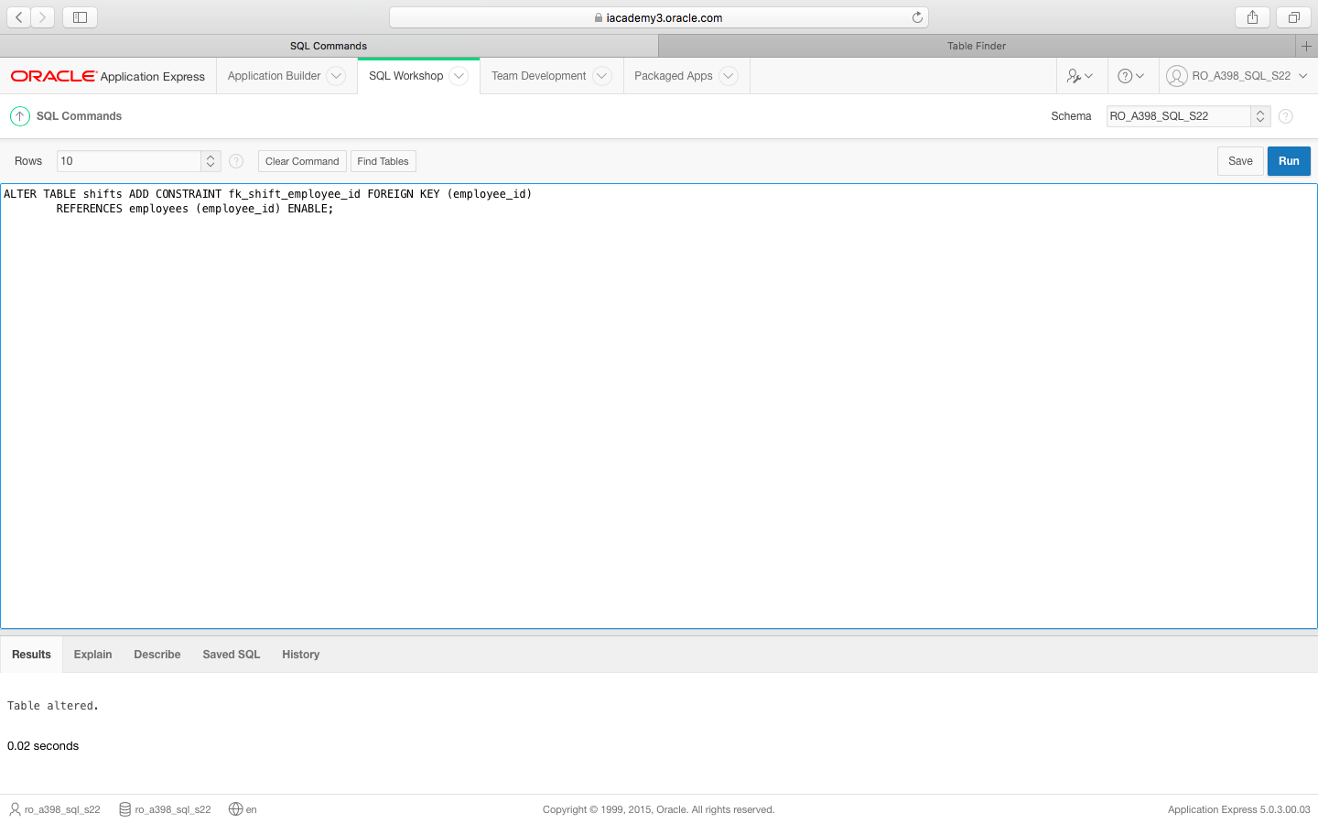

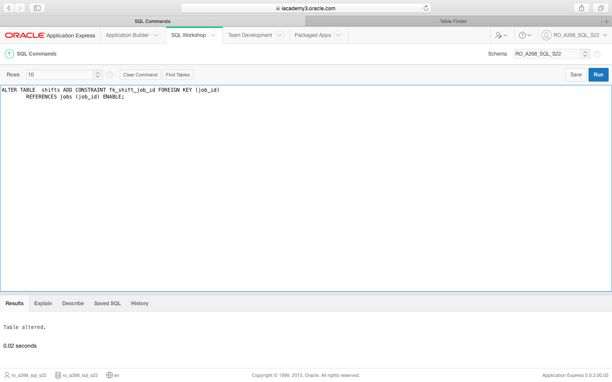

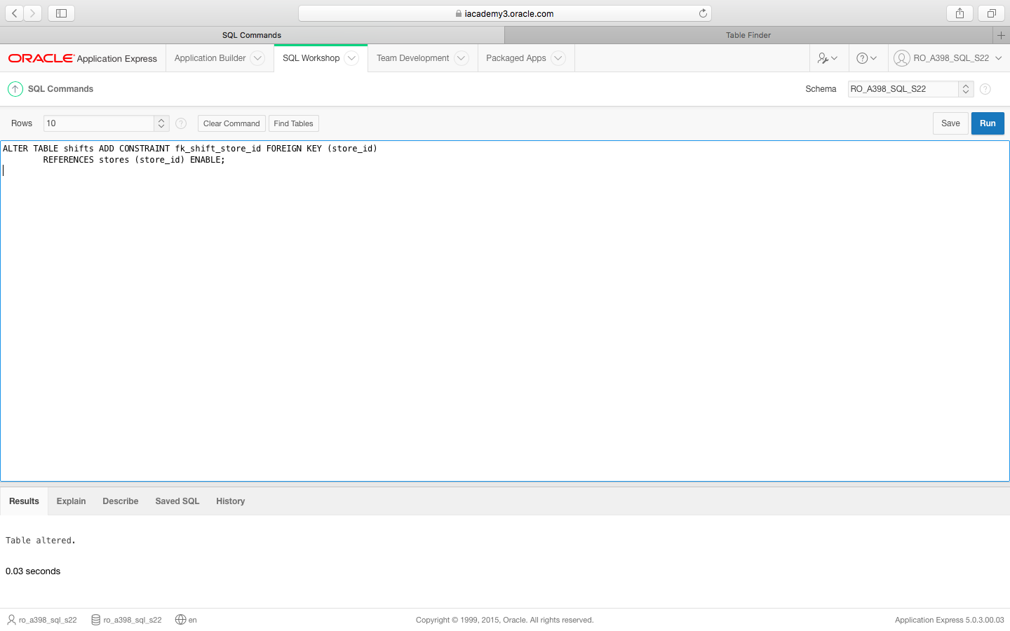

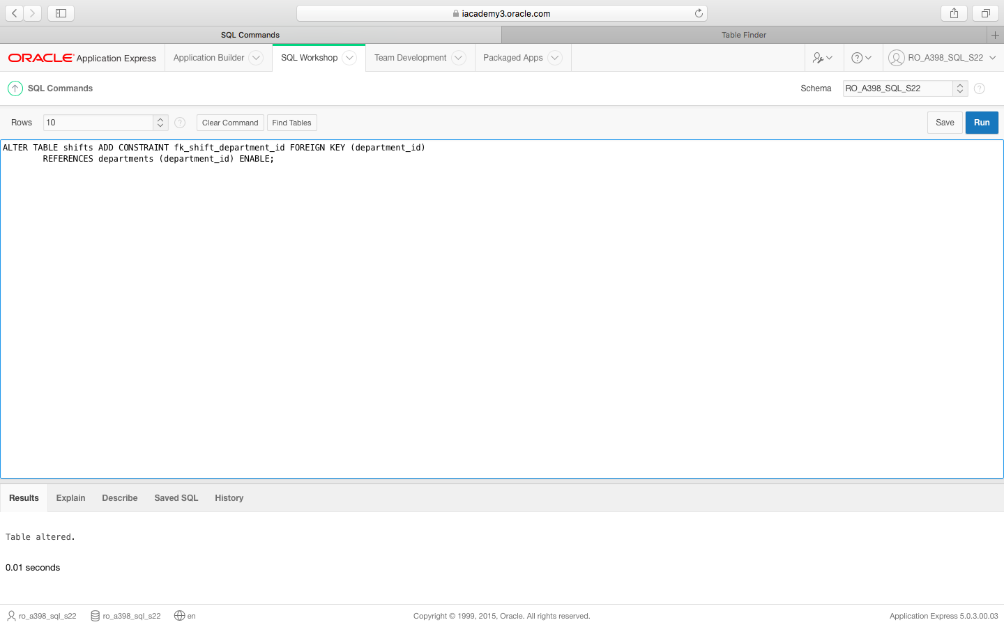

18.Job_assignments

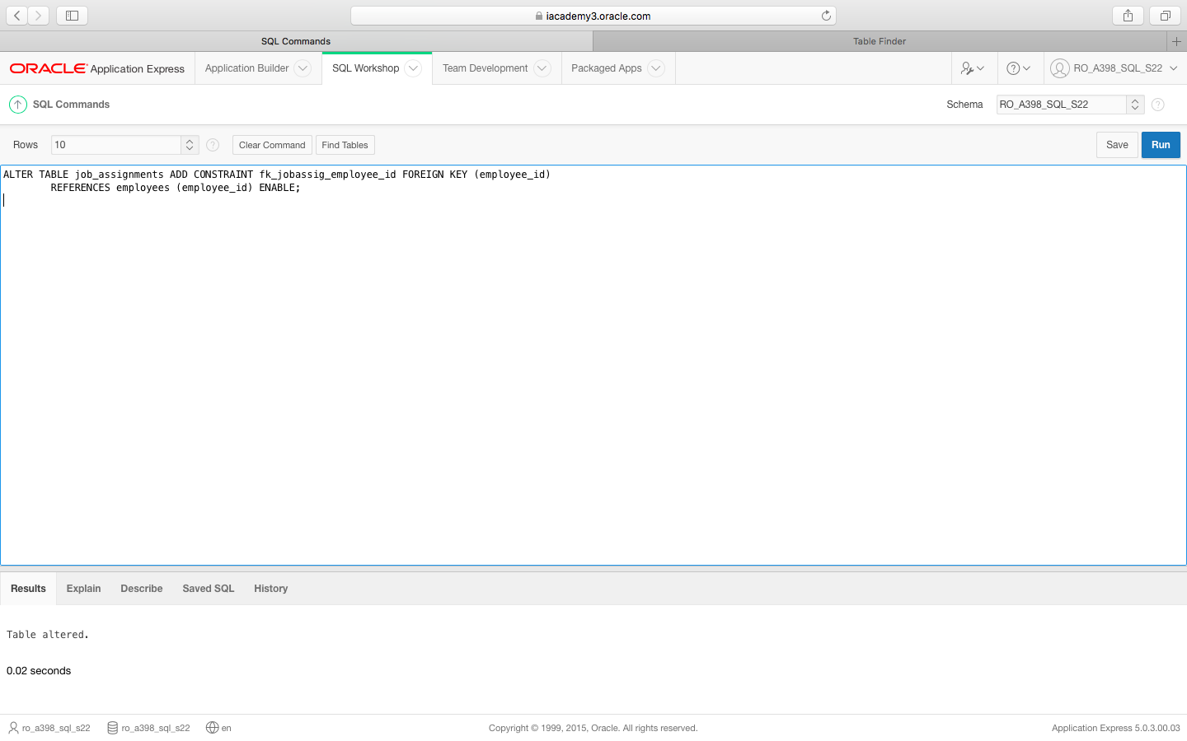

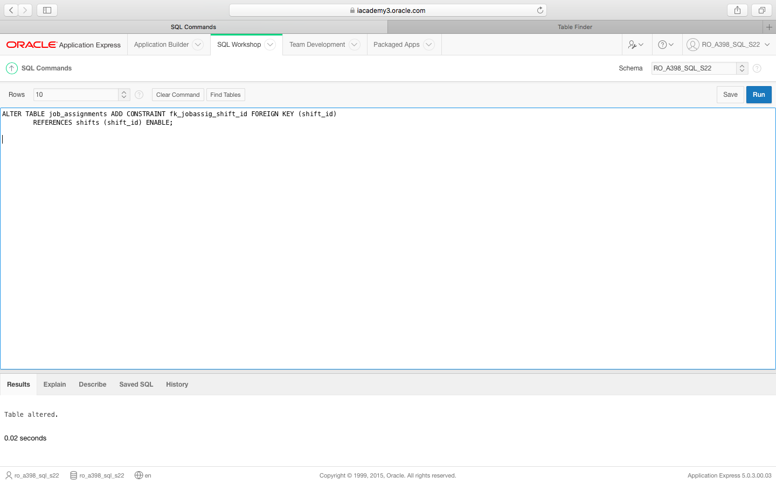

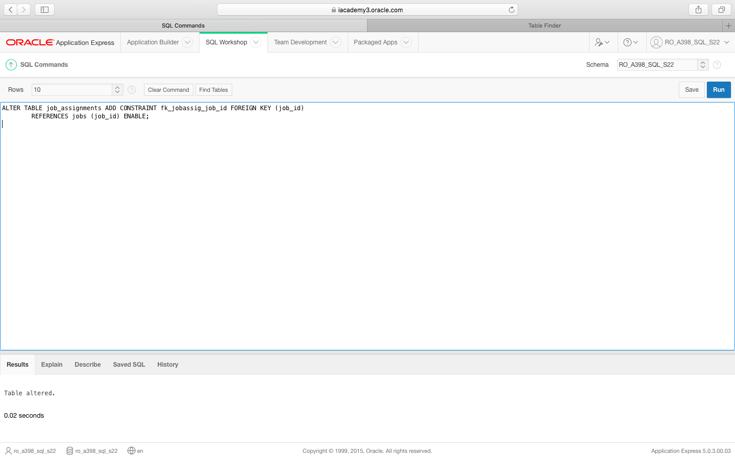

INSERT/ Popularea TABELELOR

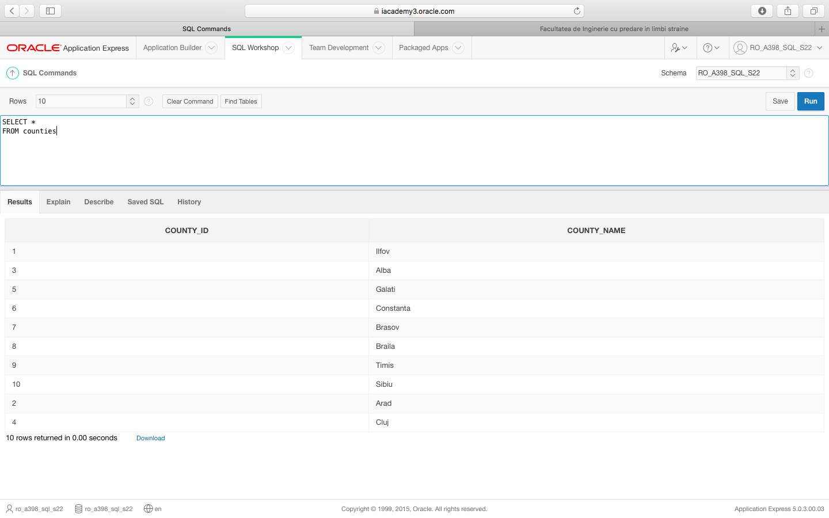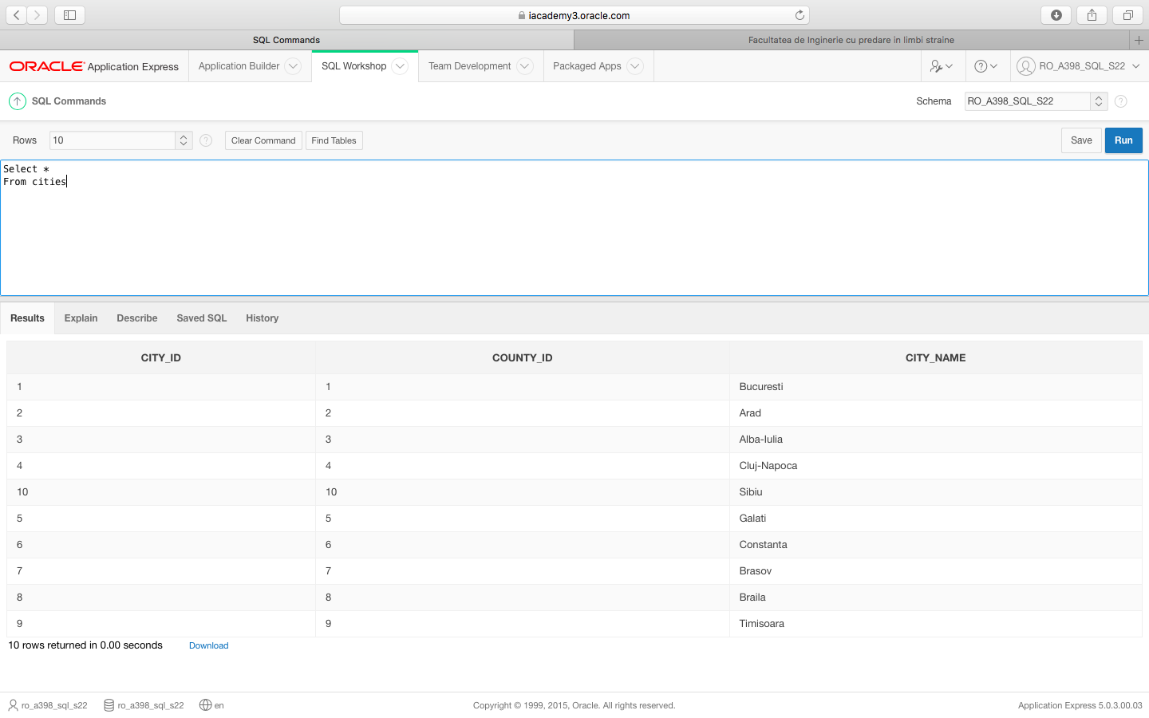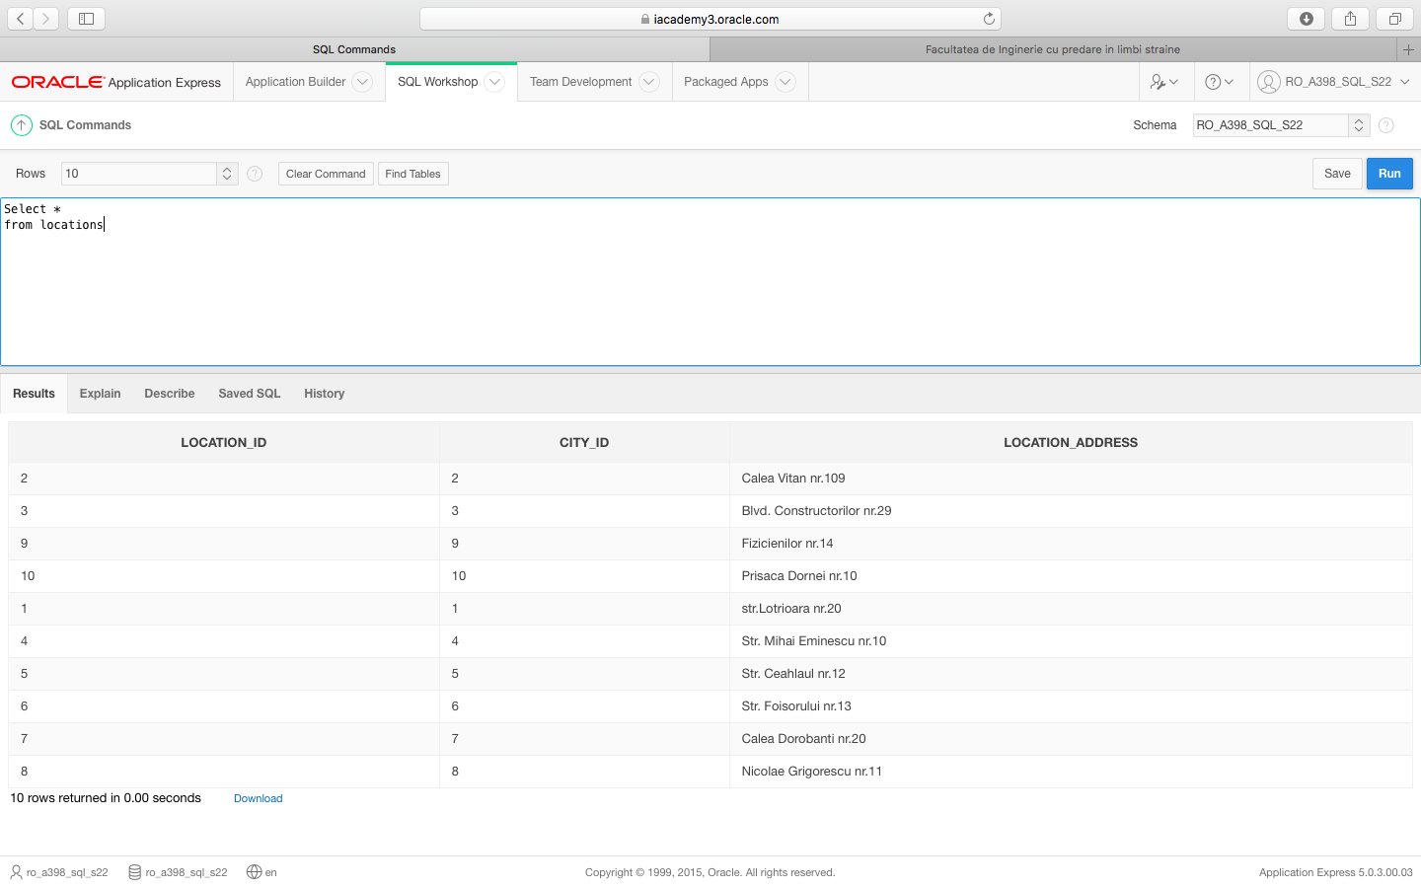

3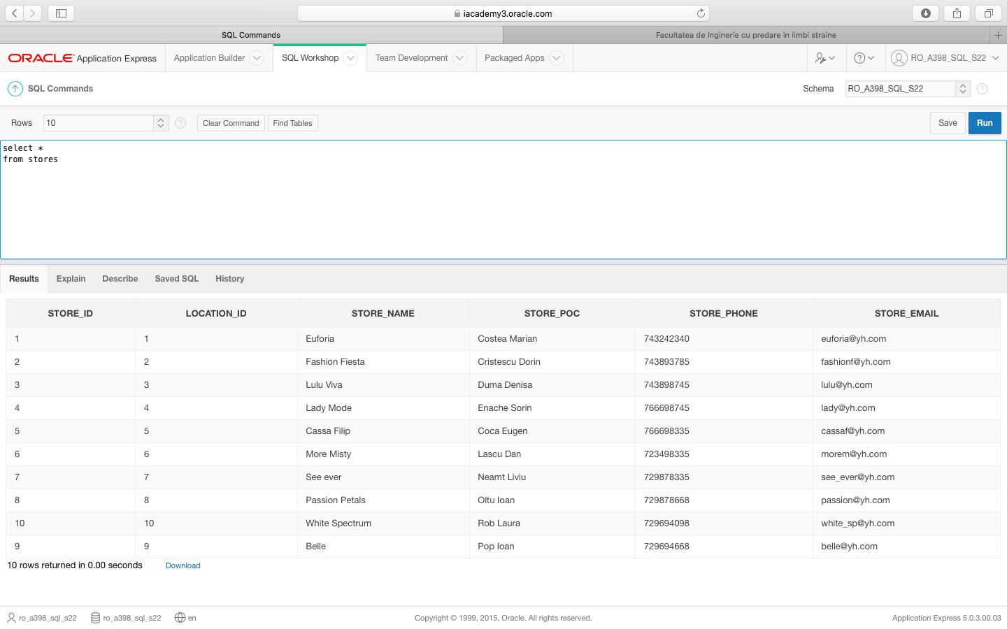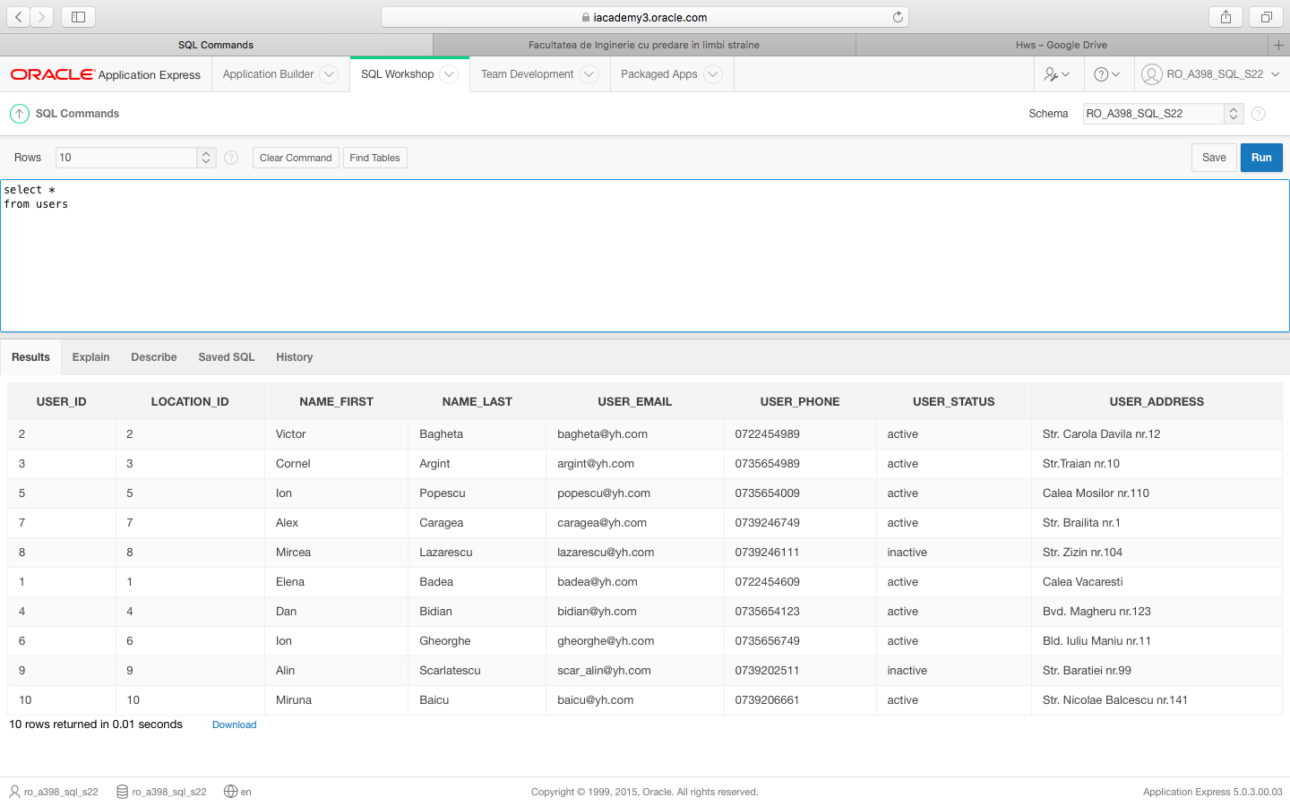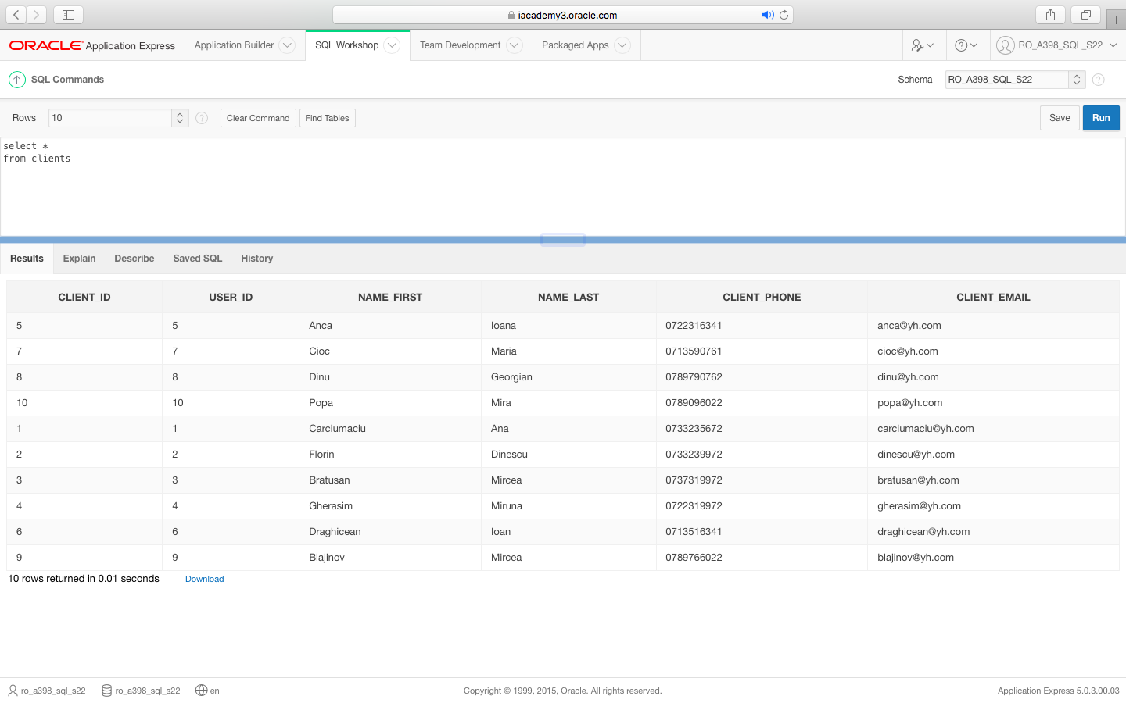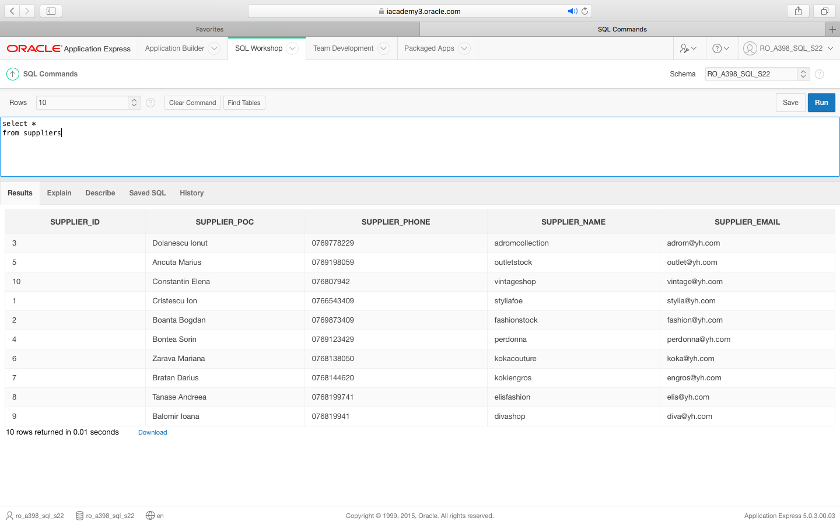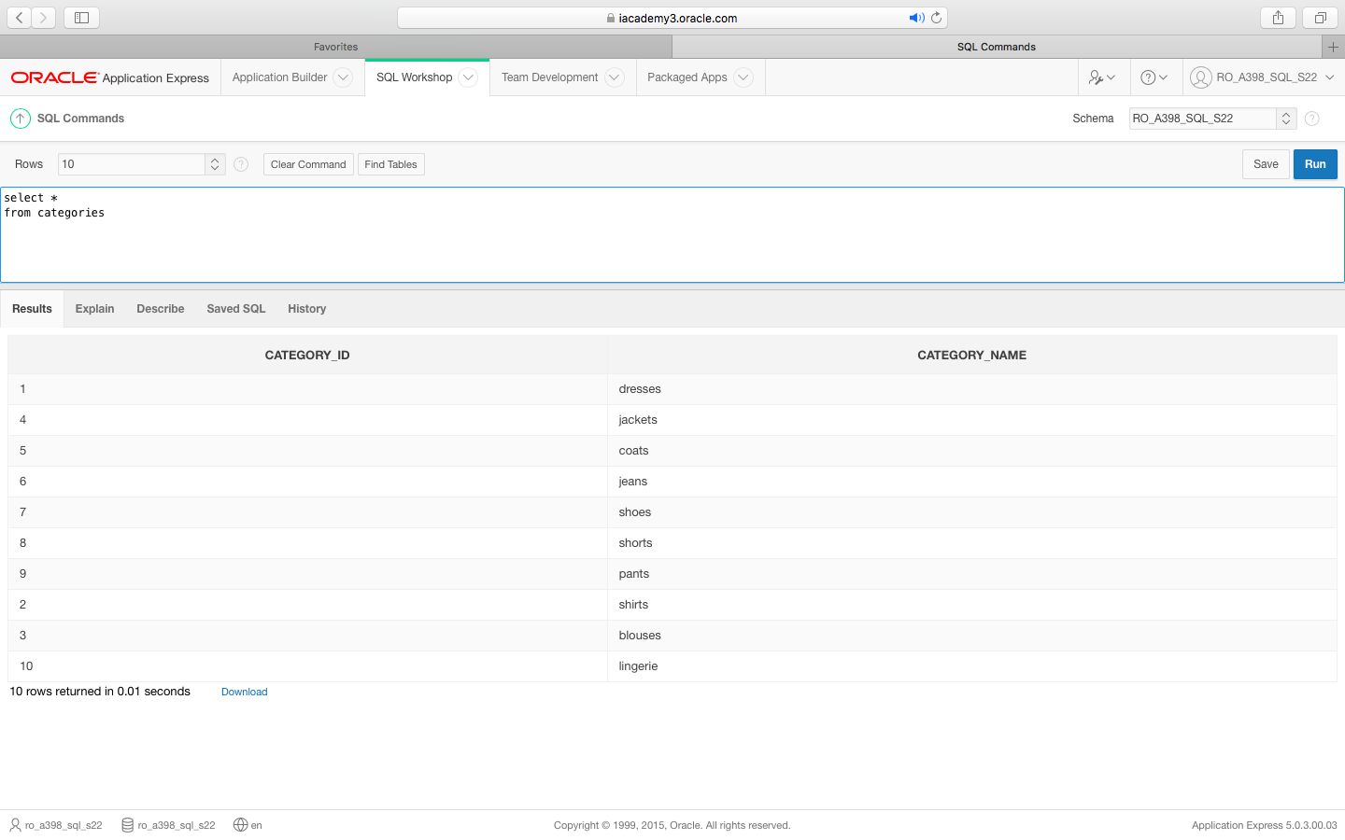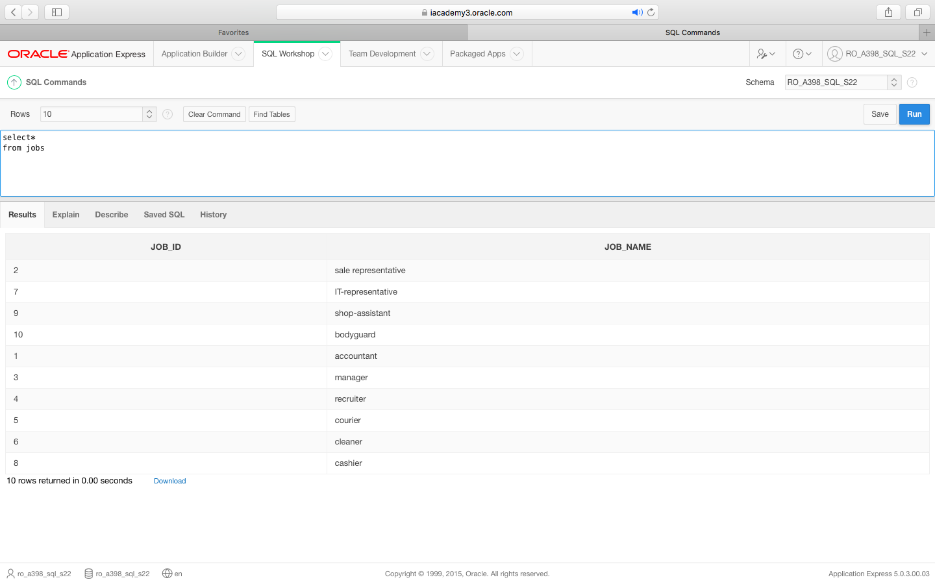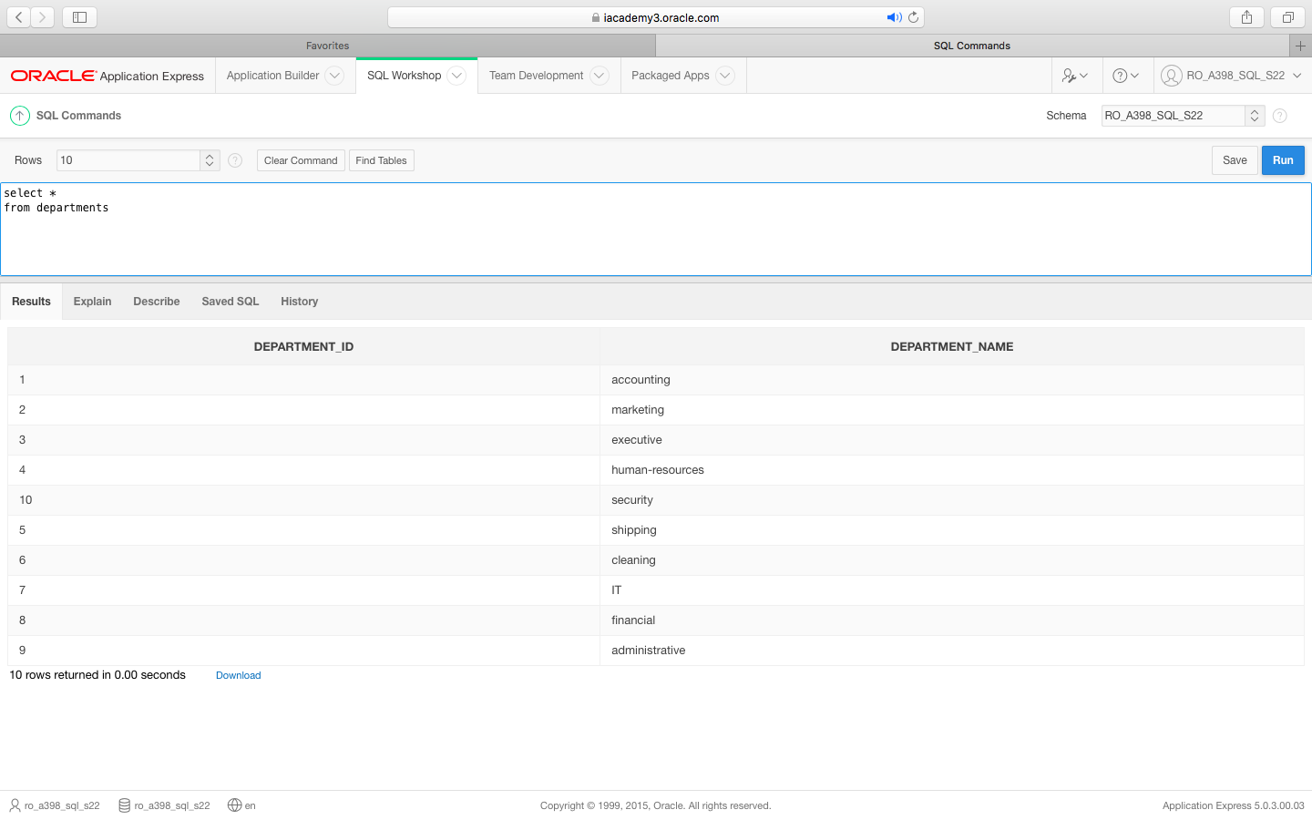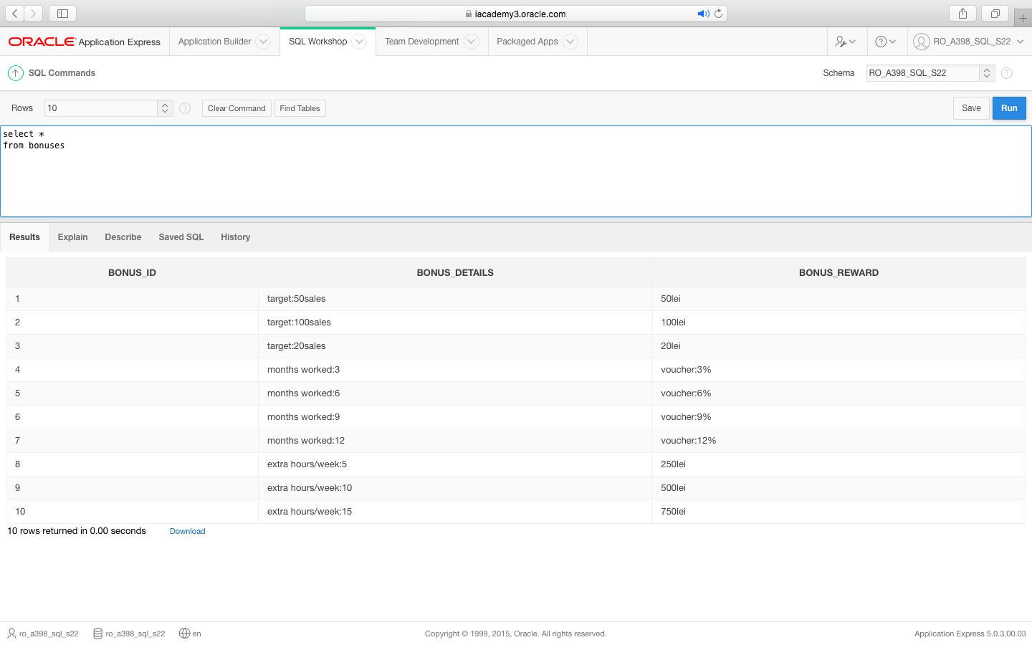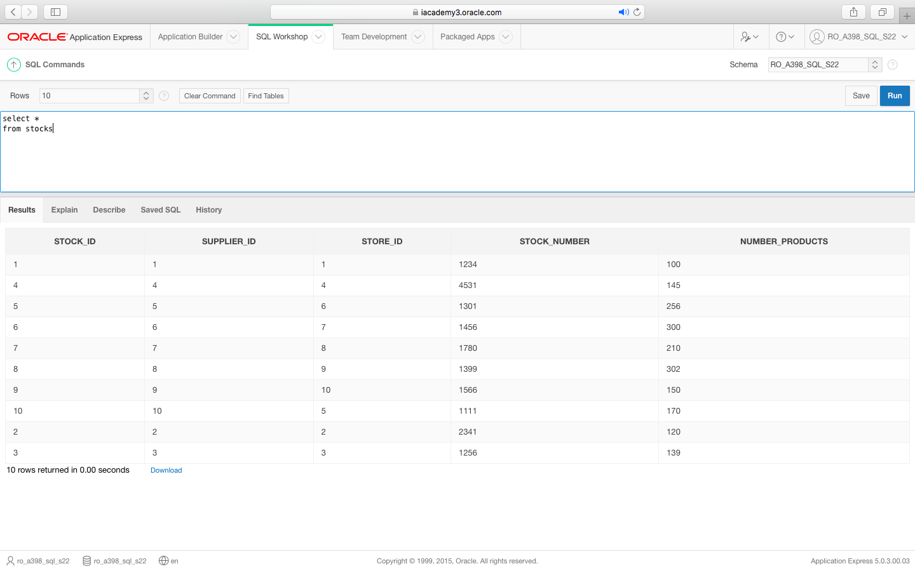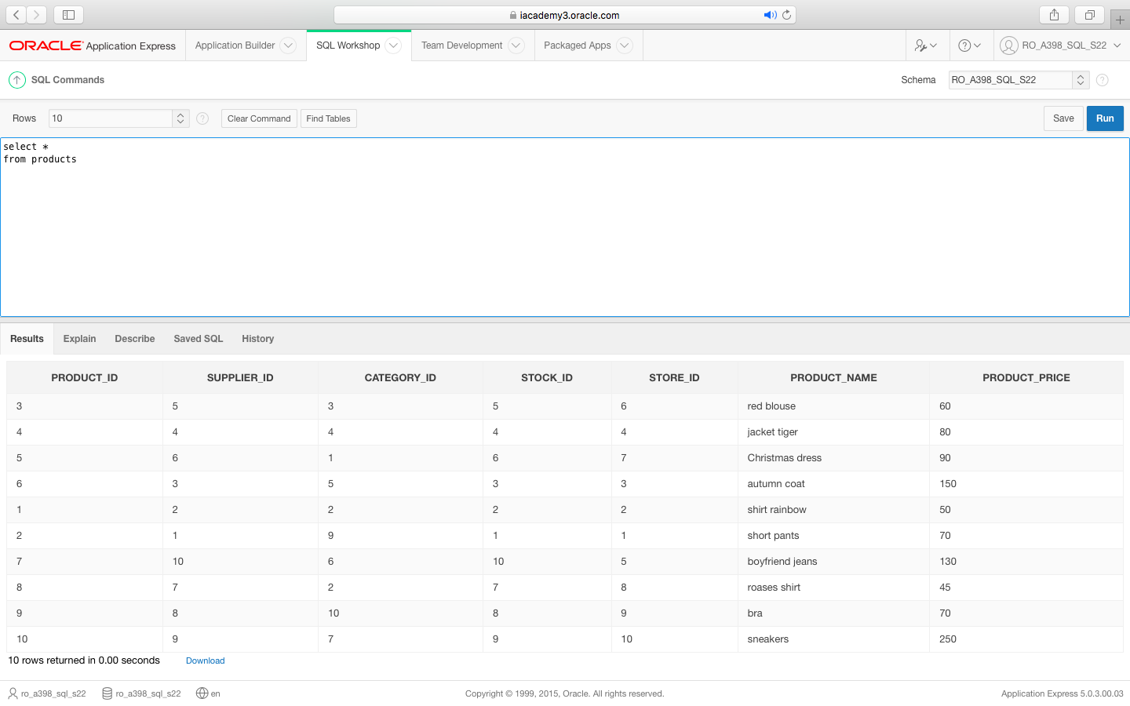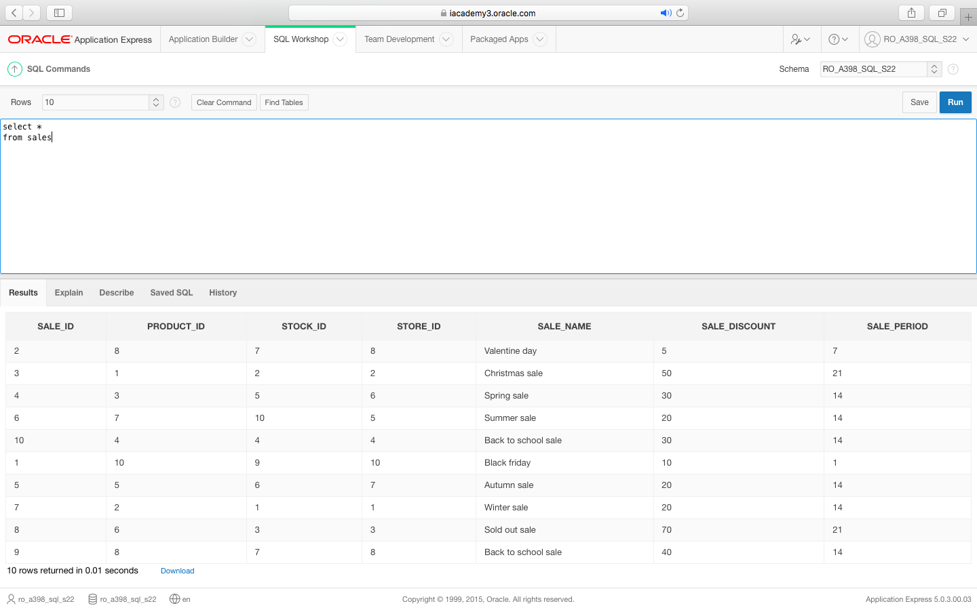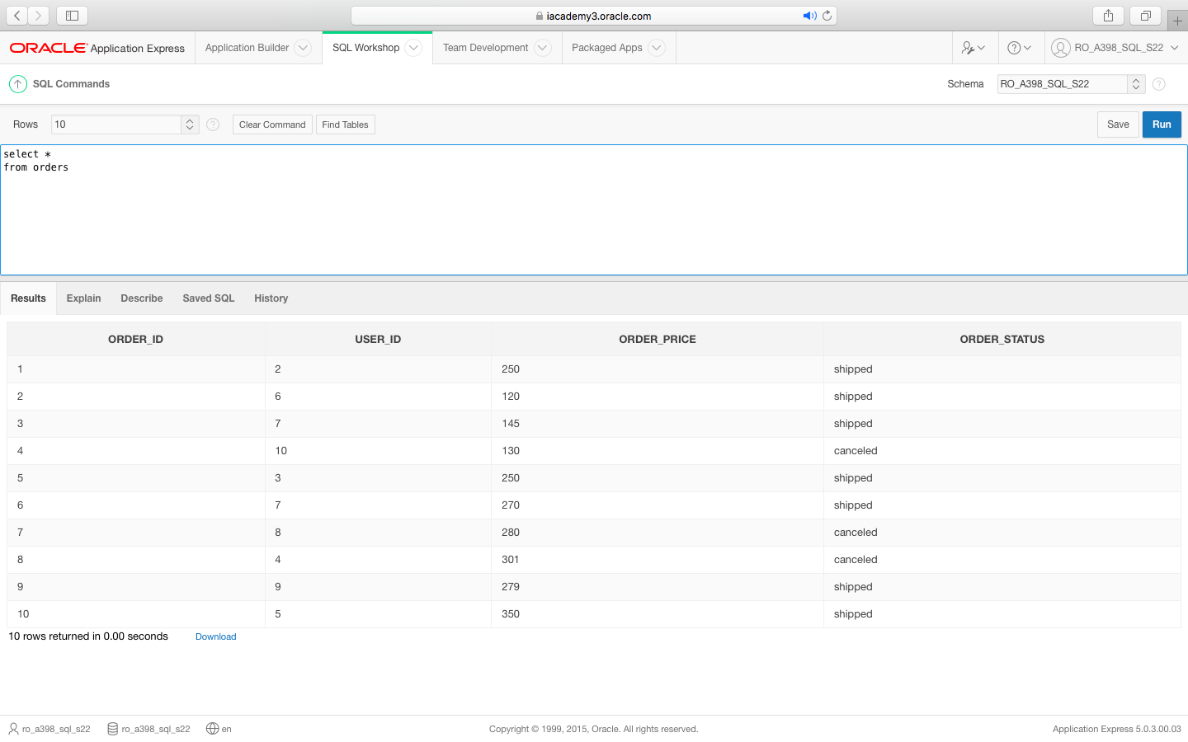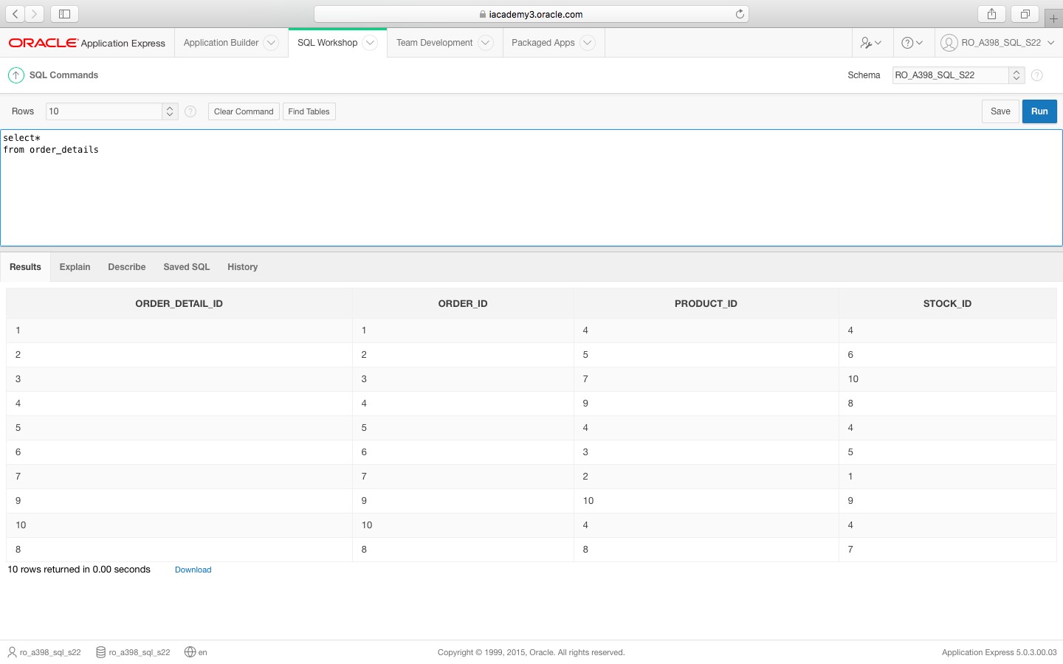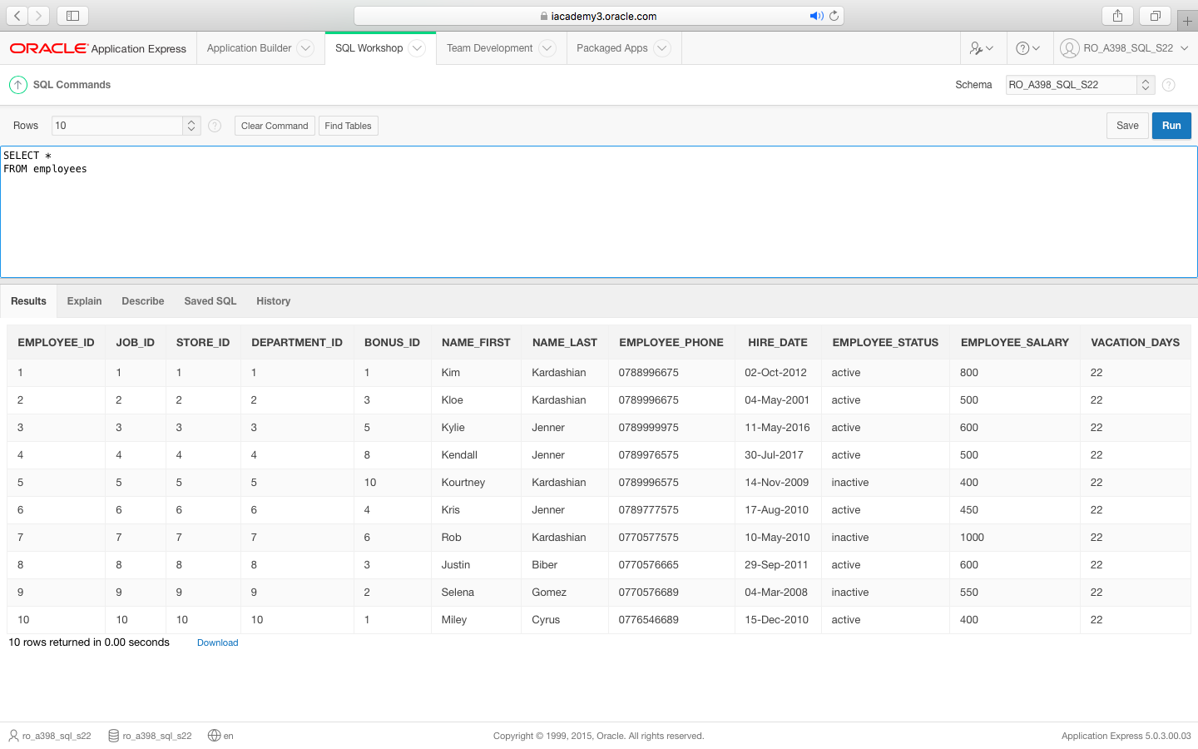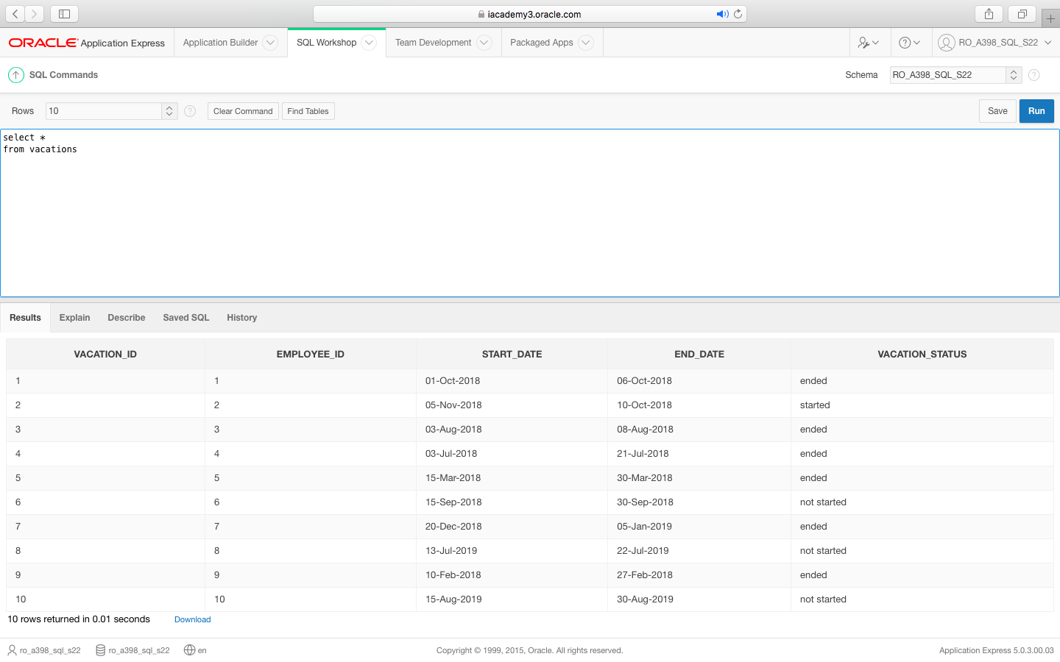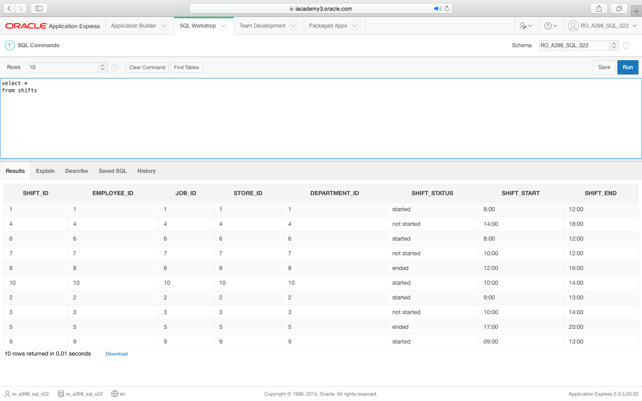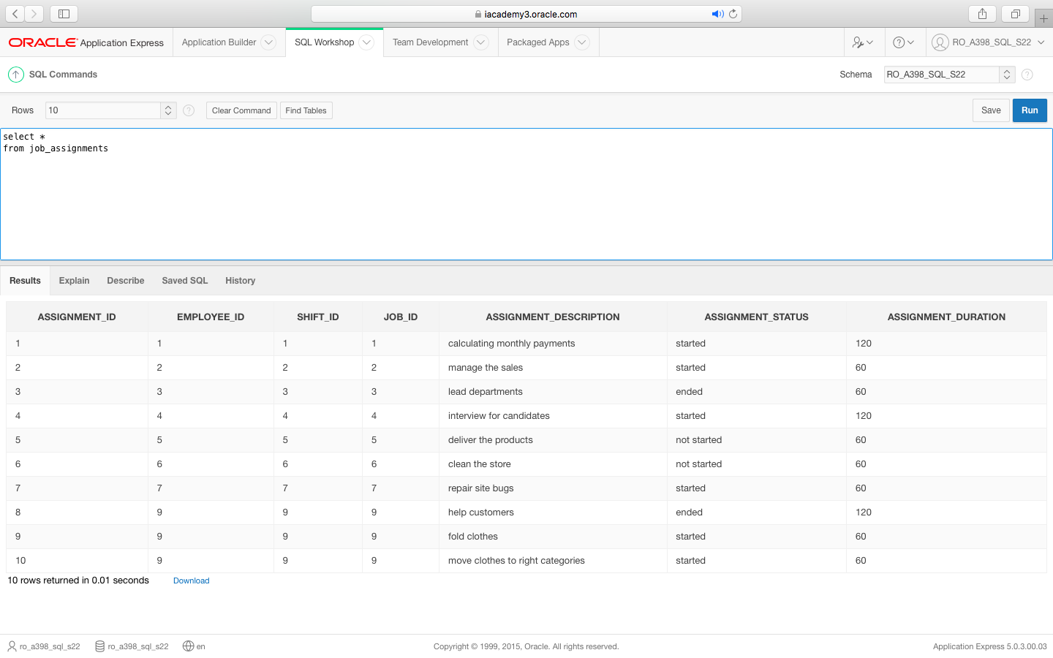

VIEWS

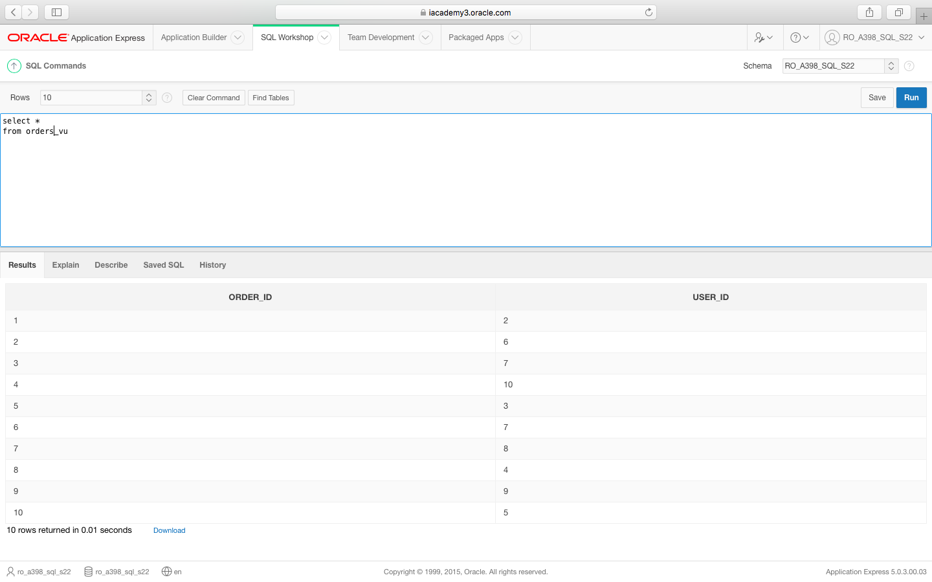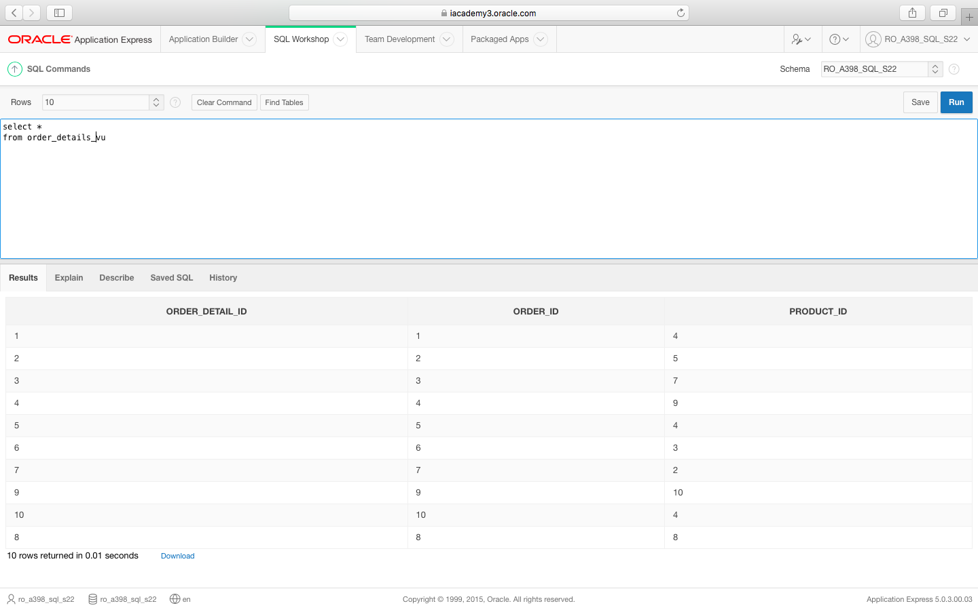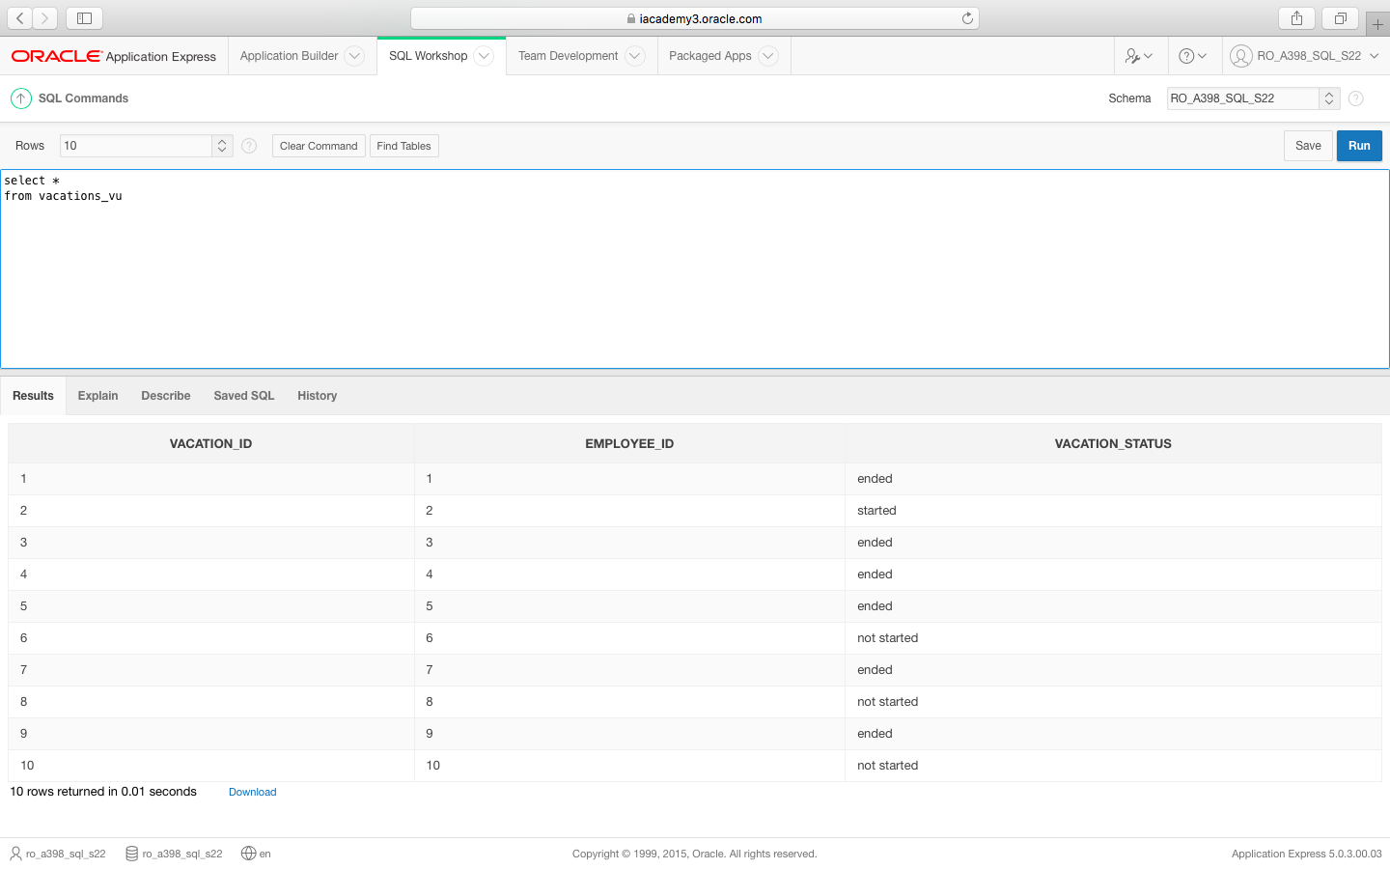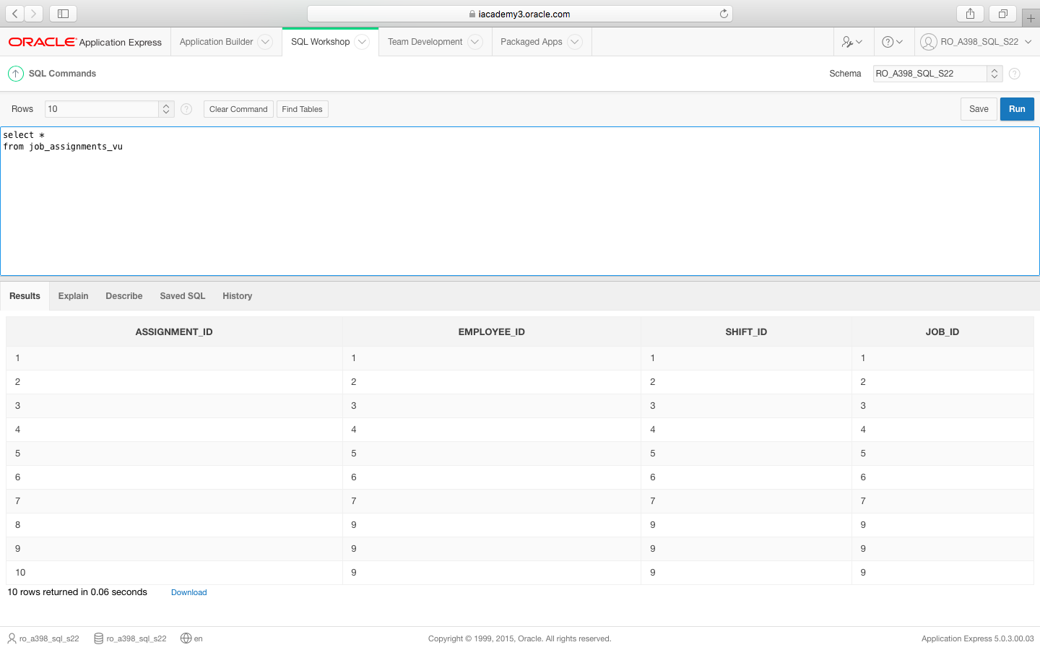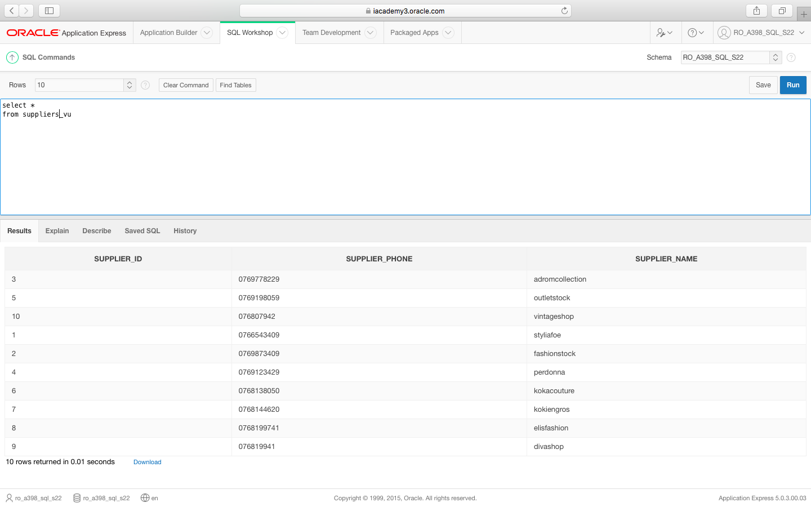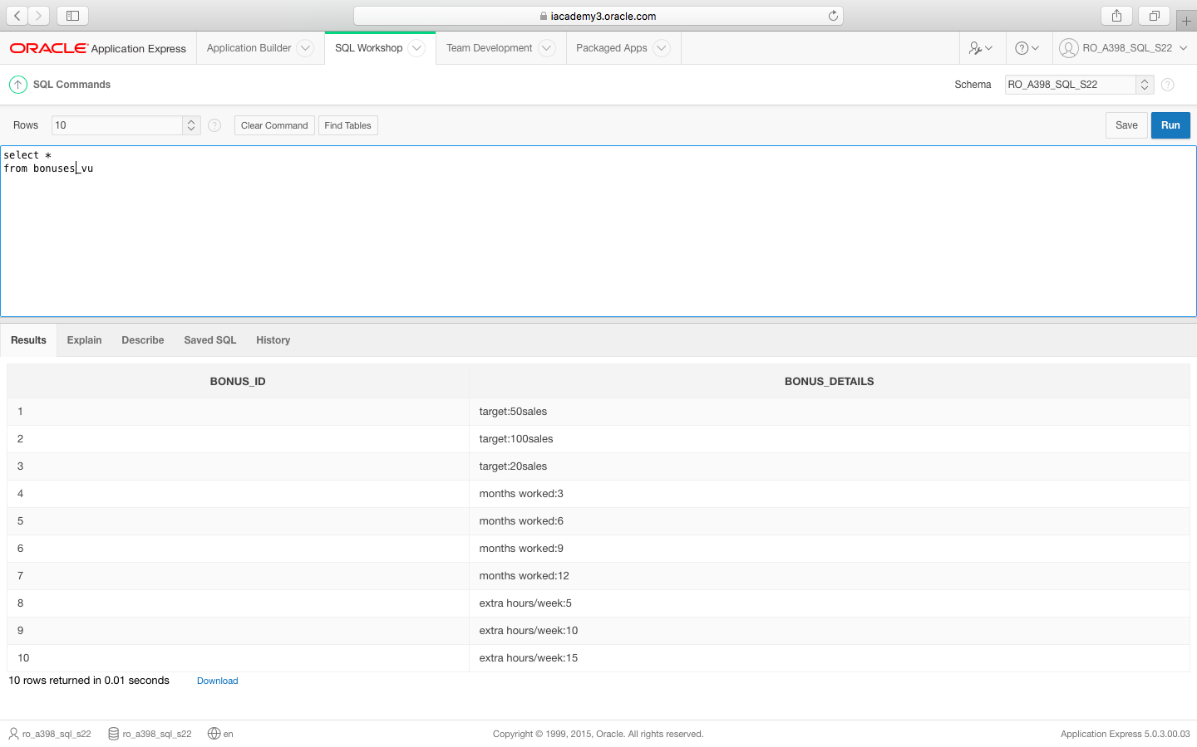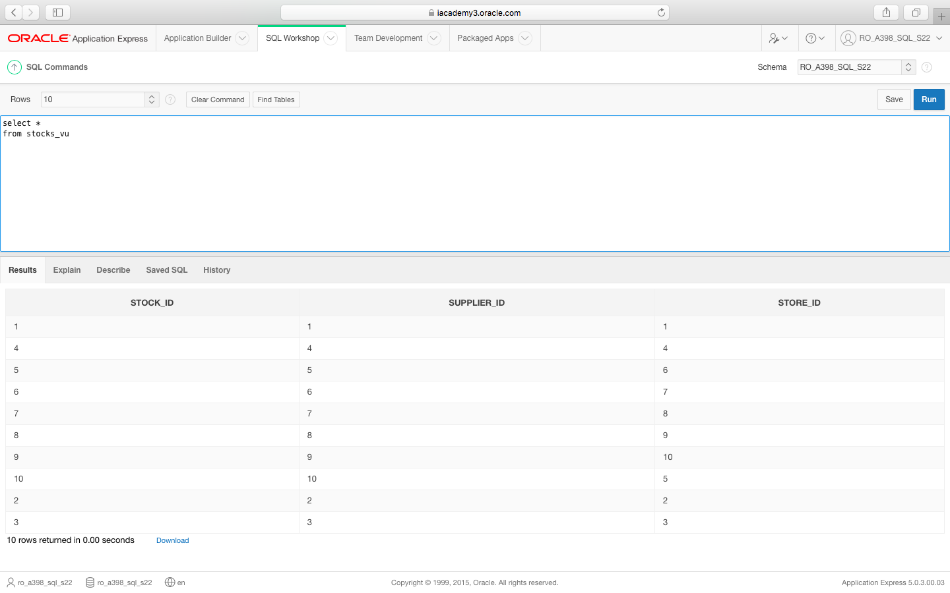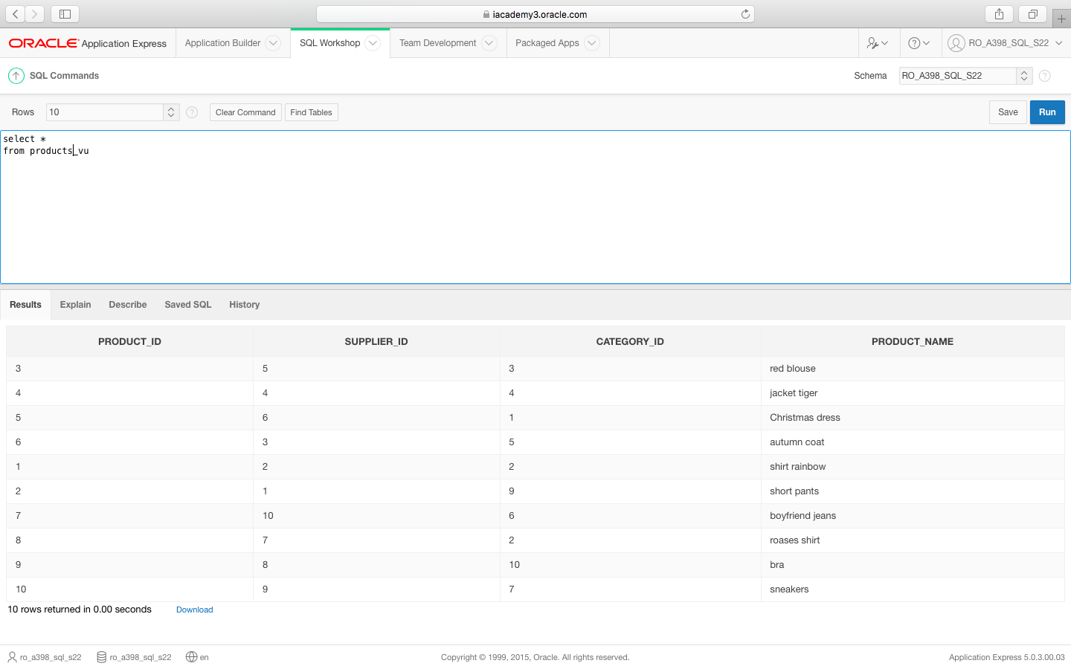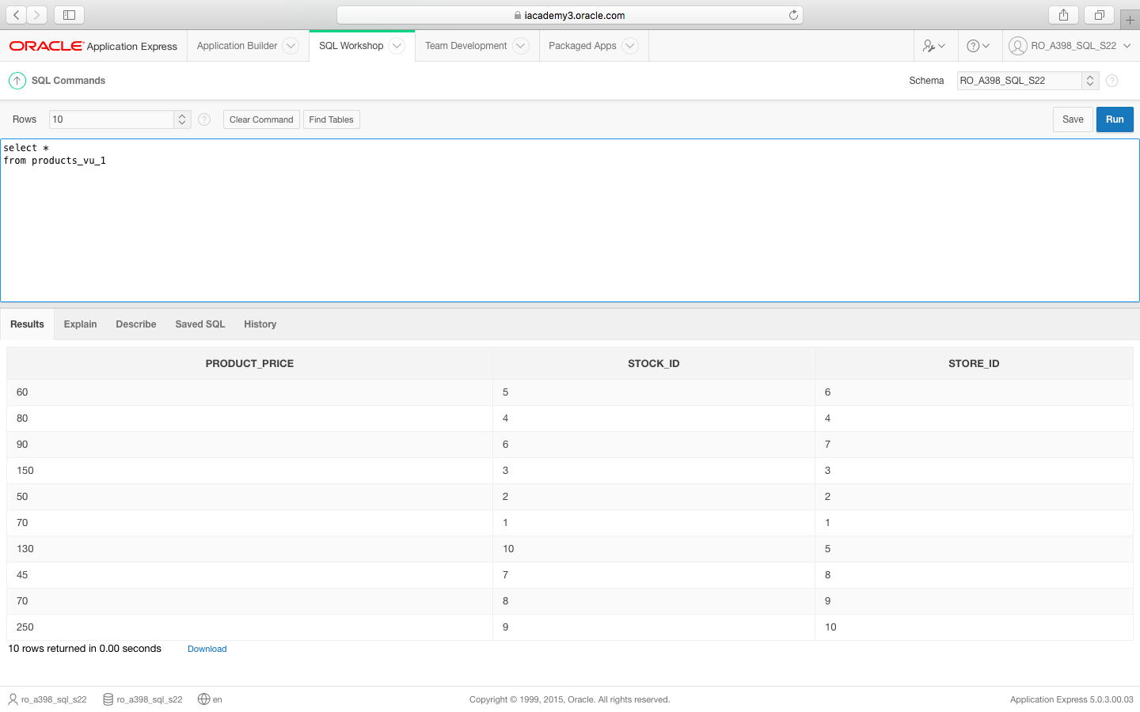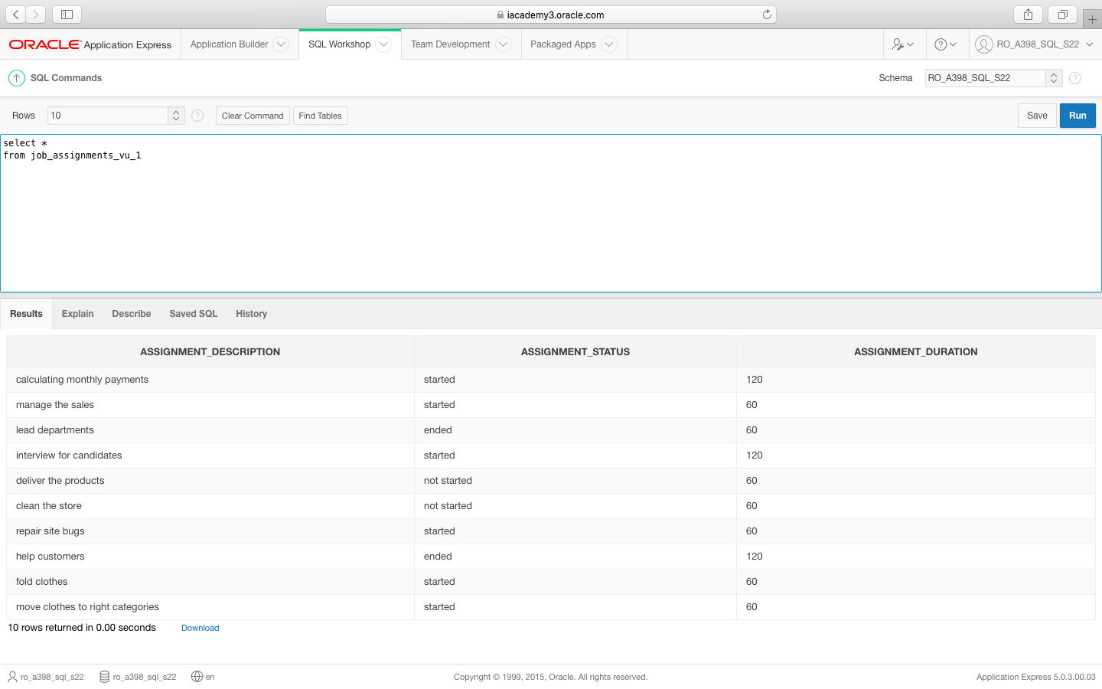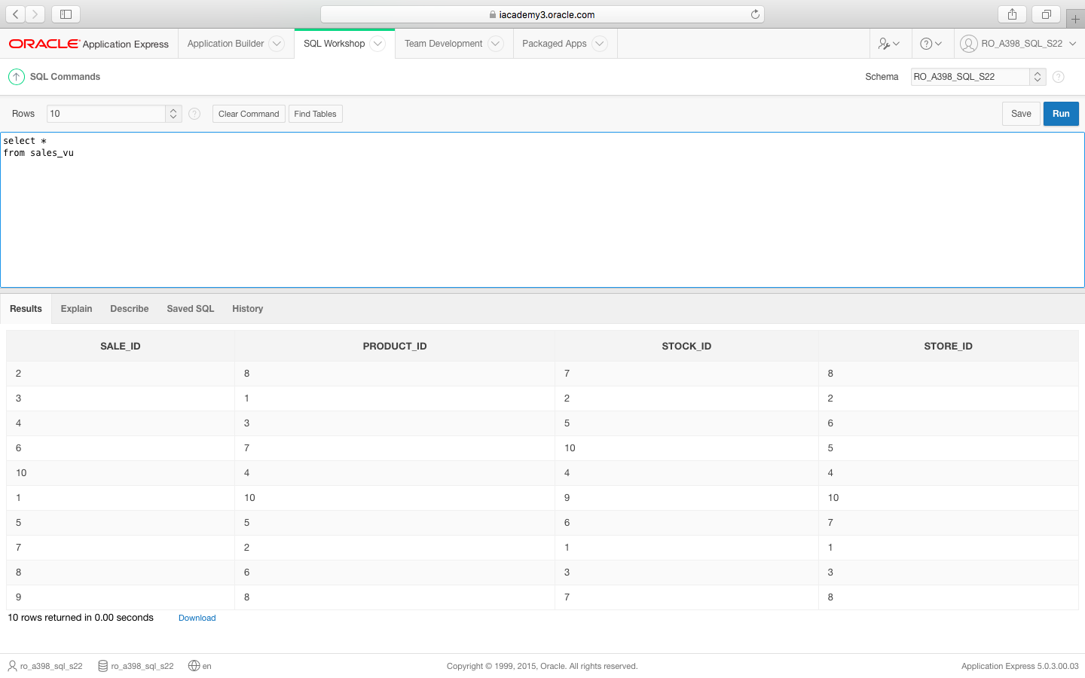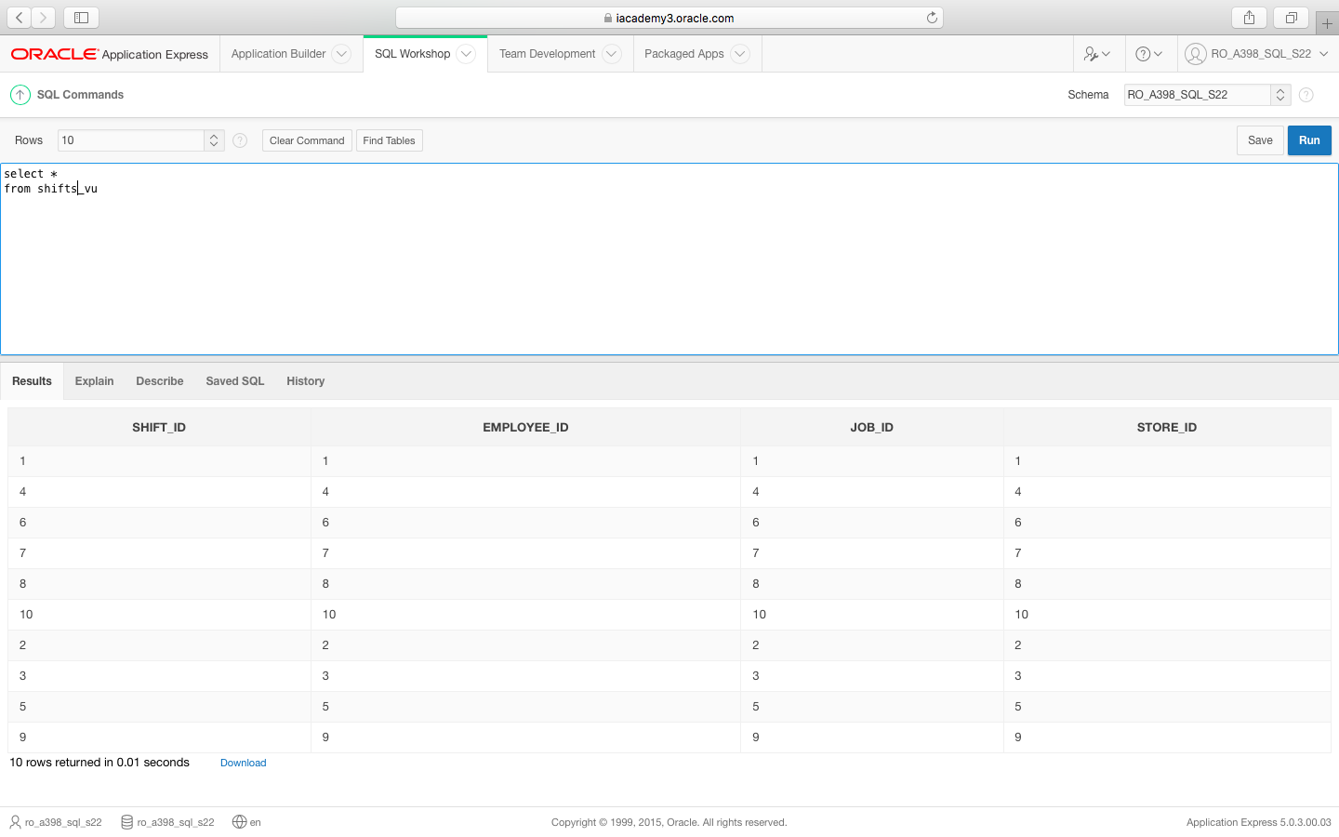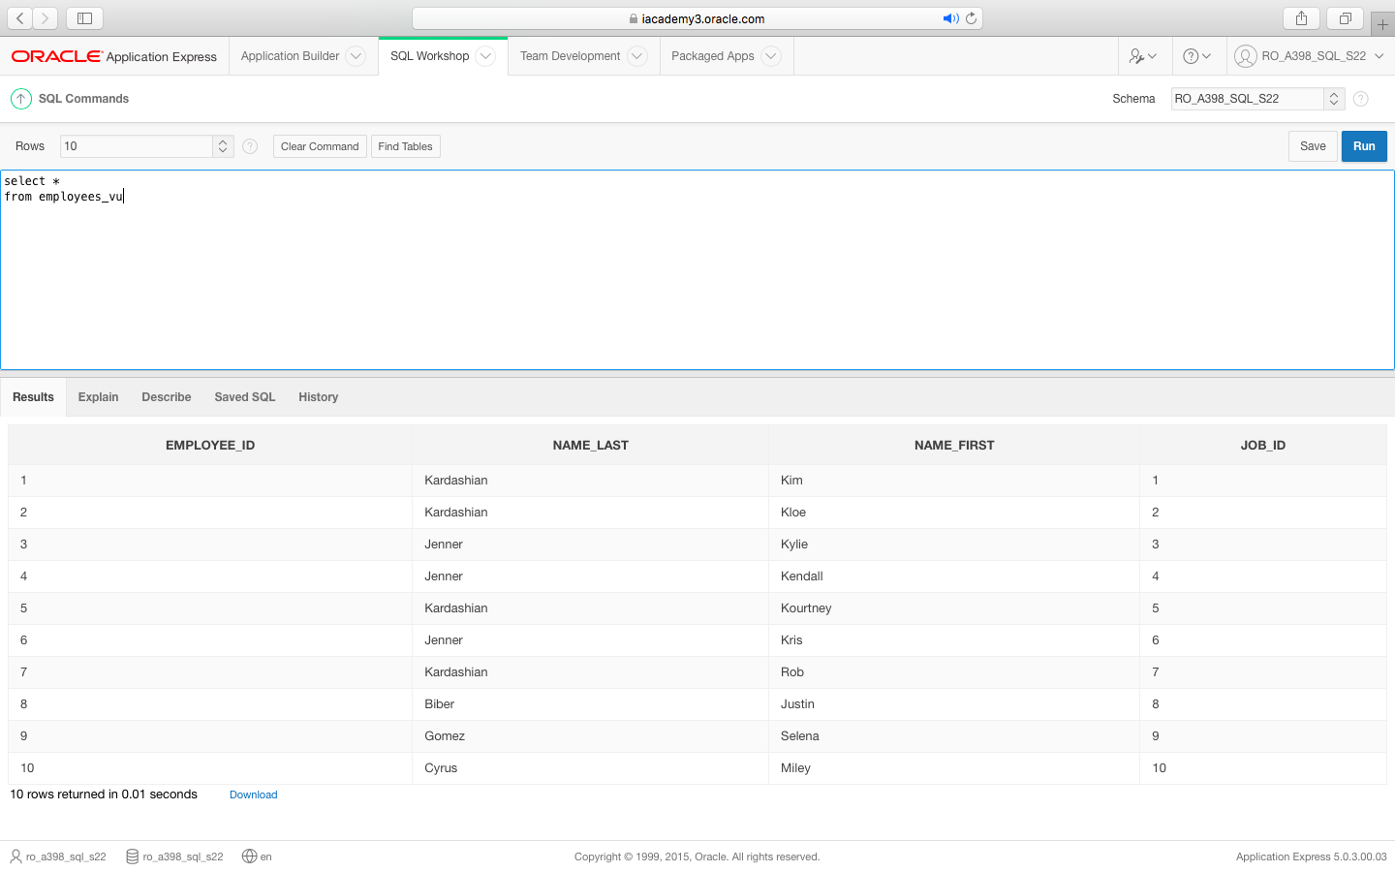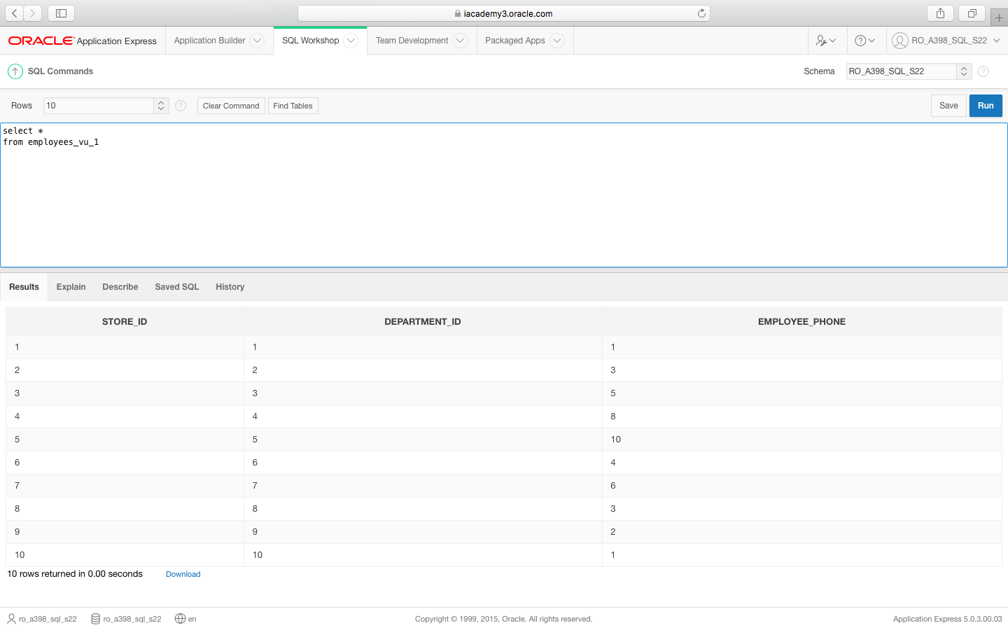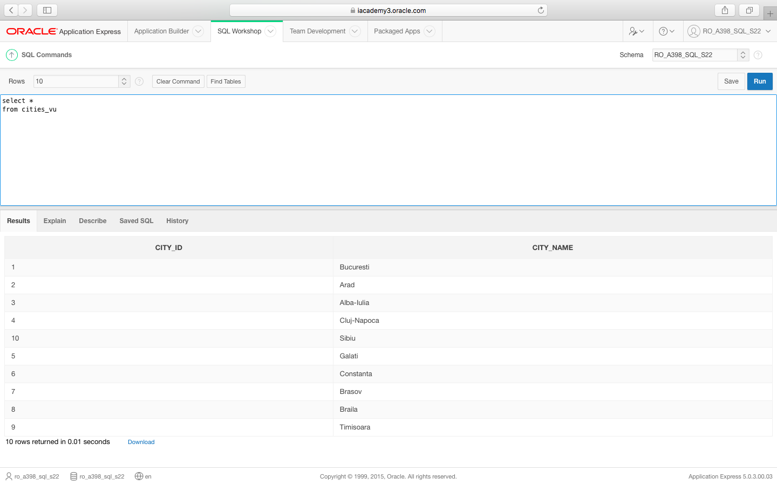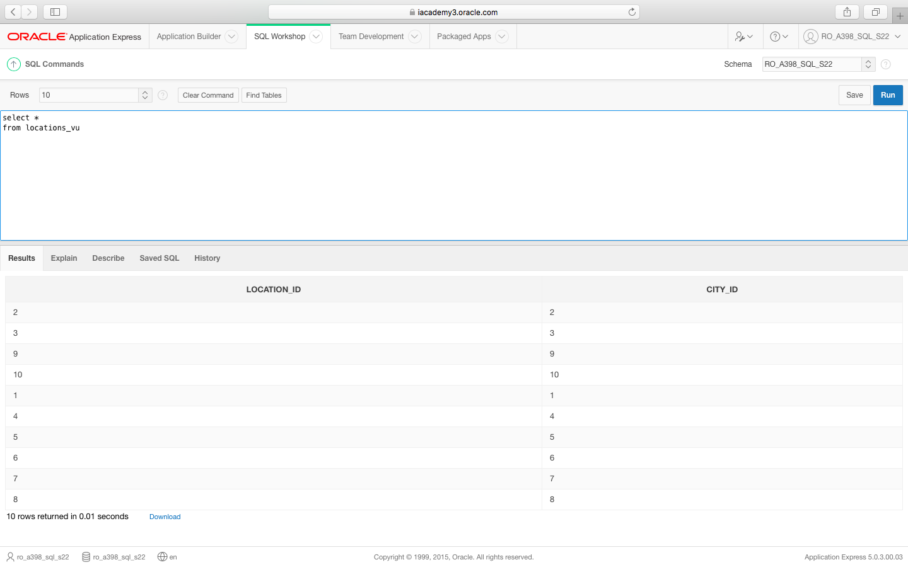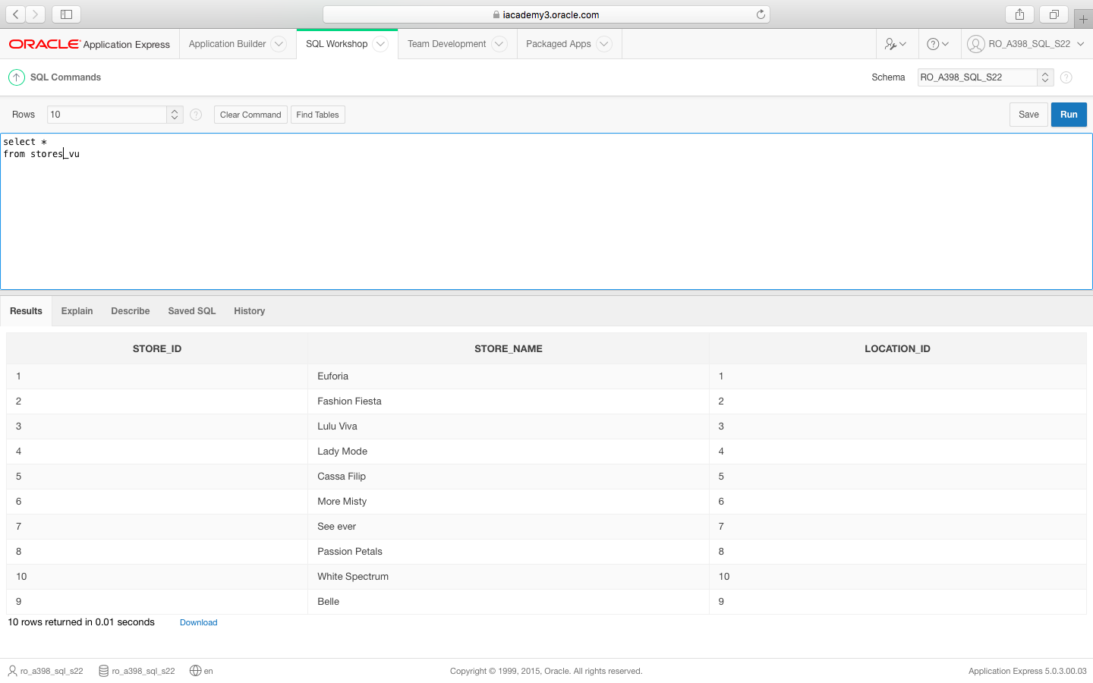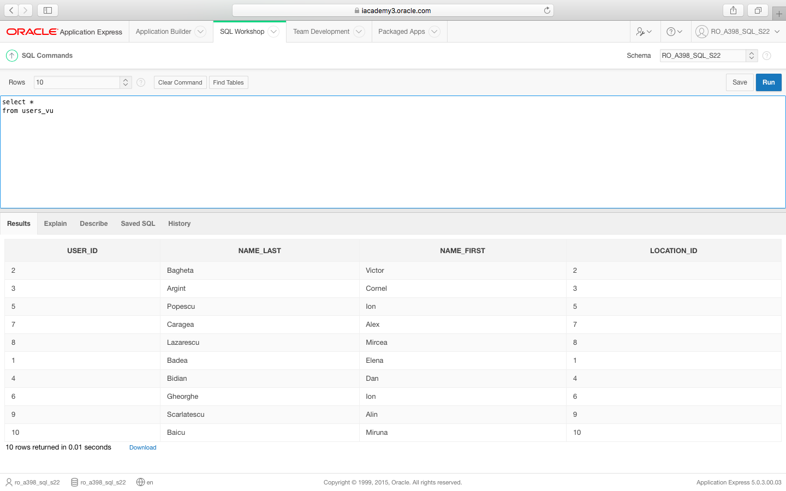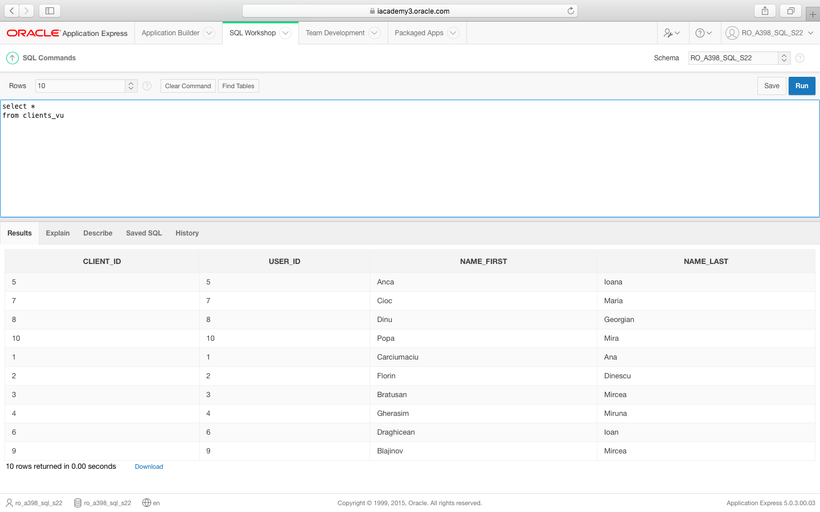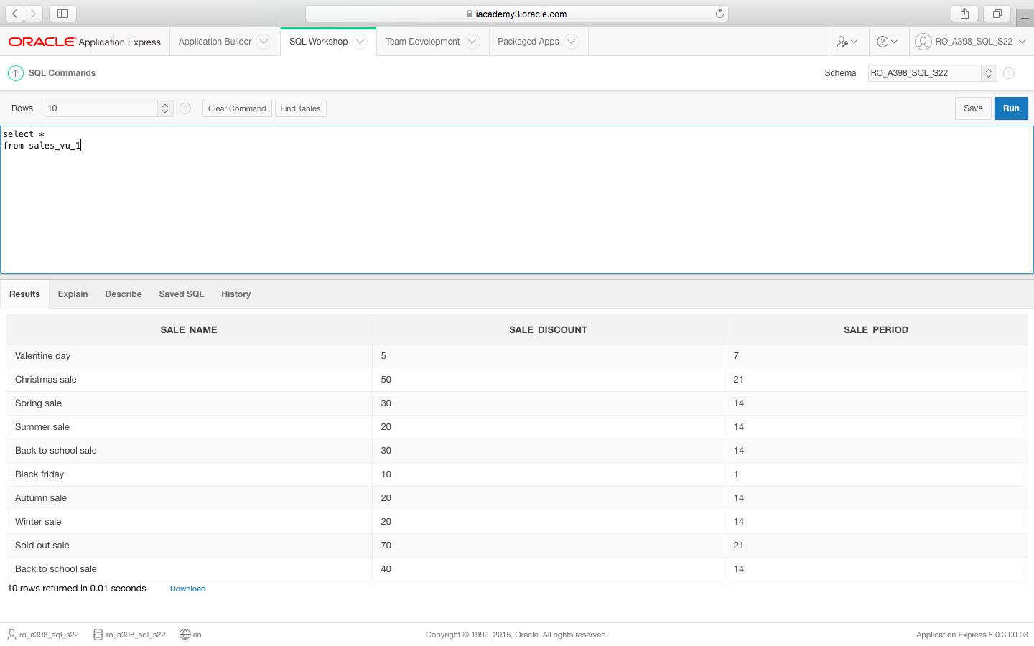

JOIN-urile

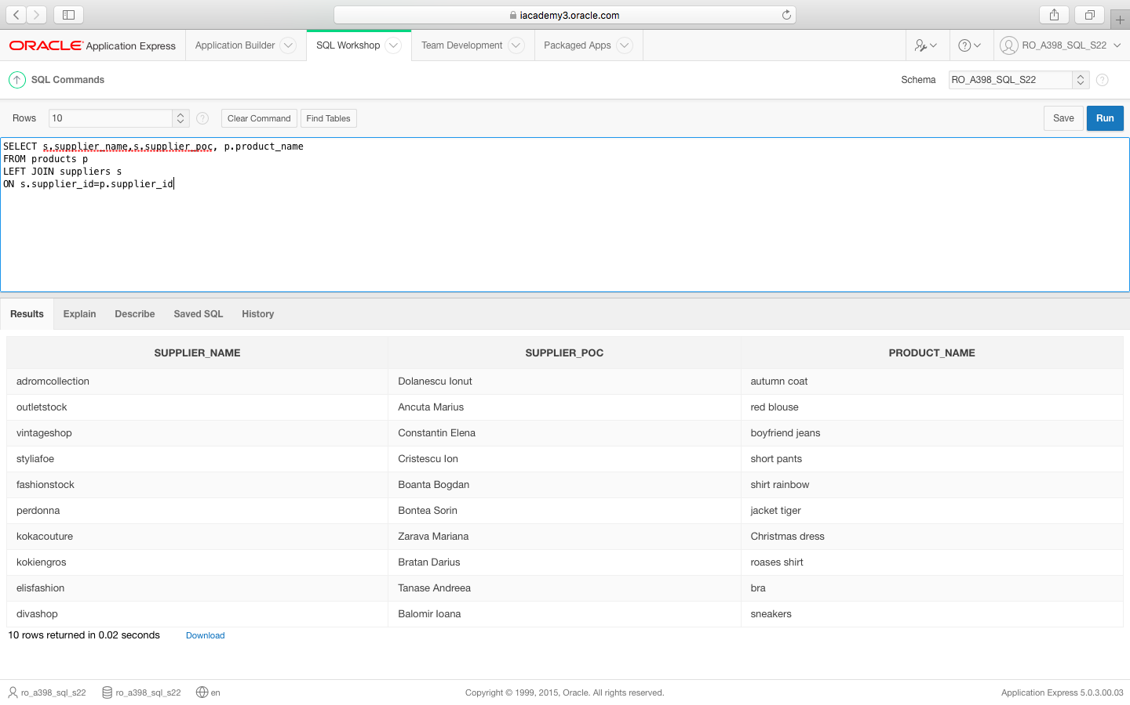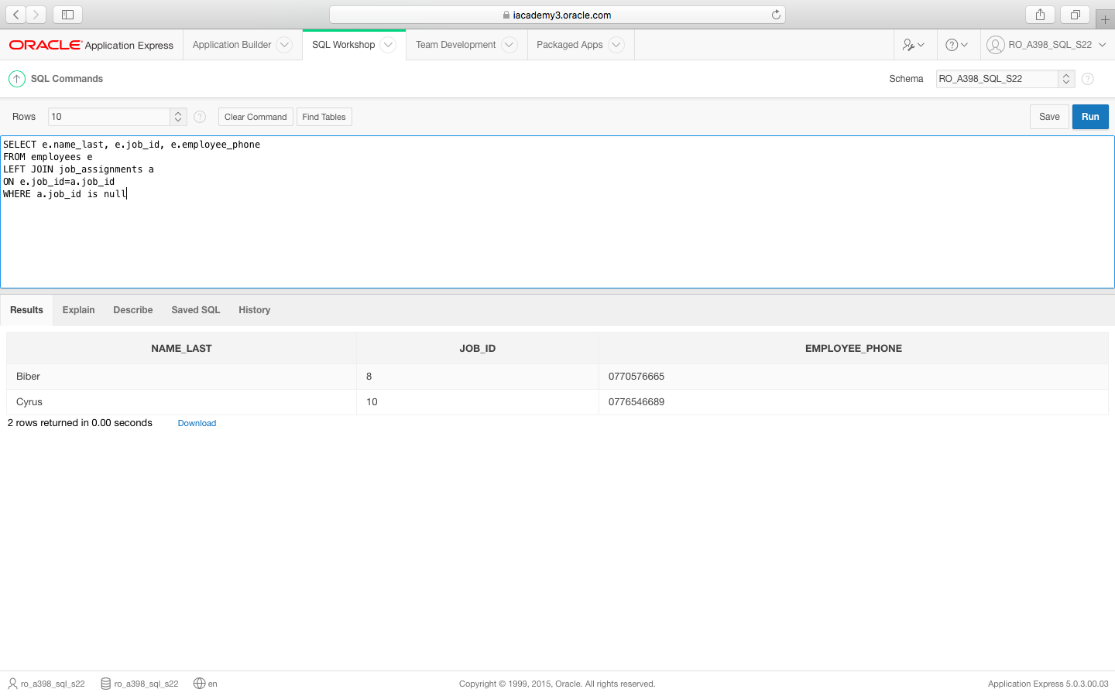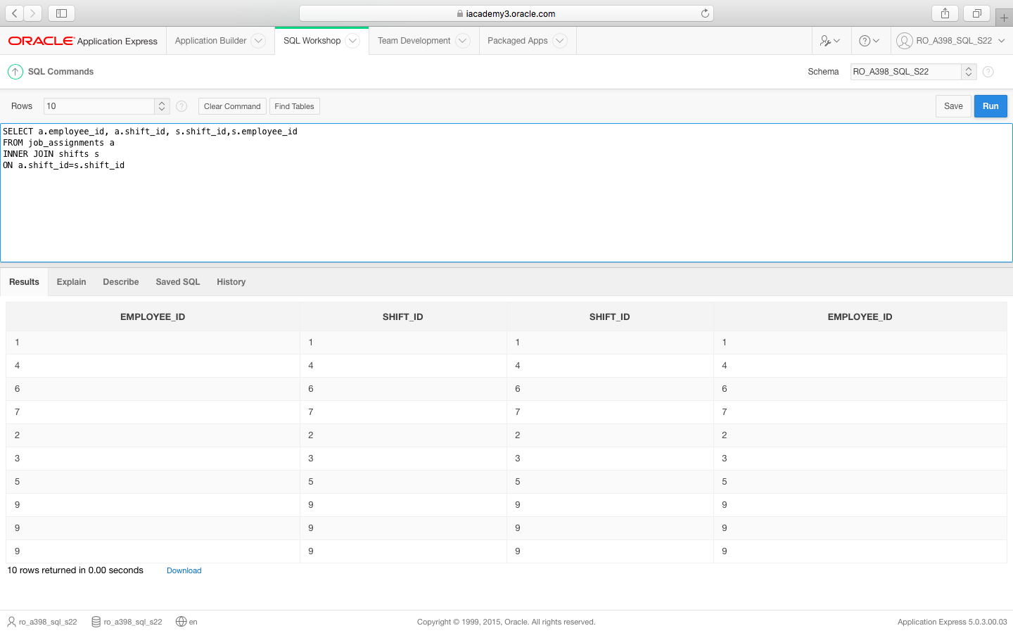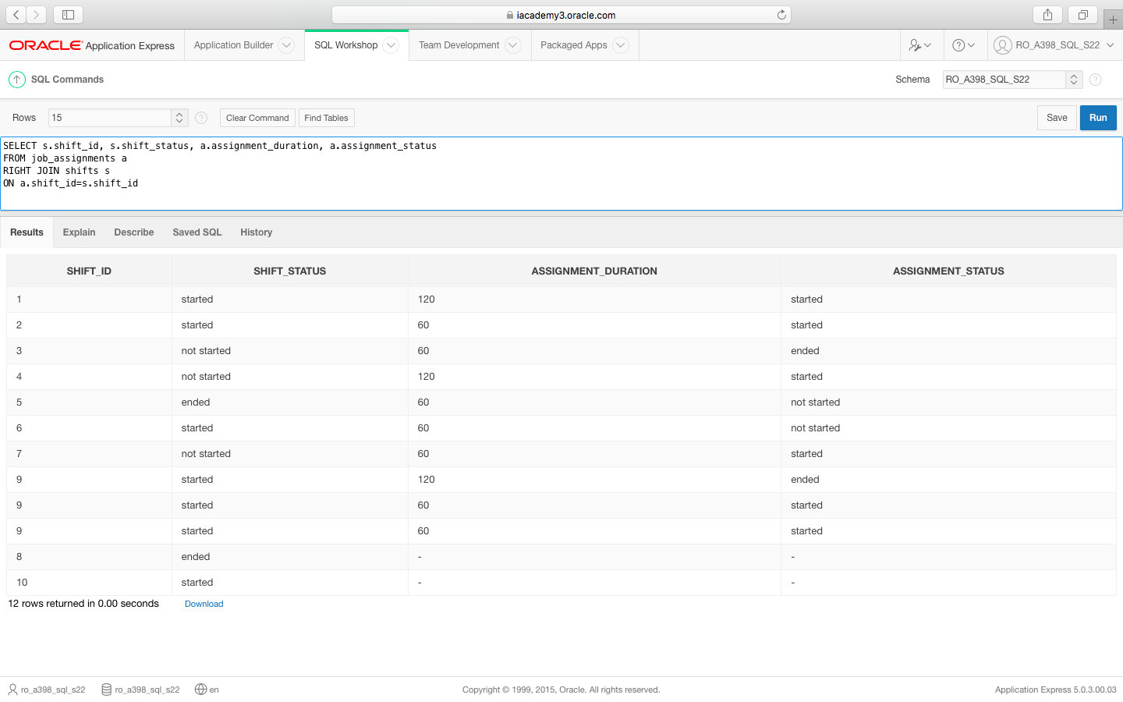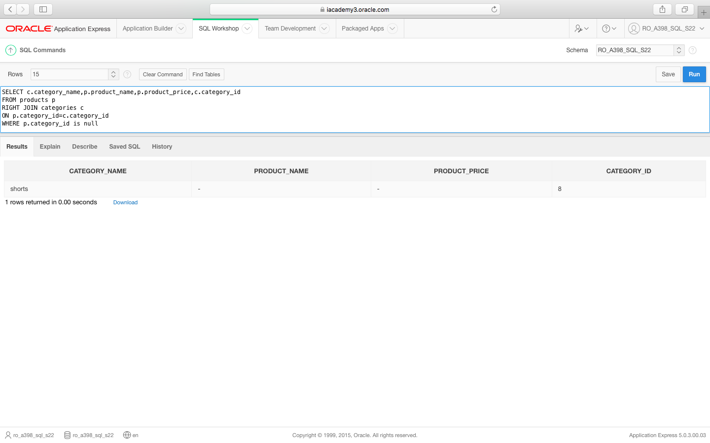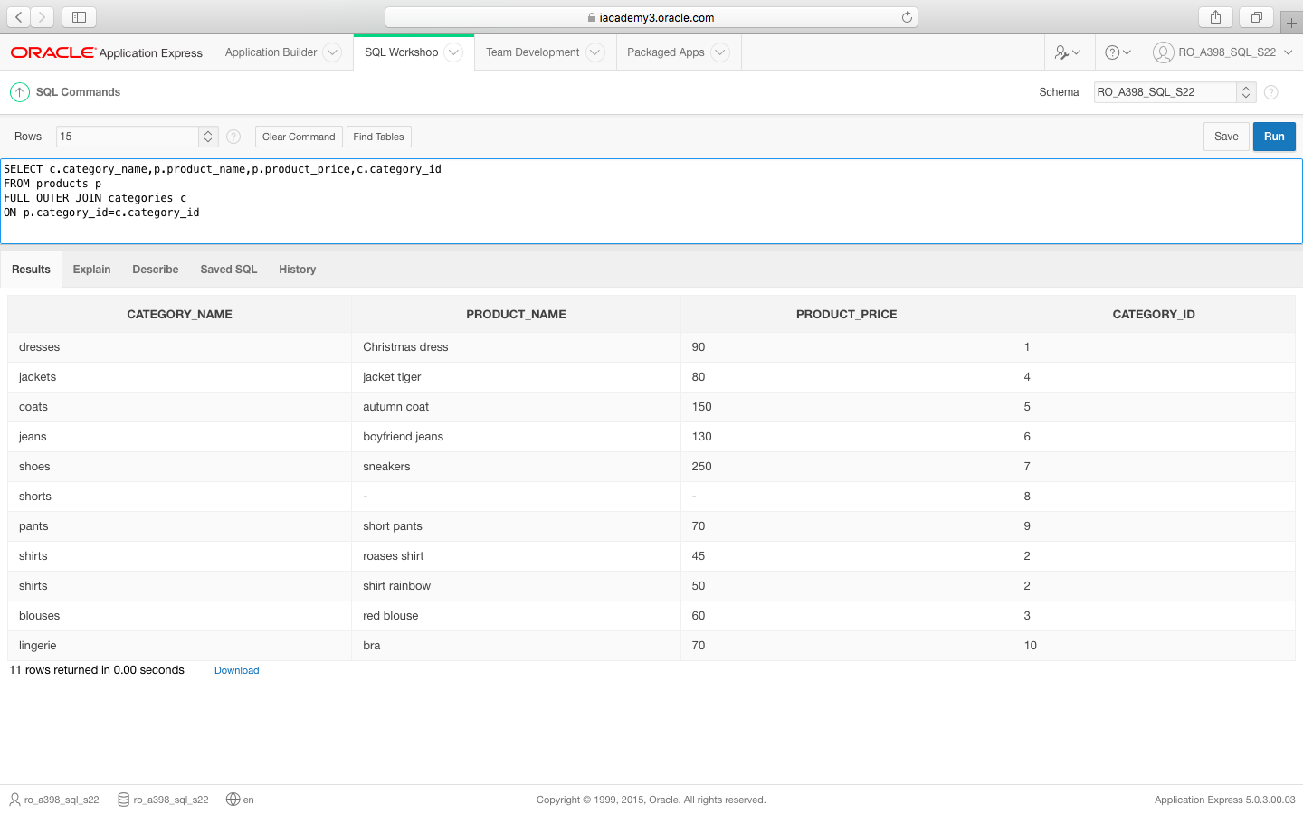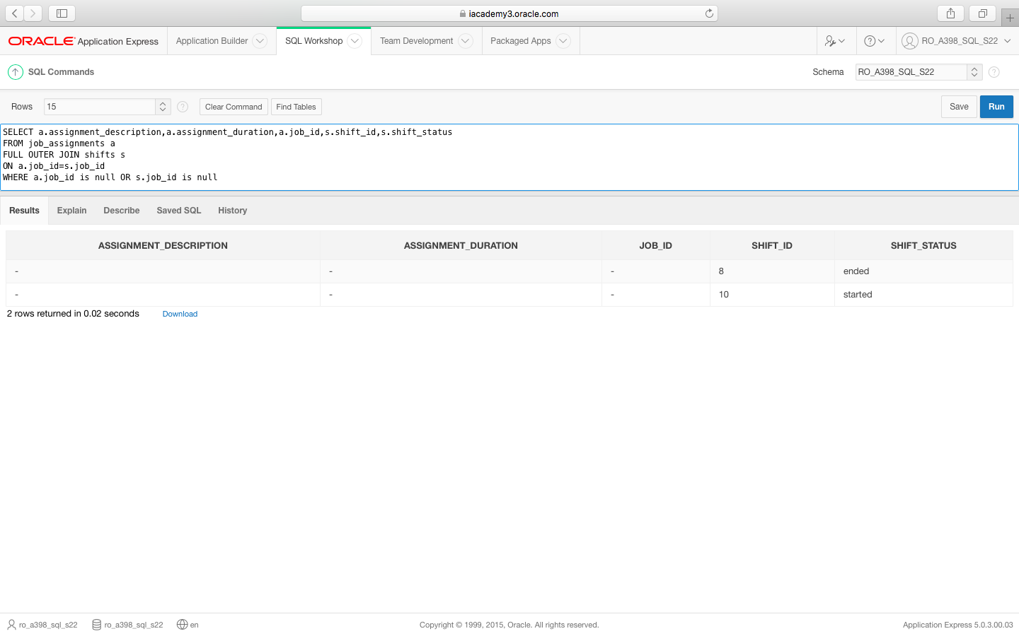

SUBQUERY

